

ART and DT

Theological Underpinning:
Spiritual growth and development: some of the big questions asked | Biblical references offering insight | Theological underpinning – why is this subject important to us as Christians?
- How do Art and Design enrich each of us and our world?  - What contributes to the development of one’s unique perspective?  - What do realistic and abstract representations offer to us in different ways? How do they help us to understand the world?  - Why do we perceive beauty in some things and not in others?  - What does art teach us about value, worth and wealth? | - And God saw that it was good’. Genesis 1  - ‘Do nothing from selfish ambition or deceit, but in humility regard others as better than yourselves’ Philippians 2:3  - ‘All worshipers of images are put to shame, those who make their boast in worthless idols; all gods bow down before him.’ Psalm 97 v7  - ‘Since we are God’s offspring, we ought not to think that the deity is like gold, or silver, or stone, an image formed by the art and imagination of mortals.’ Acts 17:29  - ‘And he gave skill to human beings that he might be glorified in his marvellous works.’ Sirach 38:6 | We all have God-given talents – our expression of these is necessarily different. Christians should appreciate and accept others, respecting creativity and achievement without overlooking flaws. It feels natural to celebrate God and his world through artistic expression, yet this is problematic in the Bible. Those who worship false idols, or who presume to know the likeness of God find their works torn down. More often than not, the doubts around ‘art’ in the Bible are due to the associations with shows of wealth and status. The true artist does not seek to curry favour or approval, but finds a path to personal expression which is singular and individual, much like faith. Art and Design can show a deep appreciation for the world around us, including the built environment. Art can also transcend spoken and written language to highlight injustices and call people to take action.
Creative Arts Intent, Implementation and Impact
At St Georges, we want our children to love creative arts! We want them to have no limits to what their ambitions are and to grow up wanting to be illustrators, graphic designers, fashion designers, curators, architects or printmakers. Our Creative Arts curriculum is designed to engage, inspire and challenge pupils, whilst equipping them with the knowledge and skills to be able to experiment, invent and create their own works of art. As pupils progress, they should gain a deeper understanding of how Art and Design reflects and shapes our history, and how it contributes to the culture, creativity and wealth of our world. We want to equip our children with not only the minimum statutory requirements of the Art and Design National Curriculum but to prepare them for the opportunities, responsibilities and experiences of later life. We want our children to use the local area as inspiration, to learn from other cultures and to respect diversity. To that end, we have carefully selected a wide range of unique and diverse artists, craft makers and designers for children to study. As a Christian school, our creative arts curriculum is underpinned by theological questions and Bible references offering insight into the subject.

At St Georges, we aim for children to acquire a range of different creative skills, under drawing, painting and mixed media, that develop each year as children progress through the school. This begins in EYFS. We want them to use their imaginations and experiences to produce creative work. They will develop their powers of observation, and develop the ability to communicate their thoughts, opinions and feelings about their own work and that of others’. They will use their analytical skills to respond knowledgably to the work of other artists, knowing that there are different kinds of art made for different purposes. Children should also have opportunities to learn about the world in which we live, understanding that art plays a key role in the fabric of our society. Above all, we aim for children to work towards achieving a greater sense of identity and belonging through the arts.
At St Georges, we use Access Art for its curriculum and resources. Every child has a knowledge organiser at the front of their sketchbooks. These knowledge organisers allow children to refer back to key vocabulary when needed, giving them an insight towards what each module will be about. Each child has a sketchbook. We give the child ownership of their sketchbook in order to foster their sense of creativity. Children use their sketchbooks to make initial sketches, develop skills, record ideas and develop opinions. Every child is given the opportunity to learn the key skills through the exploration of artists, makers, designers and their work. Teachers follow a clear progression of skills which ensures all pupils are challenged in line with their year group expectations and are given the opportunity to build on their prior knowledge. Opportunities for children to visit local art galleries and museums are planned for, as well as visits from local artists, extending creativity beyond the school walls. Cross-curricular links are promoted to allow all children to deepen their understanding across all areas of the curriculum. Opportunities to reflect and develop, and self and peer-assessment are planned into each unit of study in KS1 and KS2. To support teaching, staff access a range of CPD, resources and planning, ensuring high levels of teaching, confidence and knowledge are maintained. Our Foundation Subject Assessment Tracker allows us to use data to inform future practice.

The impact of this curriculum design will lead to outstanding progress over time across key stages relative to a child’s individual starting point and their progression of skills. Children will therefore be expected to leave St Georges reaching at least age-related expectations for Art and Design. Our Art and Design curriculum will also lead pupils to be enthusiastic Art and Design learners, evidenced in a range of ways, including pupil voice, their final pieces and sketchbooks. We ensure that children who are achieving well, as well as those who need additional support, are identified, and additional provision and strategies are planned in and discussed with class teachers. At St Georges, the creative arts are used holistically, allowing children to express themselves, understand their experiences and behaviours, build self-esteem, improve relationships and engage more with the school environment. Achievements are celebrated in classrooms during walking-galleries and corridor displays, and by building in increasing connections with local galleries, we aim to develop our future artists and their appreciation of the art around them.
Art and DT Whole School Topic Overview

 | Autumn 1  Drawing & Sketchbooks | Autumn 2  Mechanisms | Spring 1  Printing and Collage | Spring 2  Construction/Textiles | Summer 1  Working in Three Dimensions | Summer 2  Food and Nutrition
EYFS | Settling In: Me and My Family  Self-portraits, exploring/mixing colour | Transport/Space Firework art, rocket building, clay diva lamps, Christmas card designs | Traditional Tales  Winter pictures, building and constructing with Lego. Ice paintings, building homes for the Three Little Pigs | On the Farm  Creating a puppet, explaining what materials have been used | Under the Sea  Junk modelling, build a floating boat, seaside art, jelly fish paper plate | Healthy Eating and Food  Fruit kebabs, still life painting, fruit painting
Year 1 | Spirals | Moving Pictures | Printmaking | Houses and Homes | Making Birds | Sustainable Cooking
Year 2 | Explore & Draw | Moving Vehicles | Mono Printing | Fabric Puppets | Be an Architect | Perfect Pizzas
Year 3 | Gestural drawing with charcoal | Pneumatic Monsters | Working with shape and colour | Photo Frames | Making Animated Drawings | Sandwich Snacks
Year 4 | Storytelling through Drawing | Alarms | Exploring Pattern | Juggling Balls | Sculpture, Structure, Inventiveness | The Great Bread Bake Off
Year 5 | Typography & Maps | Moving Toys | Making Monotypes | Felt Phones Cases | Set Design | Super Seasonal Cooking
Year 6 | 2D Drawing to 3D Making | Automata Animals | Activism | Bridges | Take a Seat | Global Food

Autumn 1 | Autumn 2 | Spring 1 | Spring 2 | Summer 1 | Summer 2
Me and My Family  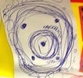  Using drawing, story maps, role play and self-portraits to express themselves. | Transport  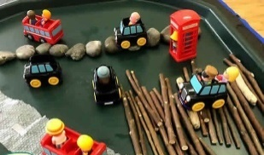  Using junk modelling, clay diva lamps, wooden blocks to explore structures. | Traditional Tales  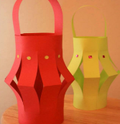  Junk modelling, Chinese art, creating own lanterns. | On the Farm  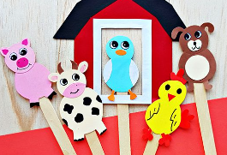  Puppet making activities, collage, decorating clay eggs. | Under the Sea  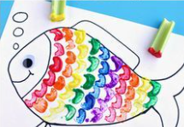  Shoebox under the sea, junk modelling, fish patterns/printing. | Healthy Eating  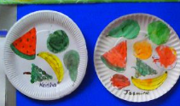  Still life painting, fruit kebabs, fruit printing, making own salad.
Birth-5 Matters (Range 5&6)  - Uses tools for a purpose  - Explores instruments and the sounds they make  - Explores colours and how colours change colours/materials  - Creates representations of both imaginary and real-life ideas, events, people and objects  - Uses role play, introduces stories and narratives | Birth-5 Matters (Range 5&6)  - Mixes colours for a purpose  - Selects specific materials to enhance their creation  - Uses 2D/3D structures to explore/express ideas  - Practises using scissors to cut  - Sings familiar songs - nativity rehearsal/BHM music | Birth-5 Matters (Range 5&6)  - Exploring colour changing via experiments i.e. ice paintings  - Uses role play, introduces stories and narratives  - Begins to build a collection of songs and dances  - Uses their increasing knowledge and understanding of tools and materials to explore their interests to develop their thinking | Birth-5 Matters (Range 5&6)  - Puppet making, decorating clay eggs, collage activities  - Selects specific materials to enhance their creation  - Uses their increasing knowledge and understanding of tools and materials to explore their interests to develop their thinking  - Creates representations of both imaginary and real-life ideas, events, people and objects | Birth-5 Matters (Range 5&6)  - Develops their own ideas through experimentation with materials  - Uses their increasing knowledge and understanding of tools and materials to explore their interests to develop their thinking  - Creates representations of both imaginary and real-life ideas, events, people and objects | ELG  - Safely use and explore a variety of materials, tools and techniques, experimenting with colour, design, texture, form and function  - Share their creations, explaining the process they have used:  - Make use of props and materials when role playing characters in narratives and stories  - Note that some children will make their own art as it is based around children’s own interests.
EYFS

Year 1
Autumn 1  Drawing & Sketchbooks | Autumn 2  Mechanisms | Spring 1  Printing and Collage | Spring 2  Construction | Summer 1  Working in Three Dimensions | Summer 2  Food and Nutrition
Spirals  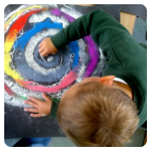  Using drawing, collage and mark-making to explore spirals. Introducing sketchbooks. | Moving Pictures  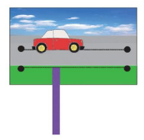  Children begin their exploration of mechanisms here and learn how levers, wheels and sliders work. | Printmaking  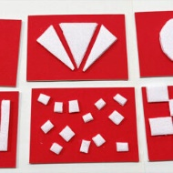  Explore simple ways to make a print. Use line, shape, colour and texture to explore pattern, sequencing and symmetry. | Houses and Homes  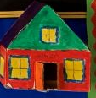  Construction project where children begin to think about uses of materials and strengthening their product. | Making Birds  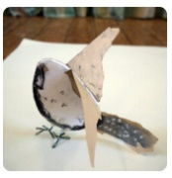  Sculptural project beginning with making drawings from observation, exploring media, and transforming the drawings from 2d to 3d to make a bird. | Sustainable Cooking  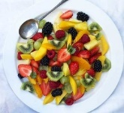  A cooking project which provides young children with all the skills and information they need to prepare a wide variety of nutritious, sustainable family meals, and helps them to make positive (and delicious!) food choices.
Key Skills  - draw lines of varying thickness;  - use dots and lines to demonstrate pattern and texture;  - use different materials to draw, for example pastels, chalk, felt tips;  - use key vocabulary to demonstrate knowledge and understanding in this strand: portrait, self-portrait, line drawing, detail, landscape, cityscape, building, pastels, drawings, line, bold, size, space. | Key Skills  - build simple structures, exploring how they can be made stronger, stiffer and more stable;  - talk about and start to understand the simple working characteristics of materials and components;  - explore and create products using mechanisms, such as levers, sliders and wheels. | Key Skills  - use their hands and feet to explore printing patterns using their bodies.  - introduced to primary paint colours and will demonstrate an understanding of how they can create a ‘print’ using controlled pressure and paint amounts.  - experiment with line, shape and colour to create drawings over the top of their prints.  - collect textured objects which they will take rubbings from, using materials such as wax crayons or pencil crayons. | Key Skills  - build simple structures, exploring how they can be made stronger, stiffer and more stable;  - with help, measure and mark out;  - cut, shape and score materials with some accuracy;  - assemble, join and combine materials and components  - talk about their design ideas and what they are making;  - as they work, start to identify strengths and possible changes they might make to refine their existing design. | Key Skills  - use a variety of natural, recycled and manufactured materials for sculpting  - use a variety of techniques, e.g. rolling, cutting, pinching;  - use a variety of shapes, including lines and texture; use key vocabulary to demonstrate knowledge and understanding in this strand: sculpture, statue, model, work, work of art, 3D, land art, sculptor, carving, sculpture, installation, shapes, materials, pyramid, abstract, geometric. | Key Skills  - explain where in the world different foods originate from;  - understand that all food comes from plants or animals;  - understand that food has to be farmed, grown elsewhere (e.g. home) or caught;  - name and sort foods into the five groups in the Eatwell Guide;  - understand that everyone should eat at least five portions of fruit and vegetables every day and start to explain why;  - use what they know about the Eatwell Guide to design and prepare dishes.
Year 2
Autumn 1  Drawing & Sketchbooks | Autumn 2  Mechanisms | Spring 1  Printing and Collage | Spring 2  Textiles | Summer 1  Working in Three Dimensions | Summer 2  Food and Nutrition
Explore and Draw  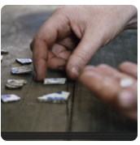  Introducing the idea that artists can be collectors & explorers as they develop drawing and composition skills. | Moving Vehicles  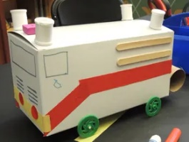  Explore axles and wheels to make a junk model moving vehicle. | Exploring the World through Monoprint  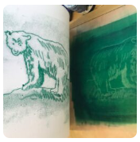  Using a simple mono print technique to develop drawing skills, encourage experimentation and ownership. | 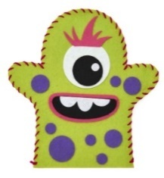  Fabric Puppets  Explore fabrics and running stitch to create a colourful hand puppet. | Be an Architect  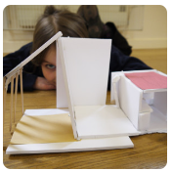  Exploring architecture and creating architectural models. | 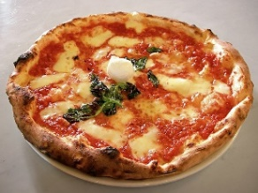  Perfect Pizzas  A project to discover what a variety of toppings and bases look like then designing a pizza based on a design brief.
Key Skills  - use a combination of materials that have been cut, torn and glued;  - sort and arrange materials;  - add texture by mixing materials; use key vocabulary to demonstrate knowledge and understanding in this strand: collage, squares, gaps, mosaic, features, cut, place, arrange. | Key Skills  - build simple structures, exploring how they can be made stronger, stiffer and more stable;  - talk about and start to understand the simple working characteristics of materials and components;  - explore and create products using mechanisms, such as levers, sliders and wheels. | Key Skills  - copy an original print;  - use a variety of materials, e.g. sponges, fruit, blocks;  - demonstrate a range of techniques, e.g. rolling, pressing, stamping and rubbing;  - use key vocabulary to demonstrate knowledge and understanding in this strand: colour, shape, printing, printmaking, woodcut, relief printing, objects. | Key Skills  - use their knowledge of existing products and their own experience to help generate their ideas;  - design products that have a purpose and are aimed at an intended user;  - with help, measure and mark out;  - demonstrate how to cut, shape and join fabric to make a simple product;  - manipulate fabrics in simple ways to create the desired effect;  - use a basic running stich;  - begin to use simple finishing techniques to improve the appearance of their product | Key Skills  - talk about their design ideas and what they are making;  - as they work, start to identify strengths and possible changes they might make to refine their existing design;  - with help, measure and mark out;  - cut, shape and score materials with some accuracy;  - assemble, join and combine materials, components  - evaluate their products and ideas against their simple design criteria; start to understand that the process can involve repeating different stages of the process. | Key Skills  - explain where in the world different foods originate from;  - understand that all food comes from plants or animals;  - understand that food has to be farmed, grown elsewhere (e.g. home) or caught;  - name and sort foods into the five groups in the Eatwell Guide;  - understand that everyone should eat at least five portions of fruit and vegetables every day and start to explain why;  - use what they know about the Eatwell Guide to design and prepare dishes.
Year 3
Autumn 1  Drawing & Sketchbooks | Autumn 2  Mechanisms | Spring 1  Printing and Collage | Spring 2  Construction | Summer 1  Working in Three Dimensions | Summer 2  Food and Nutrition
Gestural Drawing with Charcoal  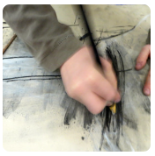  Making loose, gestural drawings with charcoal, and exploring drama and performance. | Pneumatic Monsters  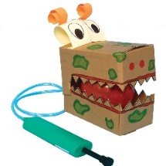  Children will learn about pneumatics in order to make their very own moving monsters. | Shape and Colour  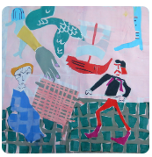  “Painting with Scissors”: Collage and stencil in response to looking at artwork. | 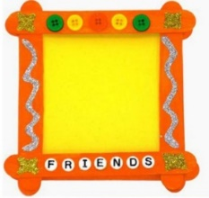  Photo Frames  Making loose, gestural drawings with charcoal, and exploring drama and performance. | 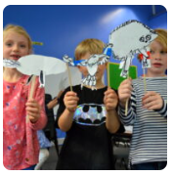  Making Animated Drawings  Explore how artists are inspired by other art forms – in this case how we make sculpture inspired by literature and film. | 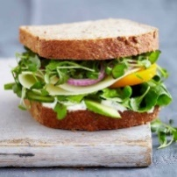  Sandwich Snacks  In this food project, children will look at seasonality of food and food hygiene and safety when making their sandwiches.
Key Skills  - experiment with showing line, tone and texture with different hardness of pencils;  - use shading to show light and shadow effects;  - use different materials to draw, e.g. pastels, chalk, felt tips;  - show an awareness of space when drawing;  - use key vocabulary to demonstrate knowledge and understanding in this strand: portrait, light, dark, tone, shadow, line, pattern, texture, form, shape, tone, outline. | Key Skills  - understand that materials have both functional properties and aesthetic qualities;  - understand and demonstrate how mechanical systems have an input and output process;  - explain how mechanical systems such as levers and linkages create movement;  - use mechanical systems in their products. | Key Skills  - use more than one colour to layer in a print;  - replicate patterns from observations;  - make printing blocks;  - make repeated patterns with precision;  - use key vocabulary to demonstrate knowledge and understanding in this strand and materials to create effect, giving reasons for their choices;  - refine work as they go to ensure precision;  - learn and practise a variety of techniques, e.g. overlapping, tessellation, mosaic and montage; | Key Skills  - with growing confidence, carefully select from a range of tools and equipment, explaining their choices;  - select from a range of materials and components according to their functional properties and aesthetic qualities;  - place the main stages of making in a systematic order;  - cut, shape and score materials with some degree of accuracy;  - assemble, join and combine material and components with some degree of accuracy. | Key Skills  - cut, make and combine shapes to create recognisable forms;  - use clay and other malleable materials and practise joining techniques;  - add materials to the sculpture to create detail; use key vocabulary to demonstrate knowledge and understanding in this strand: rectangular, concrete, terrace, architect, 2D shape, brim, peak, buckle, edging, trimmings, shape, form | Key Skills  - start to know when, where and how food is grown (such as herbs, tomatoes and strawberries) in the UK, Europe and the wider world;  - understand how to prepare and cook a variety of predominantly savoury dishes safely and hygienically;  - explain that a healthy diet is made up of a variety and balance of different food and drink, as represented in the Eatwell Guide and be able to apply these principles when planning and cooking dishes;  - start to understand seasonality.

Year 4
Autumn 1  Drawing & Sketchbooks | Autumn 2  Mechanisms | Spring 1  Surface and Colour | Spring 2  Textiles | Summer 1  Working in Three Dimensions | Summer 2  Food and Nutrition
Storytelling through Drawing  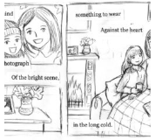  Explore how artists create sequenced drawings to share and tell stories. Create accordian books or comic strips to retell poetry or prose through drawing. | Amazing Alarms  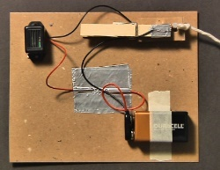  Children will experiment with circuits and switches before designing, making and evaluating their own alarm systems for a particular purpose. | Exploring Pattern  Exploring how we can use colour, line and shape to create patterns, including repeating patterns. | Juggling Balls  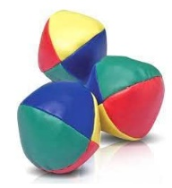  Explore Children will use a hemming and overcast stitch to make their juggling ball to the design brief. | Sculpture and Structure  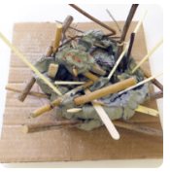  What can artists learn from nature? | 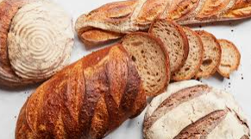  The Great Bread Bake Off  Explore the history of bread and create a design criteria for designing, making and evaluating their own bread product.
Key Skills  - experiment with showing line, tone and texture with different hardness of pencils;  - use shading to show light and shadow effects;  - use different materials to draw, e.g. pastels, chalk, felt tips;  - show an awareness of space when drawing;  - use key vocabulary to demonstrate knowledge and understanding in this strand: portrait, light, dark, tone, shadow, line, pattern, texture, form, shape, tone, outline. | Key Skills  - understand and demonstrate how mechanical and electrical systems have an input and output process;  - make and represent simple electrical circuits, such as a series and parallel, and components to create functional products;  - explain how mechanical systems such as levers and linkages create movement;  - use mechanical systems in their products. | Key Skills  - relax into making a sensory drawing by making holes in a page with a sharp pencil and needle. They repetitive nature of the activity will encourage pupil to make decisions as they go to create a rhythmic piece.  - discover an artist who explores patterns, signs and motifs that hold significance to her identity and will respond to her work in a class discussion.  - devise their own process criteria to help them make drawings inspired by Sol Lewitt.  - experiment with materials and colours to invent their own unique patterns. They will consider angles and mathematical terms such as “parallel”. They will work in sketchbooks, collaborate, and discuss aims and outcomes. | Key Skills  - use a wider range of materials and components, including textiles;  - with growing independence, measure and mark out to the nearest cm and millimetre;  - cut, shape and score materials with some degree of accuracy;  - assemble, join and combine material and components with some degree of accuracy;  - demonstrate how to measure, cut, shape and join fabric with some accuracy to make a simple product;  - join textiles with an appropriate sewing technique. | Key Skills  - cut, make and combine shapes to create recognisable forms;  - use clay and other malleable materials and practise joining techniques;  - add materials to the sculpture to create detail; use key vocabulary to demonstrate knowledge and understanding in this strand: rectangular, concrete, terrace, architect, 2D shape, brim, peak, buckle, edging, trimmings, shape, form | Key Skills  - with support, use a heat source to cook ingredients showing awareness of the need to control the temperature of the hob and/or oven;  - use a range of techniques such as mashing, whisking, crushing, grating, cutting, kneading and baking;  - prepare ingredients using appropriate cooking utensils;  - measure and weigh ingredients to the nearest gram and millilitre;  - start to independently follow a recipe.

Year 5
Autumn 1  Drawing & Sketchbooks | Autumn 2  Mechanisms | Spring 1  Printing and Collage | Spring 2  Textiles | Summer 1  Working in Three Dimensions | Summer 2  Food and Nutrition
Typography and Maps  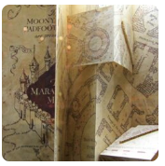  Exploring how we can create typography through drawing and design, and use our skills to create personal and highly visual maps. | Moving Toys  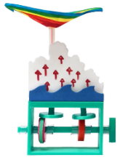  Develop knowledge of cams and forces to make a moving toy. | Making Monotypes  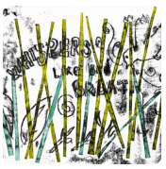  Combine the monotype process with painting and collage to make visual poetry zines. | Felt Phone Cases  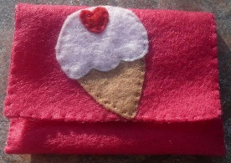  Build on previous sewing knowledge to design and make a felt phone case using a blanket stitch and adding a fastener. | Set Design  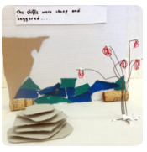  Explore creating a model set for theatre or animation inspired by poetry, prose, film or music. | Super Seasonal Cooking  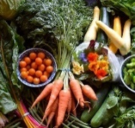  Children learn where a variety of ingredients are grown, reared, caught and processed, before designing their own balanced meal.
Key Skills  - use a variety of techniques to add effects, e.g. shadows, reflection, hatching and cross-hatching;  - depict movement and perspective in drawings;  - use a variety of tools and select the most appropriate;  - use key vocabulary to demonstrate knowledge and understanding in this strand: line, texture, pattern, form, shape, tone, smudge, blend, mark, hard, soft, light, heavy, mural, fresco, portrait, graffiti. | Key Skills  - independently plan by suggesting what to do next;  - with growing confidence, select from a wide range of tools and equipment, explaining their choices;  - select from a range of materials and components according to their functional properties and aesthetic qualities;  - create step-by-step plans as a guide to making;  - explain how mechanical systems, such as cams, create movement and use mechanical systems in their products. | Key Skills  - design and create printing blocks/tiles;  - develop techniques in mono, block and relief printing;  - create and arrange accurate patterns;  - use key vocabulary to demonstrate knowledge and understanding in this strand: Hapa-Zome, hammering, pattern, shape, tile, colour, arrange, collagraph; | Key Skills  - independently plan by suggesting what to do next;  - create step-by-step plans as a guide to making;  - demonstrate how to measure, make a seam allowance, tape, pin, cut, shape and join fabric with precision to make a more complex product;  - join textiles using a greater variety of stitches, such as backstitch, whip stitch, blanket stitch; refine the finish using techniques to improve the appearance of their product, such as sanding or a more precise scissor cut after roughly cutting out a shape. | Key Skills  - with growing confidence, select from a wide range of tools and equipment, explaining their choices;  - select from a range of materials and components according to their functional properties and aesthetic qualities;  - create step-by-step plans as a guide to making;  - shape and score materials with precision and accuracy;  - assemble, join and combine materials and components. | Key Skills  - know, explain and give examples of food that is grown (such as pears, wheat and potatoes), reared (such as poultry and cattle) and caught (such as fish) in the UK, Europe and the wider world;  - understand about seasonality, how this may affect the food availability and plan recipes according to seasonality;  - understand that food is processed into ingredients that can be eaten or used in cooking;  - demonstrate how to prepare and cook a variety of predominantly savoury dishes safely and hygienically including, where appropriate, the use of a heat source;

Year 6
Autumn 1  Drawing & Sketchbooks | Autumn 2  Mechanisms | Spring 1  Printing and Collage | Spring 2  Construction | Summer 1  Working in Three Dimensions | Summer 2  Food and Nutrition
2D Drawing to 3D Making  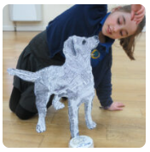  Explore how 2D drawings can be transformed to 3D objects. Work towards a sculptural outcome or a graphic design outcome. | Automata Animals  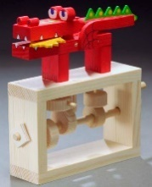  Children learn about controlling movement with a cam mechanism to create a moving animal. | Activism  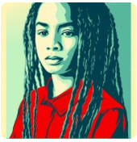  Explore how artists use their skills to speak on behalf of communities. Make art about things you care about. | Building Bridges  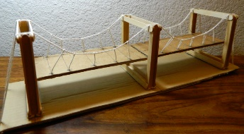  Explore real life bridges when designing a structure that is functional. | Take a Seat  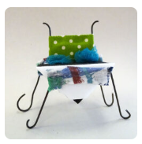  Explore how craftspeople and designers bring personality to their work. | Global Food  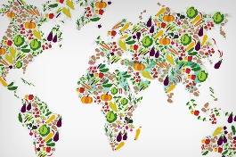  Explore how different countries and cultures cook and eat.
Key Skills  - use a variety of techniques to add effects, e.g. shadows, reflection, hatching and cross-hatching;  - depict movement and perspective in drawings;  - use a variety of tools and select the most appropriate;  - use key vocabulary to demonstrate knowledge and understanding in this strand: line, texture, pattern, form, shape, tone, smudge, blend, mark, hard, soft, light, heavy, mural, fresco, portrait, graffiti. | Key Skills  - apply their understanding of how to strengthen, stiffen and reinforce more complex structures in order to create more useful characteristics of products;  - understand and demonstrate that mechanical and electrical systems have an input, process and output;  - explain how mechanical systems, such as cams, create movement and use mechanical systems in their products;  - critically evaluate the quality of design, manufacture and fitness for purpose of products as they design and make; evaluate their ideas and products against the original design criteria, making changes as needed. | Key Skills  - create a colour palette, demonstrating mixing techniques;  - use a range of paint (acrylic, oil paints, water colours) to create visually interesting pieces;  - use key vocabulary to demonstrate knowledge and understanding in this strand: blend, mix, line, tone, shape, abstract, absorb, colour, impressionism, impressionists;  - add collage to a painted or printed background;  - create and arrange accurate patterns;  - use a range of mixed media;  - plan and design a collage; use key vocabulary to demonstrate knowledge and understanding in this strand: shape, form, arrange, fix. | Key Skills  - apply their understanding of how to strengthen, stiffen and reinforce more complex structures in order to create more useful characteristics of products;  - with growing confidence, select from a wide range of tools and equipment, explaining their choices;  - learn to use a range of tools and equipment safely and appropriately and learn to follow hygiene procedures;  - independently take exact measurements and mark out, to within 1 millimetre;  - cut a range of materials with precision and accuracy;  - shape and score materials with precision and accuracy;  - assemble, join and combine materials and components with accuracy. | Key Skills  - plan and design a sculpture;  - use tools and materials to carve, add shape, add texture and pattern;  - develop cutting and joining skills, e.g. using wire, coils, slabs and slips;  - use materials other than clay to create a 3D sculpture; use key vocabulary to demonstrate knowledge and understanding in this strand: form, structure, texture, shape, mark, soft, join, tram, cast. | Key Skills  - know, explain and give examples of food that is grown, reared and caught in the UK, Europe and the wider world;  - understand about seasonality, how this may affect the food availability and plan recipes according to seasonality;  - understand that food is processed into ingredients that can be eaten or used in cooking;  - demonstrate how to prepare and cook a variety of predominantly savoury dishes safely and hygienically including, where appropriate, the use of a heat source;  - demonstrate how to use a range of cooking techniques, such as griddling, grilling, frying and boiling;  - explain that foods contain different substances, such as protein, that are needed for health and be able to apply these principles when planning and preparing dishes;  - adapt and refine recipes by adding or substituting one or more ingredients to change the appearance, taste, texture and aroma.

