

SCIENCE

Theological Underpinning:
Spiritual growth and development: some of the big questions asked | Biblical references offering insight | Theological underpinning – why is this subject important to us as Christians?
- Can something new be created by combining elements, or are all things defined by their source?  - What of the world around me can I truly perceive?  - How does the energy of life work at so many levels?  - Is my character a result of nature or nurture? | - For in him all things in heaven and on earth were created, things visible and invisible, whether thrones or dominions or rulers or powers—all things have been created through him and for him. He himself is before all things, and in him all things hold together. Colossians 1:16-17  - All things came into being through him, and without him not one thing came into being. What has come into being in him was life, and the life was the light of all people. The light shines in the darkness, and the darkness did not overcome it. John 1:3-5 | ‘Science and religion are two sides of the same deep human impulse to understand the world, to know our place in it, and to marvel at the wonder of life and the infinite cosmos we are surrounded by.’ (Amir D Aczel) Science reveals to us the wonder and beauty of God’s creation and the interconnectedness of nature. As Physics study reveals to us the depth and breadth of what we cannot perceive in the universe around us and the expanse of it becomes clearer, we see what a unique creation we are. Science holds answers to most questions we have and study extends us and helps us to be the best of ourselves. However, the creation of consciousness and spirit remains elusive, as an act of God’s creation.
Science Intent, Implementation and Impact
We give our children a fully-inclusive Science curriculum which enables them to be scientists, through which they question, explore and discover, resulting in a deeper understanding of the world around them. Through our practical, hands-on curriculum, we foster natural curiosity and equip our children with the necessary science skills to become lifelong learners. By the end of primary school, our children are aware of environmental issues, understand the science world of work through gained science capital and be able to use a vast scientific vocabulary. As a Christian school, our science curriculum is underpinned by theological questions and Bible references offering insight into the subject.

Throughout the school we have two main aims for Science learning. Firstly, we aim to provide our children with a thorough foundation in scientific knowledge and skills that will support their successful transition into secondary school learning. Secondly, we aim to foster and grow children’s natural curiosity and enthusiasm for science in the world around them. As a highly inclusive school, we are committed to meeting the needs of children with SEND in the most effective way so that they achieve the best possible outcomes: we want pupils with SEND to acquire the knowledge and skills they need to reach their full potential, to be ready for the next stage in their education and, ultimately, to succeed in life. To do this, we adapt how we implement the Science curriculum to meet the needs of pupils with SEND so that we can develop their knowledge, skills and abilities to apply what they know and can do with increasing fluency and independence. The adaptations we make are appropriate and reasonable.

Our scientists in foundation stage will begin to question and explore the world through hands on experiences and communicating what they observe.
Children in Key Stage 1 and 2 will have blocks of Science throughout the year. Each focused topic, in line with the National Curriculum, begins with a question being posed to the children; we believe this will encourage discussion and highlight children’s previous knowledge and misconceptions. This will allow us to tailor the learning to suit the needs of the class and encourage progression in their learning. Each topic is also linked to a scientist who has worked within that field; this supports children’s understanding of science as a career. The scientists are carefully selected to reflect our school community and provide great role models for our children.
Within each topic, children are ‘working scientifically’ and expanding their scientific vocabulary and subject knowledge. They develop key skills such as asking questions, making predictions, setting up tests, observing and measuring, recording data, interpreting and communicating results and evaluating
Through completing practical enquiries and exploring ideas, children are given the opportunity to develop a strong core skill set including: predicting, experimenting and evaluating. Within the children’s learning they are encouraged to work collaboratively and communicate their ideas effectively whilst using a range of scientific language. Knowledge organisers are utilised for each unit of work and sent home ahead of learning, outlining knowledge and vocabulary which all children must master.
Alongside the core national curriculum coverage, children will spend half a term each year learning about environmental science. They will learn about issues that are currently affecting our world such as recycling, biodiversity, weather changes, air and water pollution and green energy alternatives.
An essential aspect of Science is its practical nature. Alongside in-class scientific investigations, classes will take part in trips, for example to the Natural History Museum, City Farms, Greenwich Royal Observatory and may be involved in Science workshops. We also participate in the National Science, Technology, Engineering and Maths week in the Spring time with a STEM exhibition for parents, governors and the local community. Our curriculum also covers Environmental Sciences to raise awareness with children of issues such as Recycling, Biodiversity Challenges, Water and Air Pollution and Green Energy Alternatives. Children then exhibit their learning at an open evening much like STEM week.

The impact of our science teaching on our children is to:
- achieve high quality outcomes
- make outstanding progress in relation to their individual starting points
- understand science in the world around them
- be able to question and discuss scientific issues with sound understanding and vocabulary
- have gained enough science capital to have an interest in the science world of work and of current environmental issues in our world

Science Whole School Topic Overview
 | Autumn 1 | Autumn 2 | Spring 1 | Spring 2 | Summer 1 | Summer 2
EYFS | Environmental Science: Autumn  Animals inc. Humans: The senses | Looking after the world  Weather changes | Environmental Science: Winter  Plants and Animals:  Observations | Environmental Science: Spring  Animals inc. Humans: Life cycles (Ducklings) | Living Things and their Habitats: Sea animals and their habitats | Environmental Science: Summer  Plants: Plant life cycle
Year 1 | Environmental Science: Seasonal Changes Autumn | Animals including Humans | Environmental Science: Seasonal Changes Winter | Plants | Everyday Materials | Environmental Science: Seasonal Changes Spring & Summer
Year 2 | Uses of Every Day Materials | Animals including Humans | Living Things and their Habitats | Plants | Catch up & Consolidate | Environmental Science: Recycling Plastics
Year 3 | Rocks | Animals including Humans | Forces and Magnets | Plants | Light | Environmental Science: Air Pollution
Year 4 | Electricity Part 1 | Animals including Humans | Sound | Electricity Part 2 | States of Matter | Environmental Science: Biodiversity
Year 5 | Earth and Space | Forces | Living things and their habitats | Properties and Changes of Materials | Animals including Humans | Environmental Science: Water Pollution
Year 6 | Light | Evolution and Inheritance | Living things and their habitats | Animals including Humans | SATs | Environmental Science: Green Energy Alternatives

How will the children be enabled to do this? ‘Breadth of Learning’
a. When investigating science children should:
- share their expertise in subjects that interest them and respond to relevant and current issues, locally and in the national media
- apply their knowledge and understanding in real-life contexts, relating it to the world around them and visiting places to learn about science
- work with experts and enthusiasts to find out how science is used and applied in day-to-day life

b. Children should use investigations to:
- explore a range of familiar and less familiar contexts and environments
- develop practical skills that will help them to carry out investigations
- use real-life contexts to develop scientific understanding and apply their scientific knowledge purposefully
- work collaboratively towards a common goal by sharing ideas, making compromises, negotiating and providing feedback

c. When applying their knowledge and understanding of science children should:
- think creatively and inventively about how things work, identify patterns and establish links between causes and effects
- test their ideas through practical activities and review their own and others’ ideas and investigations
- carry out their own investigations, deciding what kind of evidence to collect and what equipment and materials to use
- suggest the results they expect and explain their observations and the significance and limitations of the conclusions they draw

d. When developing their own scientific ideas children should:
- have sufficient opportunity to research and gain knowledge and understanding in each topic area
- have the opportunity to measure, record and draw conclusions based on their findings

These are the overall skills that children need to learn to make progress:
a. observe and explore to generate ideas, define problems and pose questions in order to develop investigations
b. engage safely in practical investigations and experiments and gather and record evidence by observation and measurement
c. communicate and model in order to explain and develop ideas, share findings and conclusions
d. continually make systematic evaluations when carrying out investigations to bring about improvements in processes and outcomes

Key Skills for Investigating and Observing
Years 1 and 2 | Years 3 and 4 | Years 5 and 6
- Make simple observations  - Ask simple questions and recognise that they can be answered in different ways  - Use simple equipment such as magnifying glasses and (digital) microscopes for observation and egg timers for timing.  - Make close and careful observations over time (eg. plants growing) and, with guidance, identify patterns and relationships.  - Suggest answers to questions based on their observations and ideas.  - Gather data and record it to help answer questions – also using ICT  - Use simple scientific language relevant to the area of study and in investigations  - Use ICT to record my observations  - Record my observations in writing and simple diagrams  - I compare observations using scientific vocabulary  - I say whether what happened was what I expected | - Use different types of scientific enquiry to answer questions  - Ask relevant questions that can be answered using a range of scientific enquiry approaches.  - Choose an appropriate approach to an enquiry (eg. fair test or observation).  - Set up simple practical enquiries using comparative and fair testing.  - Choose appropriate equipment for an investigation.  - Make systematic and careful observations using a range of equipment.  - Take accurate measurements using standard units (cm, g, oc), using a range of equipment, including thermometers and data loggers.  - Gather, record, classify and present data in a variety of ways to answer questions (eg. table, venn diagram, carroll diagram, bar chart).  - Record observations using drawings and labelled diagrams.  - Report results and conclusions orally and in writing.  - Report results and conclusions using displays and presentations.  - Identify differences, similarities or changes related to simple scientific ideas and processes  - Use scientific language, drawings, labelled diagrams, keys, bar charts, and tables with growing accuracy  - Draw simple conclusions from results and make further predictions from them based on patterns identified.  - Suggest how a method could be improved to provide more accurate results  - Use straightforward scientific evidence to answer questions or to support their findings. | - Identify an appropriate form of enquiry (fair testing, observation, survey, research, problem solving, classification) to answer a question.  - Work in a team to plan and carry out a science enquiry.  - Identify the equipment required to carry out an investigation.  - Identify what observations to make and how to make them using standard units where relevant.  - Recognise and control variables where necessary.  - Take accurate repeat readings of results using scientific equipment.  - Record and present data and results in a range of appropriate graphs; including bar graphs, line graphs and scatter graphs.  - Record observations using labelled scientific diagrams.  - Create a classification key using observed features.  - Use test results to make predictions that can be investigated in further comparative and fair tests.  - Report conclusions in oral and written forms.  - Identify causal relationships from results and explain what they mean.  - Comment upon the trustworthiness of results and how their accuracy could be improved.  - Identify scientific evidence that use been used to support or refute ideas or arguments.  - Use appropriate scientific language  - Suggest improvements to my work and give reasons  - plan different types of scientific enquiries to answer questions, including recognising and controlling variables where necessary  - Use test results to make predictions to set up further comparative and fair tests  - report and present findings from enquiries, including conclusions, causal relationships and explanations of and degree of trust in results, in oral and written forms such as displays and other presentations  - Identify scientific evidence that has been used to support or refute ideas or arguments.

EYFS

Autumn 1 | Autumn 2 | Spring 1 | Spring 2 | Summer 1 | Summer 2
Environmental Science Autumn  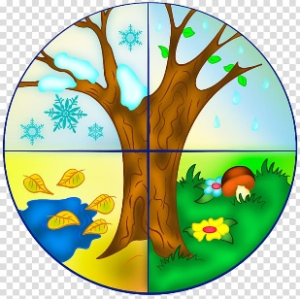  Seasonal changes  Animals inc. Humans:  How can we explore the world around us? | Environmental Science  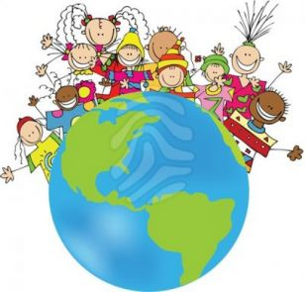  How can we look after the world around us? | Environmental Science: Winter  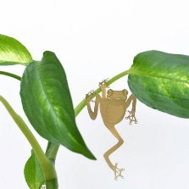  Living Things and their Habitats:  What plants and animals are there in our local area? | Environmental Science: Spring  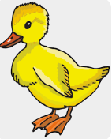  Animals inc. Humans:  How do animals grow? | Living Things and their Habitats:    What lives in our oceans? | Environmental Science:  Summer  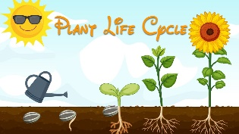  Plants:  How do plants change?

Year 1
Autumn 1  Animals including Humans | Autumn 2  Seasonal Changes | Spring 1  Everyday Materials | Spring 2  Seasonal Changes | Summer 1  Plants | Summer 2  ENVIRONMENTAL SCIENCE
How are animals different?  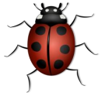 | Why is it cold in winter?   | Why did the third little pig build his house out of bricks?  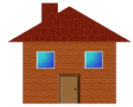 | Why is it warm in summer? | How does your garden grow?  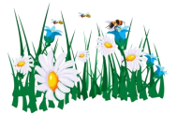 | Where have all the ice caps gone?  
Knowledge and Understanding:  - describe and compare the structure of a variety of common animals (fish, amphibians, reptiles, birds and mammals, including pets)  - identify, name, draw and label the basic parts of the human body and say which part of the body is associated with each sense.  - identify and name a variety of common animals including fish, amphibians, reptiles, birds and mammals  - identify and name a variety of common animals that are carnivores, herbivores and omnivores | Knowledge and Understanding:  - Name and identify the four seasons  - Name and describe different types of weather  - observe changes across the four seasons  - observe and describe weather associated with the seasons and how day length varies | Knowledge and Understanding:  - distinguish between an object and the material from which it is made  - identify and name a variety of everyday materials, including wood, plastic, glass, metal, water, and rock  - describe the simple physical properties of a variety of everyday materials  - compare and group together a variety of everyday materials on the basis of their simple physical properties | Knowledge and Understanding:  - Name and identify the four seasons  - Name and describe different types of weather  - observe changes across the four seasons  - observe and describe weather associated with the seasons and how day length varies | Knowledge and Understanding:  - identify and name a variety of common wild and garden plants, including deciduous and evergreen trees  - identify and describe the basic structure of a variety of common flowering plants, including trees | Knowledge and Understanding:  - Name and identify the four seasons  - Name and describe different types of weather  - observe changes across the four seasons  - observe and describe weather associated with the seasons and how day length varies  * Work will contribute to Environmental Science whole school exhibition
Investigation:  - Can we taste when we can’t smell? | Investigation:  - Does it only rain in winter? | Investigation:  - What happened to the three little pigs houses and why? | Investigation:  - Why doesn’t it snow in the summer? | Investigation:  - Do all plants have roots, stem/trunk, leaves and flowers? | Investigation:  - How does the temperature change during a week?
Scientific Enquiry Focus:  Identify and classifying things | Scientific Enquiry Focus:  Looking for naturally occurring patterns and relationships | Scientific Enquiry Focus:  Identify and classifying things | Scientific Enquiry Focus:  Observing changes over time | Scientific Enquiry Focus:  Comparative and fair testing | Scientific Enquiry Focus:  Researching using secondary sources

Year 2
Autumn 1  Use of everyday materials | Autumn 2  Animals including humans | Spring 1  All living things and their habitats | Spring 2  Plants | Summer 1 | Summer 2  ENVIRONMENTAL SCIENCE  Recycling Plastics
Which material would make the best wellies?  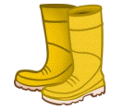 | How do animals survive?   | Who lives where?  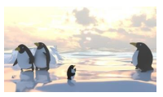 | What would a plant put on its wish list?  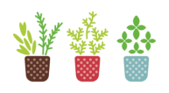 |  | Environmentalist:  Isatou Ceesay  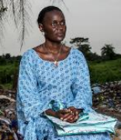
Knowledge and Understanding:  - identify and compare the suitability of a variety of everyday materials, including wood, metal, plastic, glass, brick, rock, paper and cardboard for particular uses  - find out how the shapes of solid objects made from some materials can be changed by squashing, bending, twisting and stretching. | Knowledge and Understanding:  - notice that animals, including humans, have offspring which grow into adults  - find out about and describe the basic needs of animals, including humans, for survival (water, food and air)  - describe the importance for humans of exercise, eating the right amounts of different types of food, and hygiene. | Knowledge and Understanding:  - explore and compare the differences between things that are living, dead, and things that have never been alive  - identify that most living things live in habitats to which they are suited and describe how different habitats provide for the basic needs of different kinds of animals and plants, and how they depend on each other  - identify and name a variety of plants and animals in their habitats, including micro-habitats  - describe how animals obtain their food from plants and other animals, using the idea of a simple food chain, and identify and name different sources of food. | Knowledge and Understanding:  - observe and describe how seeds and bulbs grow into mature plants  - find out and describe how plants need water, light and a suitable temperature to grow and stay healthy. | Revise and consolidate | Knowledge and Understanding:  - What are plastics?  - Why are plastics a problem?  - What can we do to help?  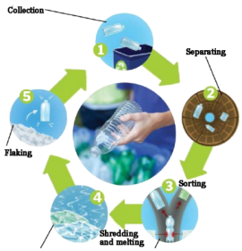
Investigation:  - When squashed, which materials return to their original shape? | Investigation:  - What do I need to eat to thrive? | Investigation:  - Do wood lice prefer the light or the dark, dry or damp conditions? | Investigation:  - Will seeds grow in anything other than soil? |  | Work will contribute to Environmental Science whole school exhibition
Scientific Enquiry Focus:  Sorting and classifying things  Comparative and fair testing | Scientific Enquiry Focus:  Researching using secondary sources | Scientific Enquiry Focus:  Looking for naturally occurring patterns and relationships | Scientific Enquiry Focus:  Observe changes over time |  | Scientific Enquiry Focus:  Researching using secondary sources

Year 3
Autumn 1  Rocks | Autumn 2  Animals including Humans | Spring 1  Forces and Magnets | Spring 2  Plants | Summer 1  Light | Summer 2  ENVIRONMENTAL SCIENCE  Air Pollution
Why did the wise man build his house upon a rock?  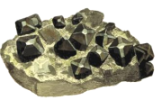 | 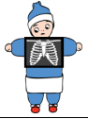  Why are our bodies special? |   Do all forces involve contact? |   How does your garden grow? | Why can we see in the dark?   | Environmentalist:  Hilton Kelley  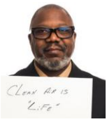
Knowledge and Understanding:  - compare and group together different kinds of rocks on the basis of their appearance and simple physical properties  - describe in simple terms how fossils are formed when things that have lived are trapped within rock  - recognise that soils are made from rocks and organic matter. | Knowledge and Understanding:  - identify that animals, including humans, need the right types and amount of nutrition, and that they cannot make their own food; they get nutrition from what they eat  - identify that humans and some animals have skeletons and muscles for support, protection and movement. | Knowledge and Understanding:  - compare how things move on different surfaces  - notice that some forces need contact between two objects, but magnetic forces can act at a distance  - observe how magnets attract or repel each other and attract some materials and not others  - compare and group together a variety of everyday materials on the basis of whether they are attracted to a magnet, and identify some magnetic materials  - describe magnets as having two poles  - predict whether two magnets will attract or repel each other, depending on which poles are facing | Knowledge and Understanding:  - identify and describe the functions of different parts of flowering plants: roots, stem, leaves and flowers  - explore the requirements of plants for life and growth (air, light, water, nutrients from soil, and room to grow) and how they vary from plant to plant  - investigate the way in which water is transported within plants  - explore the part that flowers play in the life cycle of flowering plants, including pollination, seed formation and seed dispersal. | Knowledge and Understanding:  - recognise that they need light in order to see things and that dark is the absence of light  - notice that light is reflected from surfaces  - recognise that light from the sun can be dangerous and that there are ways to protect their eyes  - recognise that shadows are formed when the light from a light source is blocked by a solid object  - find patterns in the way that the size of shadows change. | - What is air pollution?  - What are the causes of air pollution?  - What are we doing already to reduce air pollution?  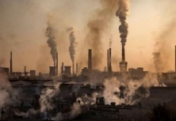  - What more can we do to help?
Investigation:  - How does the size of particles affect the flow rate of water through a funnel? | Investigation:  - Do people with large hands have large feet? | Investigation:  - Are all metal objects attracted to a magnet? | Investigation:  - How does the amount of water/light/soil affect the height/number of leaves of a plant? | Investigation:  - How does distance from the light source affect the size of the shadow? | Work will contribute to Environmental Science whole school exhibition
Scientific Enquiry Focus:  Looking for naturally occurring patterns and relationships | Scientific Enquiry Focus:  Researching using secondary sources | Scientific Enquiry Focus:  Identify and classifying things | Scientific Enquiry Focus:  Observe changes over time | Scientific Enquiry Focus:  Comparative and fair testing | Scientific Enquiry Focus:  Researching using secondary sources

Year 4
Autumn 1  Electricity Part 1 | Autumn 2  Animals including Humans | Spring 1  Sound | Spring 2  Electricity Part 2 | Summer 1  States of Matter | Summer 2  ENVIRONMENTAL SCIENCE  Biodiversity Challenges
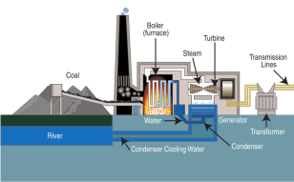  What do we need to create power? | How can we tell the difference between living things?  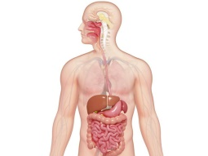 | Why do objects make different sounds?   | How do appliances work?  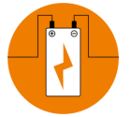 | Why do materials change state?  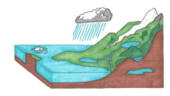 | Environmentalist:  Vandana Shiva  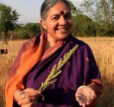
Knowledge and Understanding:  - identify common appliances that run on electricity  - construct a simple series electrical circuit, identifying and naming its basic parts, including cells, wires, bulbs, switches and buzzers | Knowledge and Understanding:  - describe the simple functions of the basic parts of the digestive system in humans  - identify the different types of teeth in humans and their simple functions  - construct and interpret a variety of food chains, identifying producers, predators and prey  - recognise that living things can be grouped in a variety of ways  - explore and use classification keys to help group, identify and name a variety of living things in their local and wider environment  - recognise that environments can change and that this can sometimes pose dangers to living things | Knowledge and Understanding:  - identify how sounds are made, associating some of them with something vibrating  - recognise that vibrations from sounds travel through a medium to the ear  - find patterns between the pitch of a sound and features of the object that produced it | Knowledge and Understanding:  - identify whether or not a lamp will light in a simple series circuit, based on whether or not the lamp is part of a complete loop with a battery  - recognise that a switch opens and closes a circuit and associate this with whether or not a lamp lights in a simple series circuit  - recognise some common conductors and insulators, and associate metals with being good conductors. | Knowledge and Understanding:  - compare and group materials together, according to whether they are solids, liquids or gases  - observe that some materials change state when they are heated or cooled, and measure or research the temperature at which this happens in degrees Celsius (°C)  - identify the part played by evaporation and condensation in the water cycle and associate the rate of evaporation with temperature. | - What is biodiversity?  - What are the biodiversity challenges? (deforestation and habitat loss, over-exploitation of species for human use, introduction of foreign species, pollution)  - What are we currently doing?  - What more can we do to help?  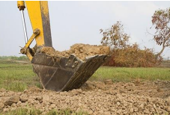
Investigation:  - Which materials conduct electricity the best? | Investigation:  - How clean are our teeth at different times during the day? (Use disclosing tablets) | Investigation:  - How can you make the best string telephone? | Investigation:  - How is brightness of the bulb affect by number of batteries/length of wire/thickness of wire/type of wire? | Investigation:  - Does the temperature of the water affect how much solid will dissolve in it? | Work will contribute to Environmental Science whole school exhibition
Scientific Enquiry Focus:  Researching using secondary sources | Scientific Enquiry Focus:  Identify and classifying things | Scientific Enquiry Focus:  Comparative and fair testing | Scientific Enquiry Focus:  Looking for naturally occurring patterns and relationships | Scientific Enquiry Focus:  Observe changes over time | Scientific Enquiry Focus:  Researching using secondary sources
Year 5
Autumn 1  Earth and Space | Autumn 2  Forces | Spring 1  Living things and their habitats | Spring 2  Properties and Changes of Materials | Summer 1  Animals including Humans  SRE | Summer 2  ENVIRONMENTAL SCIENCE  Water Pollution
Would you ever want to live in space?  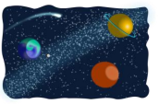 | How could forces keep us safe?   | How can we tell the difference between living things?  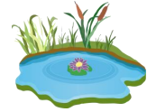 | What would you need to be a CSI investigator?   | Do all species start as an egg?   | Environmentalist:  Andreas Fath  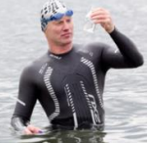
Knowledge and Understanding:  - describe the movement of the Earth, and other planets, relative to the Sun in the solar system  - describe the movement of the Moon relative to the Earth  - describe the Sun, Earth and Moon as approximately spherical bodies  - use the idea of the Earth’s rotation to explain day and night and the apparent movement of the sun across the sky | Knowledge and Understanding:  - explain that unsupported objects fall towards the Earth because of the force of gravity acting between the Earth and the falling object  - identify the effects of air resistance, water resistance and friction, that act between moving surfaces  - recognise that some mechanisms, including levers, pulleys and gears, allow a smaller force to have a greater effect | Knowledge and Understanding:  - explain the differences in the life cycles of a mammal, an amphibian, an insect and a bird  - describe the life process of reproduction in some plants and animals. | Knowledge and Understanding:  - compare and group together everyday materials on the basis of their properties, including their hardness, solubility, transparency, conductivity (electrical and thermal), and response to magnets  - know that some materials will dissolve in liquid to form a solution, and describe how to recover a substance from a solution  - use knowledge of solids, liquids and gases to decide how mixtures might be separated, including through filtering, sieving and evaporating  - give reasons, based on evidence from comparative and fair tests, for the particular uses of everyday materials, including metals, wood and plastic  - demonstrate that dissolving, mixing and changes of state are reversible changes  - explain that some changes result in the formation of new materials, and that this kind of change is not usually reversible, including changes associated with burning and the action of acid on bicarbonate of soda | Knowledge and Understanding:  - describe the changes as humans grow to old age  - SRE Year 5 programme | - What is water pollution?  - What are the causes?  - What are the environmental impacts?  - Prevention and Solutions  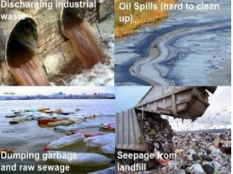
Investigation:  - How does the position of the Sun change during the day? | Investigation:  - How does air resistance affect our ability to run? | Investigations:  - What do seeds require in order to germinate?  - How does the ovary of a flower change as the flower wilts? | Investigations:  - How is evaporation of a liquid affected by size of container/ viscosity/ moving air/ additives/ temperature?  - How is boiling time of water affected by adding salt?  - Do all frozen materials melt at the same temperature? | Investigations:  - How does head to body ratio change as a human grows? | Work will contribute to Environmental Science whole school exhibition
Scientific Enquiry Focus:  Looking for naturally occurring patterns and relationships | Scientific Enquiry Focus:  Comparative and fair testing | Scientific Enquiry Focus:  Identify and classifying things | Scientific Enquiry Focus:  Observe changes over time | Scientific Enquiry Focus:  Observe changes over time | Scientific Enquiry Focus:  Researching using secondary sources
Year 6
Autumn 1  Light | Autumn 2  Evolution and Inheritance | Spring 1  Living things and their Habitats | Spring 2  Animals including Humans | Summer 1  SATs | Summer 2  Summer 2  ENVIRONMENTAL SCIENCE  Green Energy Alternatives
Why can’t I see round corners?   | Why aren’t there any dinosaurs in Camberwell?  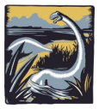 | How do we know a camel is a mammal?  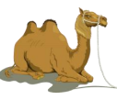 | Which bits of my body could I live without?   |  | Environmentalist:  David Katoatau  
Knowledge and Understanding:  - understand that light appears to travel in straight lines  - use the idea that light travels in straight lines to explain that objects are seen because they give out or reflect light into the eye  - explain that we see things because light travels from light sources to our eyes or from light sources to objects and then to our eyes  - use the idea that light travels in straight lines to explain why shadows have the same shape as the objects that cast them. | Knowledge and Understanding:  - recognise that living things have changed over time and that fossils provide information about living things that inhabited the Earth millions of years ago  - recognise that living things produce offspring of the same kind, but normally offspring vary and are not identical to their parents  - identify how animals and plants are adapted to suit their environment in different ways and that adaptation may lead to evolution. | Knowledge and Understanding:  - describe how living things are classified into broad groups according to common observable characteristics and based on similarities and differences, including micro-organisms, plants and animals  - give reasons for classifying plants and animals based on specific characteristics | Knowledge and Understanding:  - identify and name the main parts of the human circulatory system, and explain the functions of the heart, blood vessels and blood  - recognise the impact of diet, exercise, drugs and lifestyle on the way their bodies function  - describe the ways in which nutrients and water are transported within animals, including humans. | SATs  Catch-up and consolidate | - Greenhouse gases  - Environmentally friendly energy sources  - Fossil fuels  - What more can we do to help?  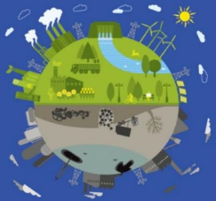
Investigations:  - How can we see round corners? – link to periscopes | Investigations:  - How are local animals/insects different from those in other locations/countries? | Investigations:  - In which groups would you put organisms from the local environment? | Investigations:  - How does my pulse change as I move? |  | Work will contribute to Environmental Science whole school exhibition
Scientific Enquiry Focus:  Identify and classifying things | Scientific Enquiry Focus:  Observe changes over time | Scientific Enquiry Focus:  Looking for naturally occurring patterns and relationships | Scientific Enquiry Focus:  Comparative and fair testing |  | Scientific Enquiry Focus:  Researching using secondary sources

