WIDER CURRICULUM POLICY 2026-2027
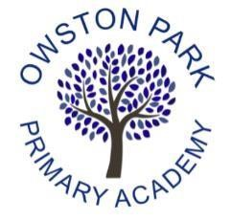

Curriculum Intent Statement

“Curious Minds, Kind Hearts, Bright Futures”
At Owston Park Primary Academy, our intent is to provide a knowledge-rich curriculum that increases the depth and breadth of what pupils know, enabling them to develop cultural capital and a lifelong love of learning. We want our children to leave us not only with strong academic foundations, but also with dignity, happiness, emotional literacy and a deep connection to their community.
Our curriculum is built around our core values of kindness, curiosity, aspiration, integrity and community. We nurture kindness in the way pupils learn and support one another; we promote curiosity through exciting opportunities to question, explore and make connections; we foster aspiration by setting high expectations and opening doors to new possibilities; we model integrity by encouraging pupils to do what is right and to value honesty; and we strengthen community by celebrating our locality and ensuring every child feels a sense of belonging and responsibility.
We believe education is a powerful tool for addressing social injustice. By giving pupils access to the best that has been thought, said and done, and showing how this connects to their own lives in North Doncaster, we empower them with the knowledge and confidence to thrive as educated citizens.
Our aim is for every child to be confident, enthusiastic and curious — equipped with the knowledge, vocabulary and skills they need to make sense of the world and to lead purposeful, fulfilling lives.

Curriculum Design Statement:
Our curriculum design is rooted in coherence, connection and cumulative knowledge. Content in each subject is carefully mapped to identify the precise knowledge, vocabulary and concepts pupils will learn, with attention to both vertical links (progression of concepts across year groups within a subject) and horizontal links (connections across subjects within the same year group).
Learning is sequenced to build securely over time, supported by distributed practice and regular retrieval, enabling knowledge to move into long-term memory. By respecting the unique traditions of each discipline, we develop pupils’ curriculum literacy and help them see how concepts inter-relate across domains.
The curriculum is structured by detail rather than vague titles, avoiding tenuous skills progressions. This ensures that pupils experience a meaningful, interconnected body of knowledge that supports deeper understanding and long-term retention.
Our curriculum is underpinned by key drivers which ensure that children are equipped with the skills and dispositions needed to thrive both academically and personally. Listening and speaking are prioritised to develop articulate, confident communicators who can express themselves with clarity and respect. Problem solving and creativity are embedded across subjects so that children learn to think critically, generate ideas and approach challenges with resilience. Through staying positive and aiming high, pupils build self-belief, aspiration and the determination to succeed. Leadership and teamwork are fostered through opportunities to take responsibility, collaborate with others and contribute meaningfully to the school community. Together, these drivers ensure that our curriculum nurtures well-rounded individuals who are ready to flourish in the wider world.



Curriculum Organisation:

When developing the curriculum, we start with our composites, which relate to the National Curriculum, these are our top-level outcomes. Subject leaders then break these composites down further, into their constituent parts, called components, focusing on how the substantive and disciplinary knowledge through their subject progresses, and how learning is sequenced and built on, year on year. Subject leaders decide what knowledge is to be taught throughout their subject and why. The component knowledge is taught through cycles of work. Medium term plans are produced by subject leads to show progression and sequential learning. Subject leaders then break the component knowledge down further, into granular knowledge, which is evidenced through short-term plans, which are produced in cycles, rather than terms
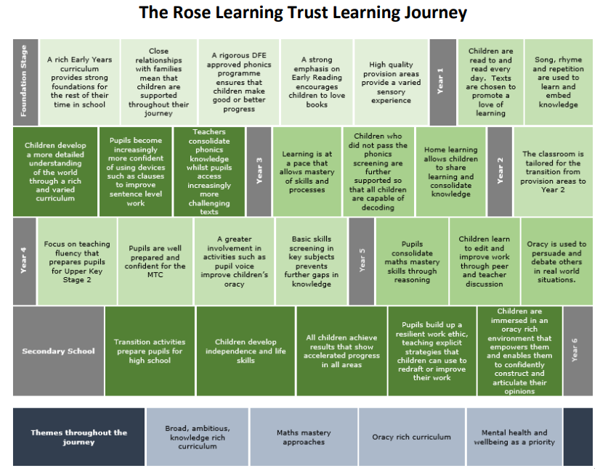

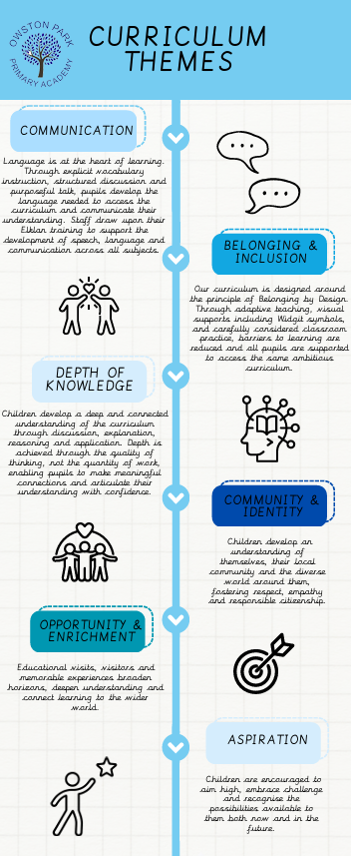

Curriculum Delivery:
Our curriculum is delivered through individual disciplines. We don’t believe in a cross-curricular approach based on tenuous links – any links, either vertical and horizontal, are made only when they are meaningful and develop children’s conceptual knowledge.
Individual Lessons:
Teachers use a variety of teaching and learning styles during lessons to ensure that pupils’ needs are met. We recognise that an overly prescriptive approach is reductive, but our lessons follow a set structure (either individually or over a series of lessons), to ensure that educational research into memory and effective learning is transferred into the classroom every lesson.
- ‘Do Now’ - Prior Knowledge is activated at the start of a teaching sequence. Regular low stakes quizzing enables knowledge to be stored in long-term memory.
- Explicit strategy instruction – New content is introduced in appropriate sized chunks, with visual or practical resources. Specific vocabulary is taught to ensure that children can access the content effectively, and helps to develop their conceptual understanding, making links to existing schema and ensuring the new knowledge has something to ‘stick’ to. Targeted questioning checks understanding and scaffolds learning.
- Modelling of learned strategy – Teacher ‘thinks out loud’ to model strategy. Children are encouraged to think about why each step happens.
- Memorisation of strategy – Targeted questioning to check understanding. Children identified for further support.
- Guided practice – Children have opportunity to practice the skill, often in the form of a Talk Task, which promotes oracy and correct use of vocabulary. Teacher gives verbal feedback.
- Checkpoint – A hinge question which elicits misconceptions and provides opportunity for AfL for the teacher.
- Independent practice – Children practice the strategy or apply the knowledge that they’ve learnt. Questioning to scaffold and extend children’s learning. Children given depth tasks to extend learning.
- Structured reflection – Guides children to reflect on their learning from today and how it fits in with their wider journey, encouraging children to make both the horizontal and vertical links.

Planning:
The planning process at Owston Park Primary begins with the National Curriculum and our Curriculum Drivers, to ensure that the topics we teach include the powerful knowledge – the best that has been thought, said and done – and is enhanced by our locality and our own unique heritage. From these, subject leaders alongside class teachers have worked together to develop Subject on a Page documents, which ensure that the key, powerful knowledge is being taught rather than just ‘doing’ a subject. The Subject on a Page documents are then considered alongside the skills progressions and conceptual knowledge maps to create a series of coherently sequenced lessons to map out the learning journey for each subject.
The Subject on a Page acts as a medium term plan, demonstrating how the key knowledge and skills fit together, ensuring balanced subject coverage and planning lessons which impart this key knowledge whilst also developing age-
appropriate skills in each subject. Subject leaders monitor medium term plans and work alongside class teachers to ensure that pupils receive full coverage of the National Curriculum.

Enrichment:
We believe that children learn best when knowledge is brought to life through rich experiences and meaningful opportunities. Our curriculum is therefore carefully enriched to inspire curiosity, spark imagination and create lasting memories.
Every topic begins with a memorable launch event that immerses children in their new learning and generates excitement from the outset. Throughout each unit, children benefit from a range of first-hand experiences, including educational visits, workshops, visitors and practical learning opportunities that enhance and deepen curriculum knowledge. These experiences are carefully planned to broaden children's horizons, increase their cultural awareness and provide opportunities that some children may not otherwise encounter. Through these opportunities, we aim to develop confident, curious learners who are eager to engage with the world around them and make connections beyond the classroom.

Assessment:
Assessment is an integral part of our curriculum design, ensuring that every child's learning journey is carefully monitored, supported and celebrated. Assessment is used to inform teaching, identify misconceptions and ensure that all pupils make progress through the curriculum.
Throughout each unit, teachers use a range of formative assessment strategies including questioning, hinge questions, discussion, retrieval practice, observation and low-stakes assessment activities. Every curriculum lesson includes a planned checkpoint, often in the form of a hinge question, to assess pupils' understanding of the key learning and inform responsive, adaptive teaching.
At the end of each unit, teachers complete a Subject Assessment Sheet which captures pupils' progress against the intended learning outcomes. The assessment process focuses on both component knowledge, which represents the building blocks of understanding, and composite knowledge, which reflects the broader concepts and understanding that pupils should develop by the end of the unit. Teachers also consider pupils' substantive knowledge (the key knowledge within the subject) and disciplinary knowledge (how pupils think, work and reason as subject specialists).
The Subject Assessment Sheet enables teachers to identify common strengths, misconceptions and next steps for learning, whilst also highlighting pupils who may require additional support, challenge or targeted intervention. This information informs future planning, adaptive teaching and curriculum development. Subject leaders regularly review assessment information, teacher evaluations and pupil outcomes to identify trends, monitor curriculum effectiveness and shape future professional development and curriculum improvement. Teachers use assessment information gathered through questioning, discussion, retrieval activities and lesson checkpoints to respond to pupils' needs in real time.

Time Allocation:
In order to ensure our curriculum is broad and balanced, we teach every subject each term. We understand that time constraints may mean that lessons do not achieve an equal time allocation on a weekly basis, but on a termly basis History should be taught as often as Geography, DT should be taught as often as Art etc.

Depth for All:
We believe that all children are capable of thinking deeply about their learning. Depth is not viewed as an additional task or activity completed once core learning has been secured; instead, it is an integral part of everyday teaching and learning.
All pupils access the same ambitious curriculum content and are supported through adaptive teaching to achieve success. Teachers provide opportunities for children to deepen their understanding through discussion, reasoning, explanation and the application of knowledge in a range of contexts. Through skilled questioning, structured talk, debate and collaborative learning, pupils are encouraged to justify their ideas, make connections, evaluate evidence and explain their thinking using precise subject-specific vocabulary.
Depth is achieved through the quality of thinking rather than the quantity of work produced. Children are encouraged to refine their explanations, build upon the contributions of others and articulate their understanding with increasing confidence and accuracy. This focus on oracy enables pupils to develop a richer understanding of curriculum content whilst strengthening their communication skills across all subjects.
By maintaining high expectations and providing appropriate support and challenge, we ensure that all pupils are given opportunities to engage in deep, meaningful learning.
Inclusion:
At Owston Park, we are committed to creating an inclusive learning environment where every child feels valued, represented and able to succeed. We maintain high expectations for all pupils and believe that all children are entitled to access the same ambitious curriculum regardless of their starting point, background or additional needs.
Adaptive teaching is at the heart of our approach. Teachers carefully respond to pupils' strengths and needs through strategies such as scaffolding, explicit vocabulary instruction, pre-teaching, modelling, visual supports, targeted questioning and opportunities for retrieval and practice. These adaptations enable all learners to access the curriculum whilst maintaining high expectations and common learning goals.
Our approach is underpinned by the principle of Belonging by Design. We proactively consider the needs of all learners when planning learning experiences, ensuring that barriers are reduced before they arise. Universal strategies, including the use of Widgit symbols, visual timetables, worked examples, vocabulary support and accessible classroom environments, help pupils to participate confidently and independently in learning.
Particular consideration is given to vulnerable groups, including pupils with SEND, pupils with English as an Additional Language (EAL), disadvantaged pupils, young carers, pupils with irregular attendance, and those experiencing social, emotional or mental health challenges. Through high-quality adaptive teaching, targeted support and effective collaboration with families and external agencies, we strive to ensure that every child experiences success, develops a sense of belonging and achieves their full potential.

Oracy & Communication:

We recognise that language is fundamental to learning and that vocabulary development plays a crucial role in enabling pupils to access, understand and communicate their knowledge across the curriculum. Explicit vocabulary instruction is therefore embedded within all curriculum areas, with key vocabulary carefully selected, taught and revisited to support long-term retention and understanding.
At Owston Park, we place a strong emphasis on oracy and communication. Pupils are regularly provided with opportunities to discuss, explain, justify, question and refine their thinking through purposeful talk and collaborative learning. Structured discussion supports pupils in developing confidence, deepening their understanding and articulating their ideas using increasingly precise subject-specific vocabulary.
This approach is supported by whole-school Elklan training, which has provided staff with a shared understanding of speech, language and communication development. The strategies gained through Elklan are embedded within classroom practice and include the use of visual supports, modelling, pre-teaching vocabulary, sentence scaffolds and carefully planned opportunities for talk. These approaches help all pupils to communicate effectively and are particularly beneficial for pupils with SEND, pupils with EAL and other vulnerable groups.
Through high-quality vocabulary instruction and rich opportunities for discussion, we ensure that pupils develop the language, confidence and communication skills needed to access the curriculum successfully and participate fully in school life.

Diversity:
We recognise that our children live in a predominantly White British, working-class community and may have limited opportunities to encounter diversity in their everyday lives. Because of this, our curriculum is deliberately designed to provide rich and meaningful opportunities for pupils to learn about, appreciate and celebrate the diverse cultures, histories and perspectives that make up both modern Britain and the wider world. In doing so, we broaden pupils’ horizons, challenge stereotypes and equip them with the understanding, empathy and respect needed to thrive in a multicultural society.
We weave diversity into the curriculum by:
- Representing a wide range of voices, cultures, traditions and perspectives across subjects.
- Celebrating the contributions of people from diverse backgrounds, both historically and in the modern world.
- Actively challenging stereotypes and bias, ensuring positive and authentic representation.
- Preparing children to thrive as responsible citizens in an interconnected, multicultural society.
By embedding diversity across all areas of learning, we ensure that our curriculum is not only ambitious and knowledge-rich, but also inclusive, inspiring and equitable. This commitment supports our school values and underpins our vision of enabling every child to aim high, stay positive, work collaboratively and grow into a kind, curious and confident member of society.

Marking and Feedback:
Pupils’ work will be marked in line with the Marking Policy and will model how corrections should be made, giving pupils a chance to learn from their misconceptions.
- Marking should always be focused on the Learning Challenge.
- Children are given opportunities to self-assess their learning against the Learning Challenge where possible, using the metacognition colours familiar to them.
- Feedback should perform 3 purposes; ensure children understand what they have done well; ensure children are clear about how to improve; ensure children make visible signs of improvement.
- Marking should always ‘close the gap’ and give an improvement suggestion; of which there are 4 types:
  - o a challenge prompt; o a reminder prompt; o a scaffold prompt e.g. a question or unfinished question, steps to complete tasks; o an example prompt.
- Children to have opportunities to self and peer assess their work, when appropriate. This should be recorded and monitored.
- When the arrow icon is shown it indicates what the next step for the child will be or action to complete, either as a consolidation activity or an opportunity to extend learning.
- Wherever possible, the checking or marking of work will be done with the child who will be given the opportunity to ask questions and self-correct.

Classroom Environment:
Classrooms clearly display the topic being taught. Evidence of the children’s learning should be visible, and children’s work should be celebrated. Displays should be eye catching, engaging and appropriate to the age of the children. Key vocabulary should be on display, as should supporting resources to further children’s understanding, e.g. time lines.
Leadership and Management:
The subject leader’s role is to empower colleagues to teach wider curriculum lessons to a high standard and support wider curriculum subject leaders in the following ways. Their role includes leading, managing, monitoring, motivating, training and guiding colleagues.
- Knowing the curriculum requirements of their subject throughout school, and using their knowledge of their subject to create road maps of the learning journey and assist teachers in developing knowledge organisers, ensuring that the content maintains fidelity with the National Curriculum.
- Showcasing and raising the profile of their subject throughout school, e.g. through thematic days, displays etc.
- Monitoring their subject through book scrutinies, lesson observations, data analysis and pupil interviews to ensure comprehensive monitoring of wider curriculum subjects and to inform them of the quality of the wider curriculum provision across the school.
- Keeping up to date on current issues; disseminating relevant information and providing training for staff members (either directly or through other professionals).
- Identifying and acting on subject specific development needs of staff members with support from SLT - books are scrutinised by SLT throughout the term with a compliance check completed half termly and feedback is provided.
- Monitoring expectations, provision and attainment across the school and providing feedback to develop practice further in order to raise standards.
- Providing necessary equipment and maintaining it to a high standard, managing the subject budget effectively.

Wider Curriculum Non-Negotiables:
- Immersive experiences to be exciting, awe-inspiring events to engage and excite children. The classroom environment should reflect the topic. Key vocabulary should be displayed within the classroom, as should resources which support key knowledge e.g. timelines, diagrams.
- Learning objectives and titles to be present in children’s books/folders. The title should contain a context. The learning challenge should be highlighted in the corresponding colour according to the metacognitive level achieved.
- Vocabulary should be explicitly taught within the lesson.
- Presentation expectations in wider curriculum lessons to mirror expectations in core subjects.

