

Fantastic work this week to the girls for their victory!

Look out for a new battle between the boys and girls this week.
Who managed to beat their previous scores? I can see lots more of you are now playing – excellent Year 3 – keep up the great work!

Shout out to Amelia and Sina for being the most valuable players for your teams during this week’s competition…
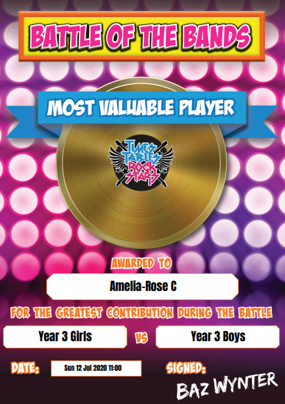
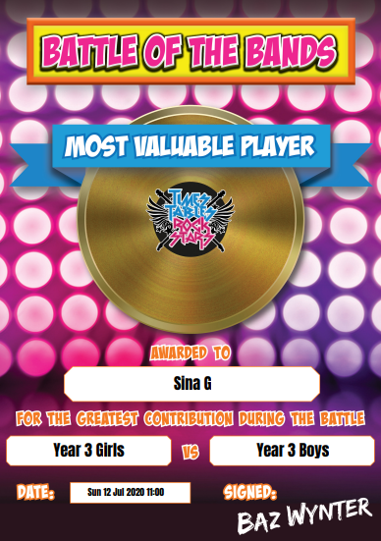

Unlucky Year 3 – you were so close!

I’ve set up a new battle against Year 6 so you can have a go at beating them this time!

Well done to Amelia and Isla for being the top players against Year 6!

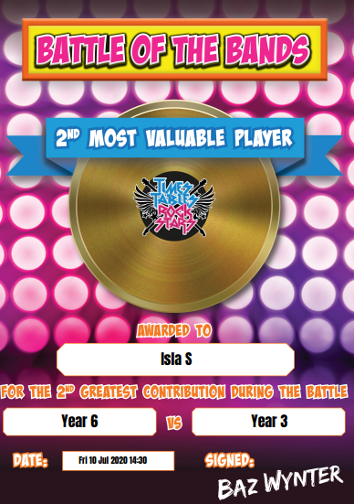
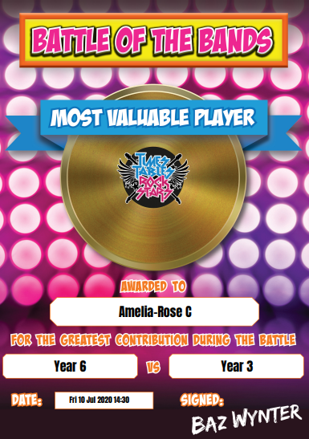

WOW AMAZING PROGRESS THIS WEEK, SINA!

