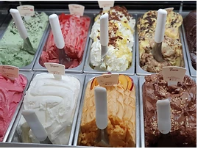

Ice Cream
July 1st was officially 'Creative Ice Cream Flavour Day’!

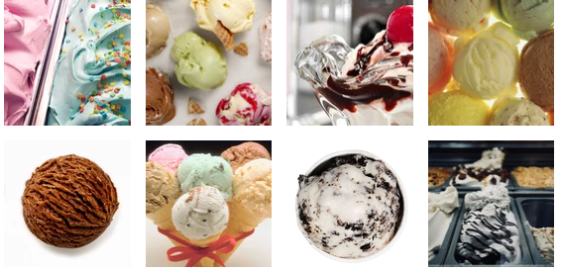
- Look at a range of pictures of Ice Cream or real Ice Cream if you have it!
- Create a list of ideas about all about Ice Cream.
Look at some of my ideas:
Greatest  Coldest  Frostiest | Scummiest  Yummiest  sweetest | Superb  Tasty  Delicious  Exquisite  Incredible  Amazing  wonderful
Homemade  Colourful  Dripping  Melting  smooth | Velvety  Heavenly  Gooey  Lumpy  Sugary/sweet | Scrummy  Silky  Frozen  Creamy  Glistening
Soft  Runny  swirls | Toppings  sprinkles  Flake  Choc-chips | Cone  Tub  Scoop  Flavours

- Now write your own poem using your ideas.
- Illustrate your poem.
- If possible create your own Ice Cream Sundae or a simple two scoops and enjoy!!
