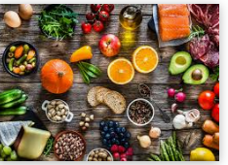

English Tasks all about Food.

Task 1-  To use adjectives to describe | Watch this You tube video:  https://www.youtube.com/watch?v=tgxsX4fRTuQ  The book is Eating the alphabet by Lois Ehlert  Create your own A to Z of food book.  Draw each food and add a caption underneath including adjectives to describe.  Example:  - Juicy, green pears ripe and ready to pick.  - Crunchy, fresh baguette layered with yummy cheese and tasty ham.
Task 2-  To read accurately and recall information | Read Where does chocolate come from?  Write an account/ bullet points of where chocolate comes from in your own words.
Task 3-  Create your own poem. | July 1st was officially 'Creative Ice Cream Flavour Day.  Refer to Ice Cream activity file on the blog to create an Ice cream poem!  