Maths Challenge Year 2
Green Challenge
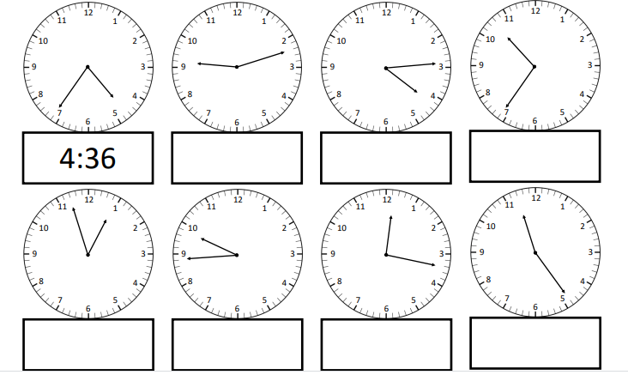
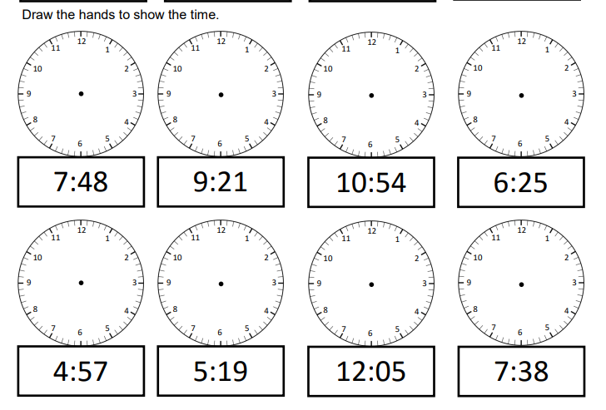
Time- to the nearest minute

