Maths Challenge Year 2
Amber Challenge
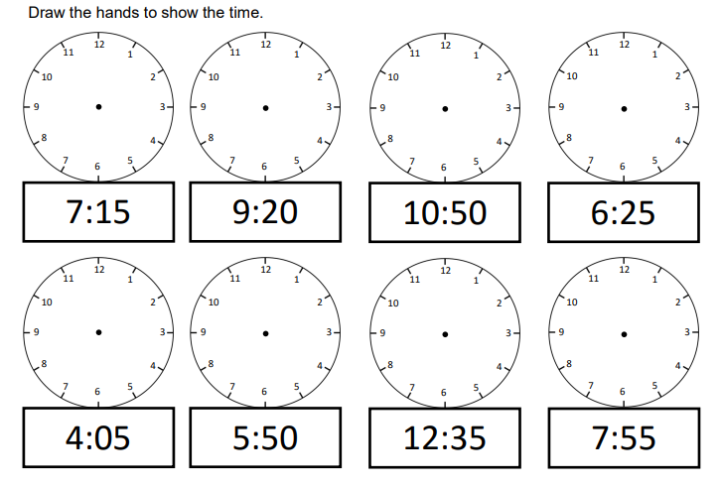
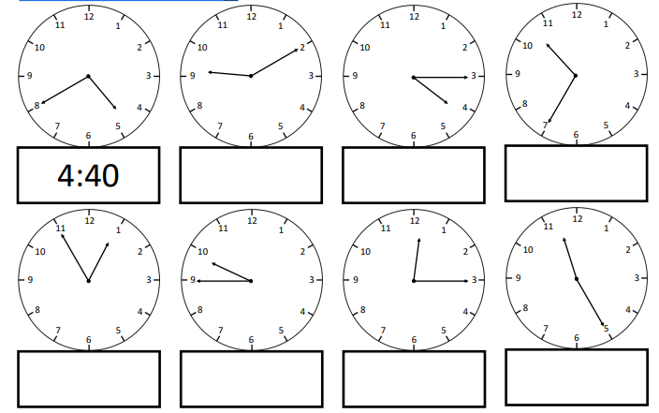
Time- to the nearest 5 minutes, including quarter past/ to the hour

