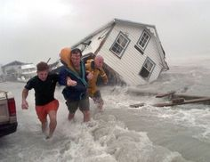
What do you think happened before this picture was taken?
What is happening in this picture?
What will happen after this picture?
Year 4 Inference

Look at this picture and answer the following questions. Look carefully at the details within the picture and think about the feelings of the people in it.

