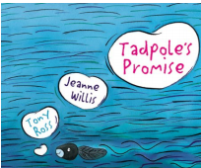
Tadpoles Promise
Year 2

Discussion questions: | 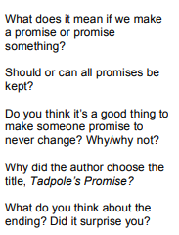
Key Vocabulary | 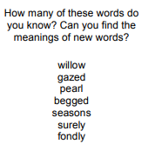
Sequence the story | Use the pictures to correctly sequence the story and add captions in full sentences under each picture.
Speech Bubble | Add your own ideas to complete the speech bubble.
Review- use the special tadpole paper | Write a review of this book.  Did you like this book? Why?  Did you like the ending? Explain  Would you recommend this book and to who/why?

