**Guided Reading Planning Overview**

Monday

Text exploration and tricky word scan

Tuesday

Vocabulary exploration

Friday

Catch up

Thursday

Whole class reading strategies

Wednesday

Mixed skills questioning

|  |  |  |  |  |  |
| --- | --- | --- | --- | --- | --- |
| **\*READING STATEGIES\***  **\*TEXT TITLE\*** | | | | | |
| **National Curriculum objectives**  *NC objective that is being covered linked to the reading strategy/ies being taught* | | | | | |
| **Monday** | **Tuesday** | **Wednesday** | **Thursday** | **Friday** |
| ***Text reading type*** | ***Text reading type*** | ***Text reading type*** | ***Text reading type*** | ***Catch up*** |
| **Tricky word scan**  **Text Reading**  **Text exploration** | **Vocabulary exploration**  Use the following:  *Hear and see*  *Acknowledge*  *Read and say*  Define  Apply  Connect  Analyse  Word meaning sheets linked to vocab | **Mixed skill questioning**  Paired discussion then teacher models answers  **Independently answer the following questions in written form** | **Choose a reading strategy and whole class work on same task**  **Reading strategy focus:**  **Altogether**  *question*  **In pairs**  *question*  **On own**  *question* |  |

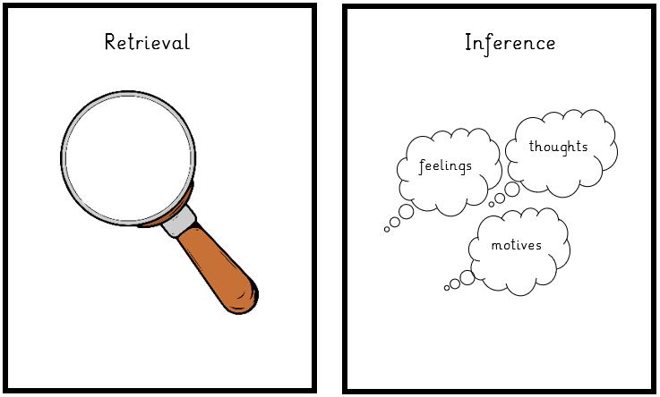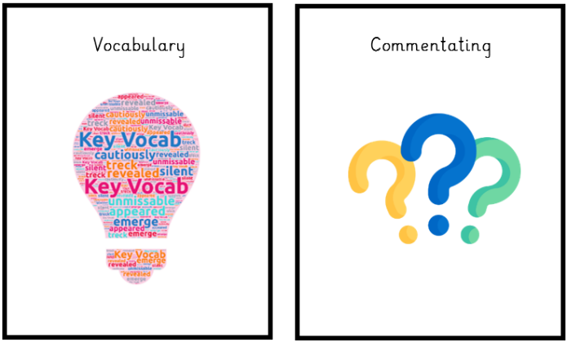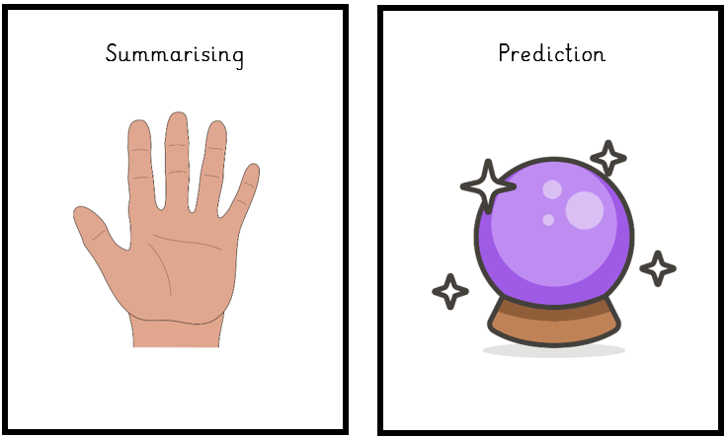

**Reading Intent**

We pride ourselves in celebrating a love of reading throughout Moss Hey from the moment the pupils arrive until the moment they leave.

We have a focus on learning to read and then reading to learn.

We understand the importance of reading for practise, purpose and pleasure.