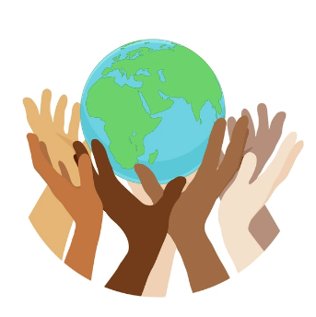
Our Wonderful World
Summer 2 2026

Expressive Arts
We will sing songs, learn a rap and keep a steady beat to songs and music from around the world. We will be exploring and experimenting with different materials and media including developing our sewing skills. We will present our own version of stories using role play and present our rap to an audience. We will continue to use our colour mixing skills and develop our use of tools in our own creations.

Communication and Language
We will use past tense verbs in our retelling of and sharing our understanding of our favourite stories using new vocabulary, some repeated phrases and our own words. We will listen to and discuss to a selection of non-fiction texts, songs, poems and a rap linked to our wonderful world topic. We will be using conjunctions to add more detail to our sentences.
PSED
We will be continuing to play games that involve following rules and understanding that someone else’s point of view can be different to our own. We will also be working out how to deal with change and take on more responsibilities as we begin our transition to Year One. We will continue to reflect on our learning and what we might change to make it even better.

Maths
We will explore sharing including using the language fair, equal and the same. We will look at what happens when we share odd and even numbers. We then move onto grouping and try some real- life problems. We will continue to count beyond 20 and look at the patterns we can see in the number sequence.
We will also revisit repeated patterns and link this to our environment.
Physical Development
Letter formation will continue to be a big focus and we will also continue to focus on writing on the lines and controlling our letter size. In the outside area, children will engage in gross motor activities. In PE, the children will be working on their gymnastic skills including developing their balance and strength.
Literacy
We will continue to develop our phase 4 phonics knowledge and start to add in some new phase 5 phonemes. We will learn to read and write longer words. We will continue to use stories to inspire us to write simple sentences that we are able to read back to ourselves and others to ensure it makes sense. We will have a focus on correct formation of capital letters.
Understanding the World
We will explore similarities and differences between where we live and other countries in the world. We will identify people within our community who help us look after our world. We will also begin to understand how we can be responsible for looking after our world ourselves. We will be exploring the season of summer.

