The Iron Man - Chapter 4
Wednesday 24th June 2026
QFL: Can I read aloud with expression and answer questions about what I have read?
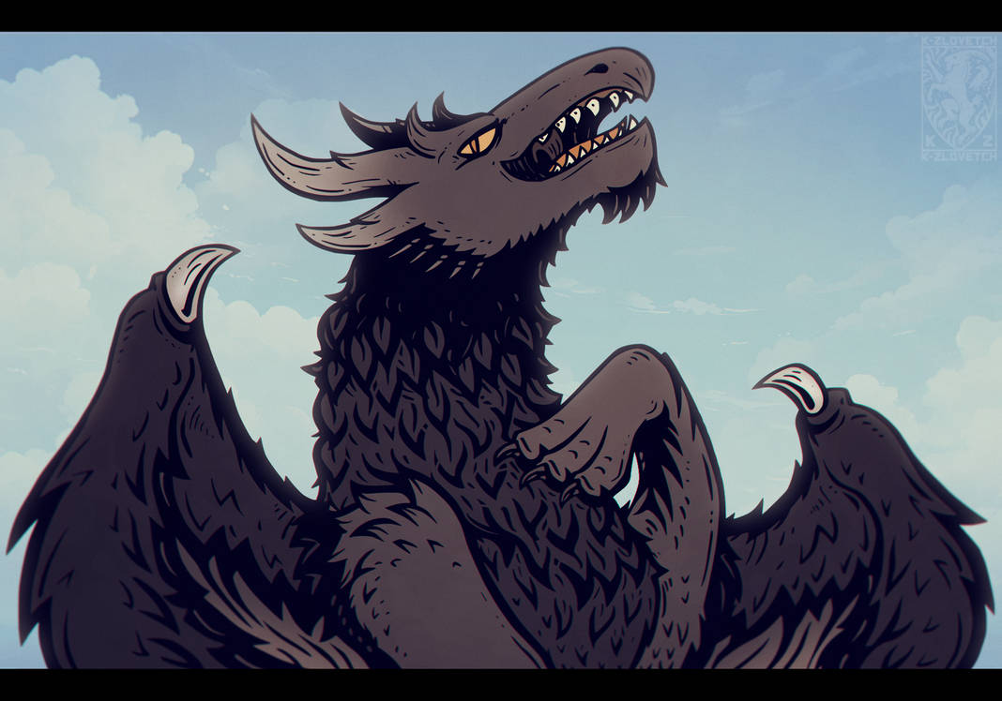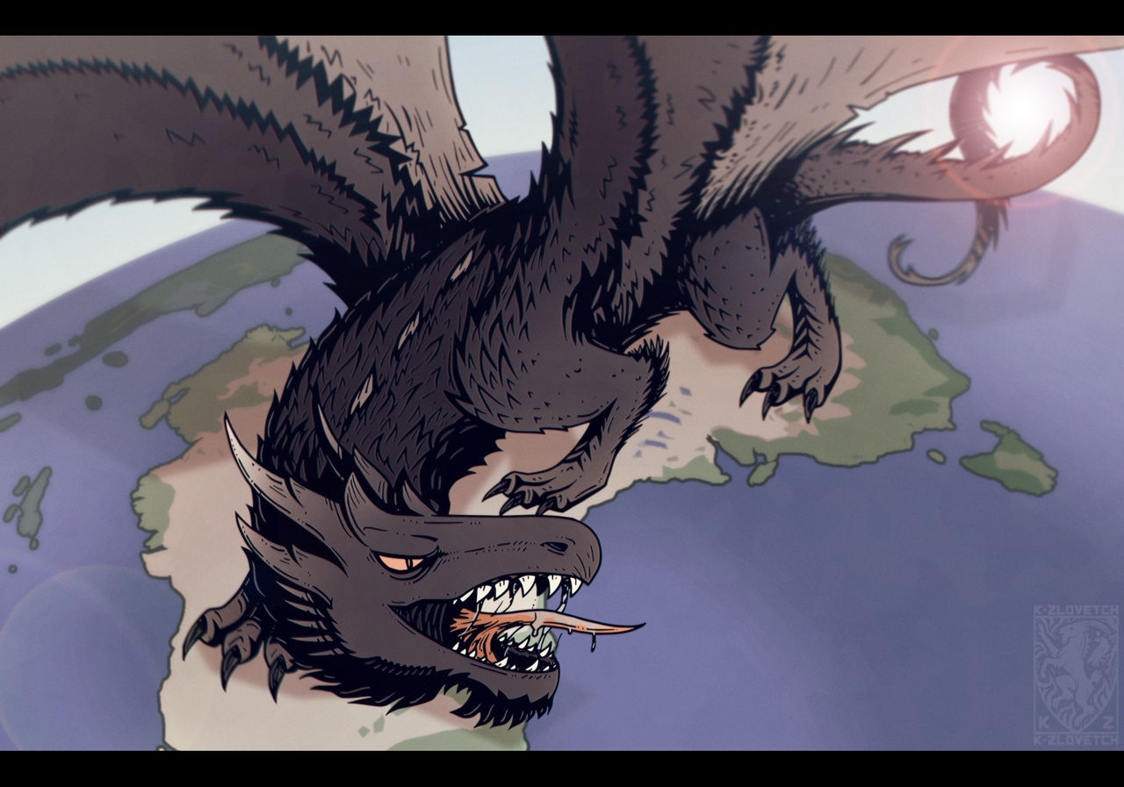
One day, strange news spread across the world.
A giant creature from outer space had landed in Australia. It was called the Space-Bat-Angel-Dragon because it looked like a bat, an angel and a dragon all at the same time.
The creature was enormous and fiery. It flew through the sky and burned everything in its path. Forests, fields and towns were destroyed by its hot breath.
As the monster travelled around the Earth, it grew bigger and bigger. It became more powerful every day.
People everywhere were terrified. They watched the news, trembled with fear and wondered how they could stop the monster. Nobody had a plan.
Scientists discussed ideas. World leaders held meetings. Soldiers prepared to fight. But nothing seemed powerful enough.
Then Hogarth had an idea.
He remembered the Iron Man.
The Iron Man was huge, strong and brave. He had helped people before, and Hogarth believed he was the only one who could stand up to the terrible space creature.
Hogarth suggested that they ask the Iron Man for help.
At first, people were unsure. The monster from space was far bigger and more frightening than anything they had ever seen.
However, they had no other hope.
The message was sent to the Iron Man.
When he heard about the Space-Bat-Angel-Dragon, he agreed to help.
The people of Earth began to feel hopeful again.
Perhaps the Iron Man could save the world.
Vocabulary:
Creature – a living thing
Enormous – very large
Terrified – extremely frightened
Suggested – gave an idea
Powerful – very strong
Hopeful – feeling that something good might happen
Questions
- What was the monster called?
- Where did the monster land?
- What happened wherever the monster went?
- How did people feel about the monster?
- Who suggested asking the Iron Man for help?
- Why did Hogarth think the Iron Man could help?
- How did people feel after the Iron Man agreed to help?

Thursday 25th June 2026
QFL: Can I describe a character using evidence from the text?
1. Character Web
Draw the Space-Bat-Angel-Dragon in the middle of the page.
Write adjectives around your drawing.
Word Bank:
huge, fiery, terrifying, powerful, dangerous, giant, scary, fierce, enormous, unstoppable
2. Explain Your Ideas
Choose three adjectives and write a sentence for each.
Example:
Terrifying – The monster made people tremble and cry.
Enormous – The creature grew bigger and bigger.
Fiery – It burned forests and fields with its fire.
3. Vocabulary Challenge
What do these words mean?
gigantic
flames
terrified
enormous
brave

4. Newspaper Headline
Imagine you are a newspaper reporter.
Write a headline for the day the monster landed.
Examples:
MONSTER FROM SPACE LANDS IN AUSTRALIA!
EARTH IN DANGER!
WORLD LEADERS SEARCH FRO HELP!
5. Prediction Challenge
Write 3–5 sentences predicting what will happen when the Iron Man meets the Space-Bat-Angel-Dragon.
Sentence starter:
I think the Iron Man will...

