Wednesday 24th June 2026
Qfl: Can I identify and highlight the key features of a newspaper report?
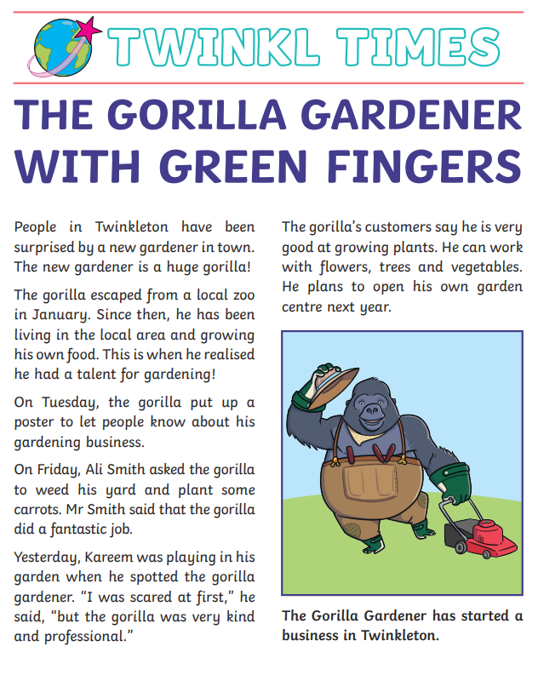
Identify and highlight the key features listed below using different colours:
- Headline
- Picture
- Caption
- Introduction
- Third person
- Fronted adverbial
- Quote
- Conclusion

Thursday 25th June 2026
QFL: Can I identify the 5 W’s from the introduction paragraph?
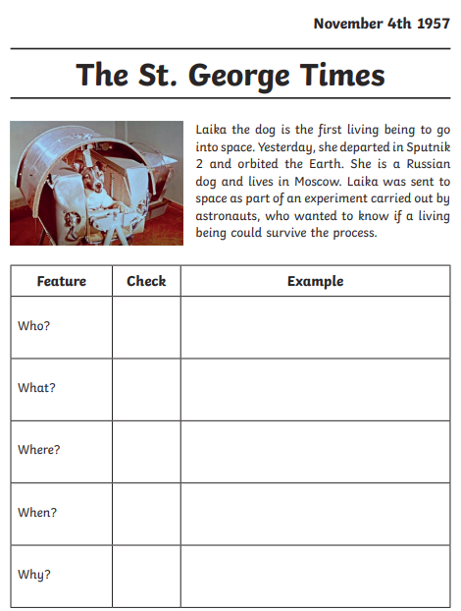
Identify the 5 w’s from the introduction paragraph of the news article and fill in the table.

