Pippins School: Marking and Feedback Guidelines

Contents
Objectives | p.3
Types of marking | p.3
Support for staff | p.3
Marking symbols | p.4-6
Types of marking and feedback | p.6
Examples of effective feedback | p.7
Self and peer feedback | p.8
Whole class feedback | p.9
Yellow Box Marking | p.10

Appendix
1.Marking Symbols
- Types of marking & feedback
  - Conferencing
  - Pupil self and peer evaluation
  - Whole class feedback
  - Yellow box marking
- Teacher feedback to improve pupil learning summary of finding from the Education Endowment Foundation

“The most powerful single moderator that enhances achievement is feedback.” (Hattie, 1992)

Our guidelines for Marking and Feedback at Pippins Primary are informed by research carried out by the EEF (Education Endowment Fund) and the Assessment Reform Group into ‘Assessment for Learning’ (AfL).

Taking in to consideration recommendations from the 'Reducing workload in your school' DfE guidance https://www.gov.uk/guidance/reducing-workload-in-your-school , Pippins Primary designed this guidance to ensure:
- Teachers make best use of the time spent marking and providing feedback to pupils
- Pupils develop the skills to become reflective self and peer-markers

Marking and Feedback Objectives
There are two main reasons we mark work and give feedback:
- To motivate the child
- To further the learning of each pupil and to raise standards throughout the school by:
Addressing misconceptions
Reinforcing a skill or piece of information
Extending a child’s understanding or ability to do something

Types of Marking and Feedback
Marking and feedback at Pippins may be given on a 1:1 basis, to a pair of children, to a group of children or to the class as a whole and could include:
- conferencing
- peer-marking
- self-marking
- yellow box marking
- whole class feedback forms. Please see the appendix for more detailed explanations and examples.
Markers at Pippins can include: teachers, teaching assistants (TA), supply teachers and children.
Marking and feedback at Pippins should always have a positive impact on the child(ren) and be given with consideration to learning and needs. Recommendations for the Education Endowment Fund state ‘Feedback should focus on moving learning forward, targeting the specific learning gaps that pupils exhibit. Specifically, high quality feedback may focus on the task, subject, and self-regulation strategies.
Although the marker is responsible for using their professional judgement when it comes to how to mark a piece of work or provide feedback, it is our intention that all work should have some form of evidence of marking. At Pippins, for example, we do expect teachers to use conferencing (see appendix) in English and Maths lessons.
Where marking codes are used (as shorthand) pupils need to be clear about what the symbols represent. Marking codes for children are located inside the front cover of our English, Maths and Science books (see appendix).
It is acceptable to give general praise (e.g. ‘great work’ or ‘I really enjoyed this’ etc) but only when it is accompanied by feedback (either verbal or written) that helps the children know what they have achieved and what they need to do next to deepen their understanding.

Support for staff

At induction, new staff will have training on our core marking and feedback approaches e.g. conferencing. All staff will have regular training and input on marking and feedback as part of our annual CPD offer and monitoring.
Marking and feedback will be monitored through deep dives which include: diagnostic learning walks, work/book sampling, teacher self-evaluation forms, pupil voice and other methods as deemed appropriate. If there are any queries, we will have professional dialogues with staff and will offer further support and guidance where it might be required. If staff are ever unsure about the most effective type of feedback to give for a particular task, they would be encouraged to speak to a colleague, Phase Leader or member of SLT, any of whom are more than happy to offer their advice and support.
Appendix
1.Marking Symbols
2. Types of marking & feedback
- Conferencing
- Pupil self and peer evaluation
- Whole class feedback
- Yellow box marking

1. Marking Symbols
Symbols to support marking and assessment in Foundation:

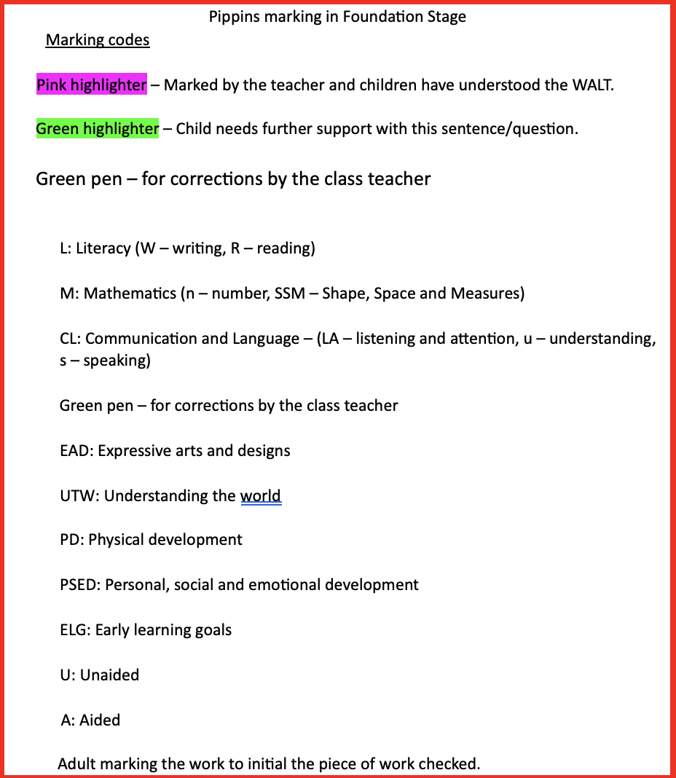

Symbols to support marking and assessment in KS1:

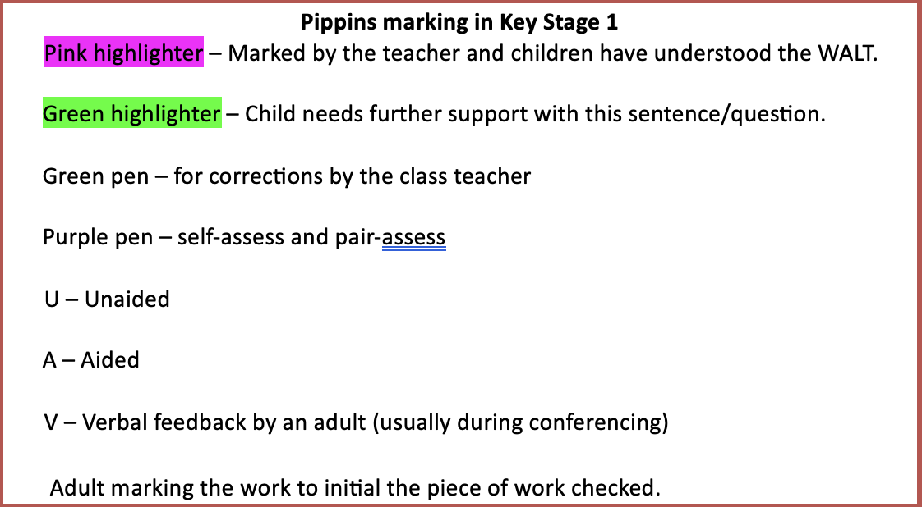

Symbols to support marking and assessment in KS2:

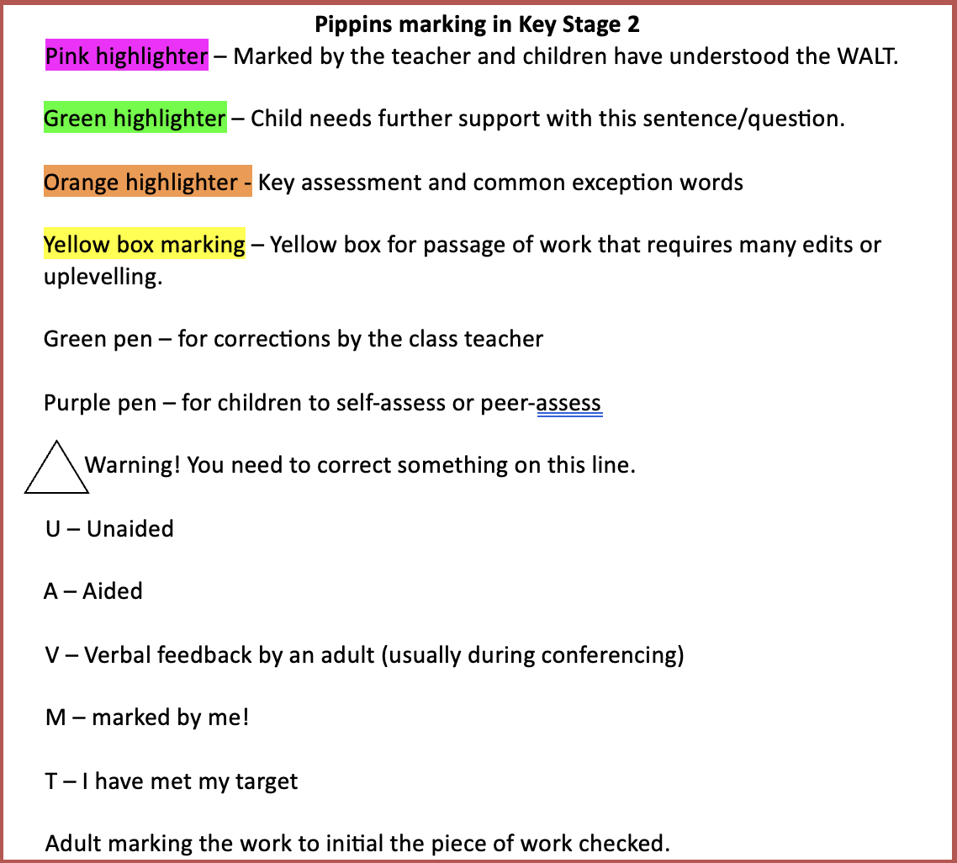

Symbols to support marking and assessment at pre key stage level: 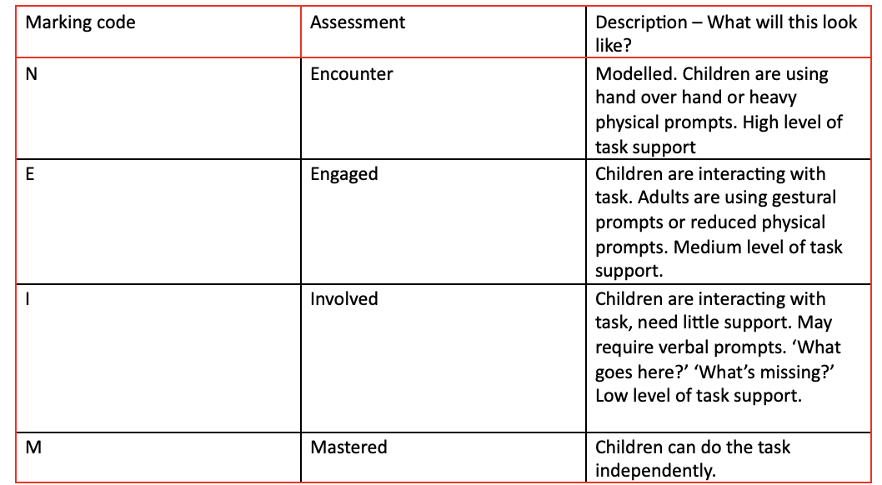

2. Types of marking & feedback

Conferencing
Research ( Oxford University – Education Endowment Fund, 2016 ) indicates that masses of ‘after-the-event’ written feedback is neither efficient nor effective.
Through pupil-conferencing, you will be providing, on a daily basis, high quality teaching to individual students. You will be conducting not only assessment for learning but also assessment of learning.
How to Conduct Conferences
Circulating the room – It is important to remember that an informal conference with a child need only be 40 seconds long, although it will take longer until the time when both you and the children are familiar with the idea. You should aim to see every child at least twice a week, which, in experience, is quite manageable – even without the aid of a TA. Ask how it is going. Alternatively, ask the child what they feel they need particular help with. Do they have any ‘sticky’ places? Finally, you should formulate a question or suggestion, particularly if you sense that they lack confidence about their topic.
Things to remember: Don’t talk more than the child. In writing, don’t try to redirect the child onto something you find more interesting. Only direct the child onto a different course or subject if it’s clearly not working. Don’t ignore the writer’s original intention for the piece. Try not to supply words or phrases that you like, but if possible quietly guide the writer towards the means of expression. Don’t hesitate to say to a child that you don’t understand or that you’re confused by the subject choice.
For all conferencing when you’ve finished a conference, simply mark the child’s book with ‘verbal feedback’ and your initials.
It is a well-known fact that ‘after the event’ responses written in books come too late for children to do anything about them. Verbally conducted revision conferences, on the other hand, provide more opportunity for high quality teaching, alongside the child, in real time, and allow the child to act on the feedback immediately.
Verbal feedback has maximum relevance to the child because the child, in effect, determines what is to be taught and what learning opportunities they require.

Examples of effective feedback
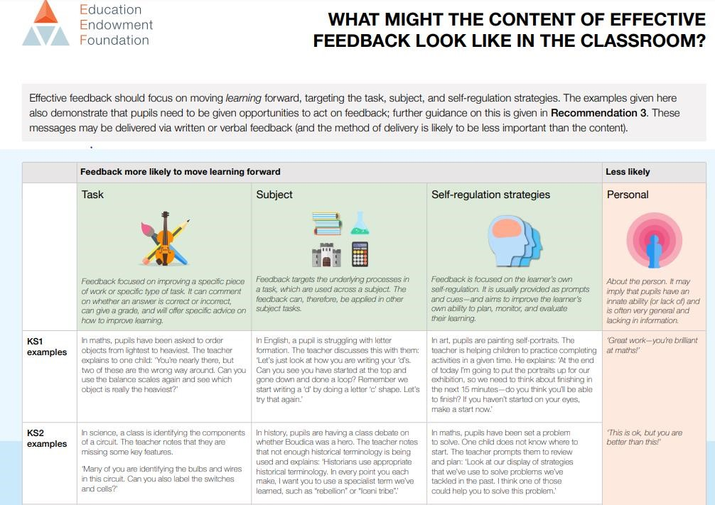

Pupil Self and Peer Evaluation
“Independent learners have the ability to seek out and gain new skills, knowledge and understandings. They are able to engage in self-reflection and to identify the next steps in their learning. Teachers should equip learners with the desire and the capacity to take charge of their learning through developing the skills of self-assessment.” (Assessment Reform Group, 2002).

Children marking their own work and that of their peers are important parts of effective marking practice.
Why use Pupil and Peer Evaluation?
- The greatest impact is an overall rise in self-esteem.
- Children can feel more able to talk about their learning.
- Children can say where they need help without a sense of failure.
- Children are thinking deeply about their own learning.
- Children are starting to be more in control of their learning.

It takes time to introduce a system of self-marking. Self and peer-marking and the time to act in response to feedback should be seen as part of the lesson itself. Children will need to have the process modelled to them (e.g. in a plenary) until they feel confident to carry out the process independently. Children should be confident and practiced in self marking before beginning to peer assess.

Using the class i-pad to ‘mirror’ children’s work are effective ways of modelling the marking process. A child’s name can be selected intentionally or drawn randomly and their work displayed. The rest of the class identify where that child has met the success criteria and suggest where improvements can be made. The teacher then models making the improvement using suggestions from the class.
The rest of the class are then given time to mark and improve their own work. This could be used at any point during the lesson i.e. as a mini plenary or built into planning as part of a lesson.
In addition to the success criteria, children may check their work against their targets e.g. cold task writing targets, those set in lessons using conferencing toolkits or those set at parents evening discussions.
A model to develop self-marking in KS2:
- Children highlight their own work where they have used each success criteria and share with a partner; (2) Children underline one place where an improvement could be made. This is a place where they did not apply the success criteria. (3) They make the improvement as part of the lesson or in a separate session.

Developing peer-marking:
(1) Show a partner the self-marking that has been done; (2) Swap a piece of work with a partner to share something they liked about the person’s work; (3) In pairs, read each other’s work, say two positive things, and suggest for improvement. (4) Phase in highlighting successes, finding an area for improvement and then making the improvement; (5) Children work independently to identify the successes and an area for improvement in a peer’s work.
Pen power:
Children work with a partner. Partner A places their book on top of Partner B’s book because Partner A has their book on top they have the ‘pen power’ (purple polishing pen). Partner B reads through the work and gives suggestions on what they think could be improved/edited and Partner A has to decide whether to take the advice or not. After 5 minutes the children swap the books over Partner B has their book on top of Partner A’s and the pen is given to Partner B so they now have Pen power.

Whole class feedback:
To be completed at the end of a foundation subject lesson as a whole class. The form is saved on common in planning and will be revisited by the class at the beginning of the next lesson. A WCF stamp may be used in books to show that this method of feedback has been used.
An example of a whole class feedback form
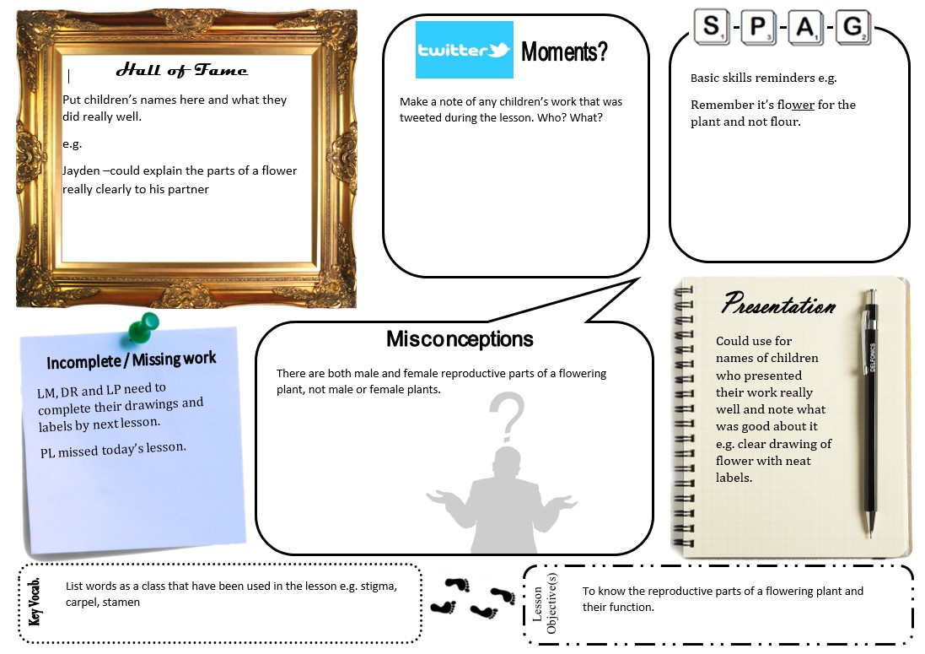

Yellow box marking
How Does Yellow Box Work?
Choose one area of a pupil’s work to mark. Just one section. Mark it well and in detail and offer sophisticated feedback (verbally or in writing) and no matter what, ensure that the feedback is specific and diagnostic (e.g. see verbal technique = not yet). By avoiding any assessment, pupils should understand that their work is in progress and by ‘zooming in’ on one area to improve, the Yellow Box focuses students to act on that feedback in a clear and specific framework.
The addition of a new (empty) Yellow Box should vary in size and allow the student to comprehend what work is expected in their redraft / improvements. It also doesn’t need to have a redraft zone at all – the box could limit improvements. Ultimately, the Yellow Box (or ‘zonal marking’ as I now associate the strategy with) is about finding and selecting one area of work the student can fix.
Why Is It Effective?
The pupil knows where to work and what to target; improvements can be identified much more clearly to help aid student progress. This ensures staff are marking for the child – meaning they are not observers in the process – to reduce workload with more direct, specific comments. that lead to greater impact.
The school wouldn’t expect teachers to mark the re-drafted version (ever). An example of yellow box marking
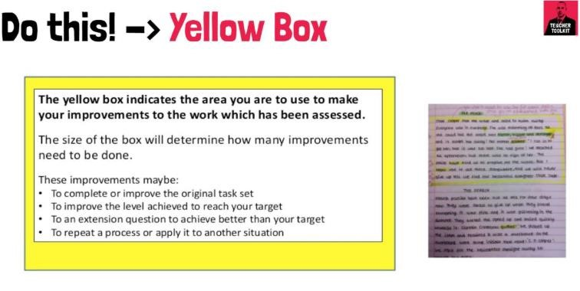
NB: This can be applied to hot and cold tasks

