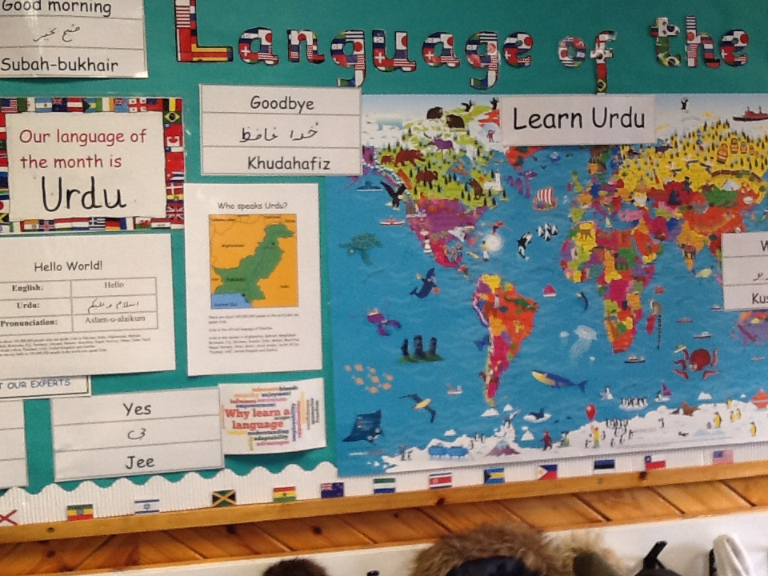
Click on the videos below to view our ‘Pippins Experts’ speaking key phrases in Urdu!
language of the month

Numbers
Hello
How are you
Good Morning

Who speaks Urdu?

There are about 105,000,000 people in the world who can speak Urdu.
Urdu is the official language of Pakistan.
Urdu is also spoken in Afghanistan, Bahrain, Bangladesh, Botswana, Fiji, Germany, Guyana, India, Malawi, Mauritius, Nepal, Norway, Oman, Qatar, Saudi Arabia, South Africa, Thailand, UAE, United Kingdom and Zambi

Reception learning all about Eid celebrations!
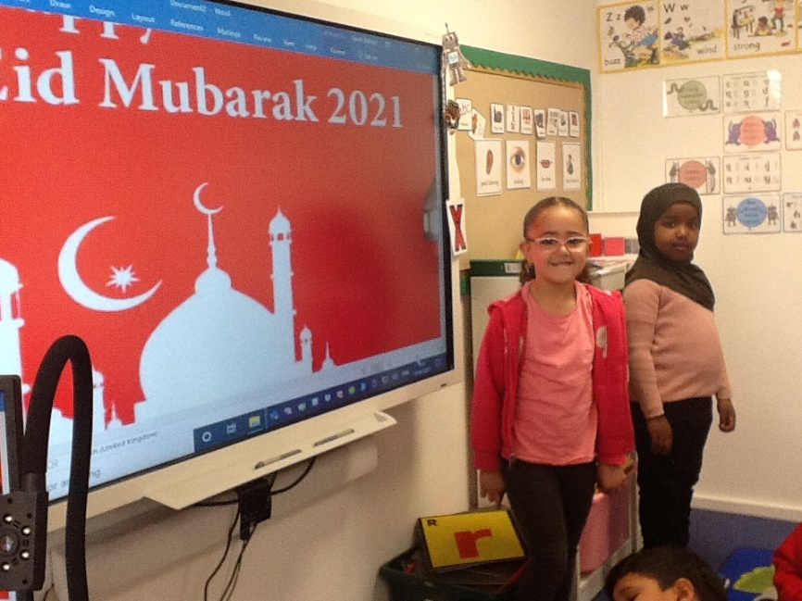

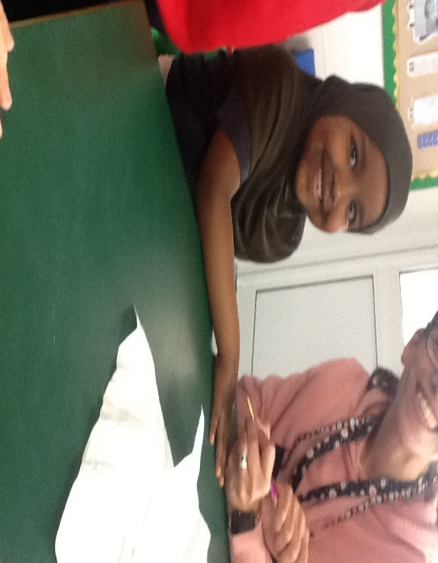

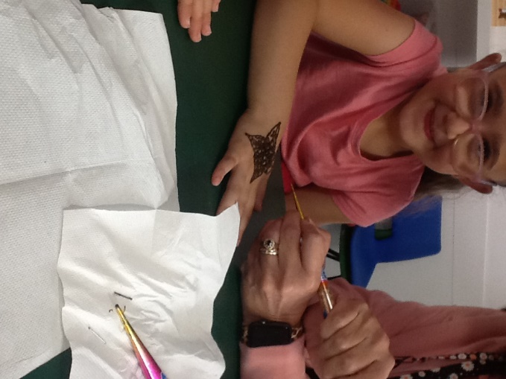

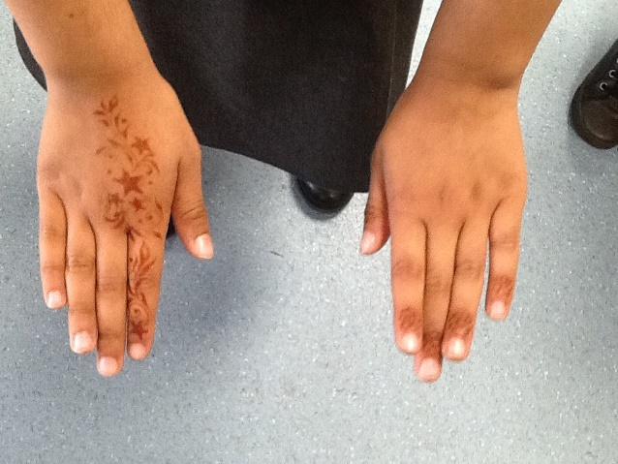
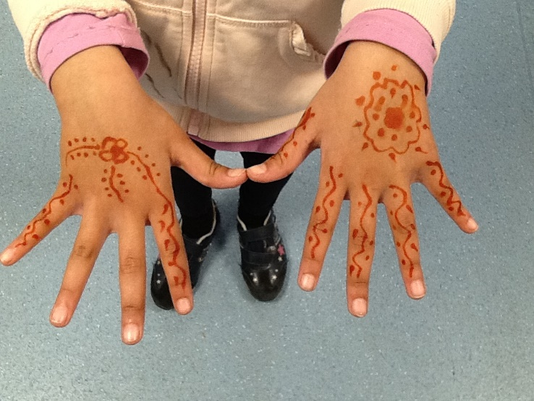
Beautiful Henna designs in Reception and Year 1.

Our Urdu ‘experts’ across the school!

