Click on the videos below to view our ‘Pippins Experts’ speaking key phrases in Polish!
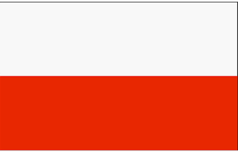

Dear Parents and Children,

This month our Language of the Month has been Polish. It was so lovely to see our youngest nursery children learning some Polish phrases with Mrs Fowler and Mrs Butler! Other classes have also been busy learning Polish and facts about Poland.

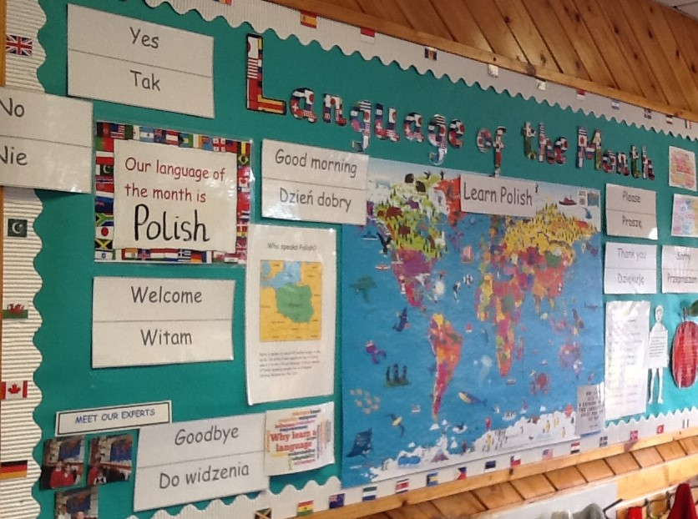

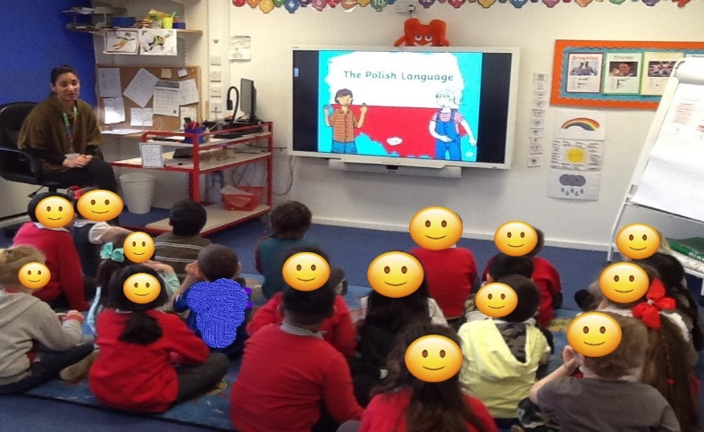

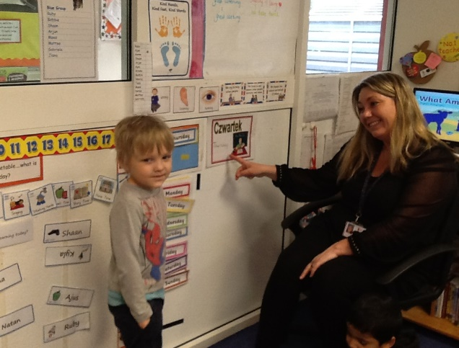

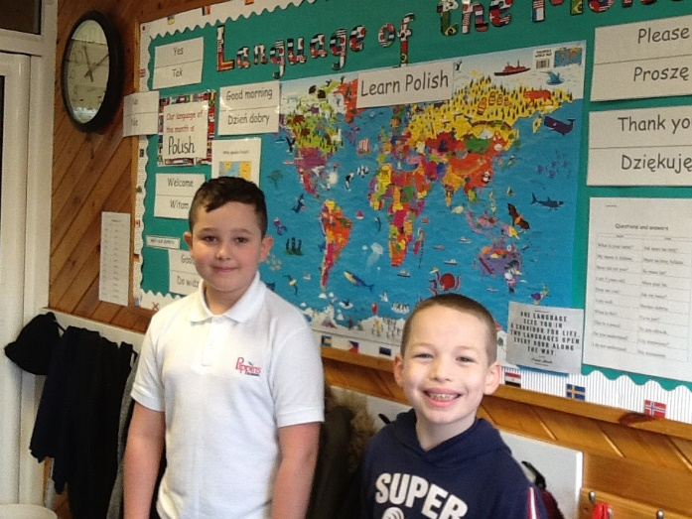
Meet our experts at Pippins, who speak Polish as an additional language. We value the opportunities of having many children that speak an additional language. These children will help newcomers settle in and support any pupils who may need help with their English especially at playtime and lunchtime.
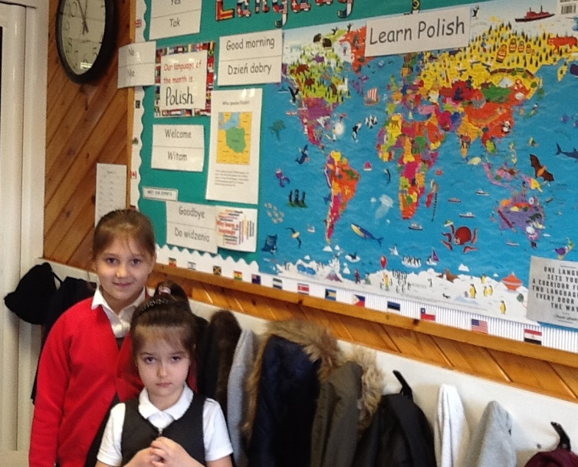

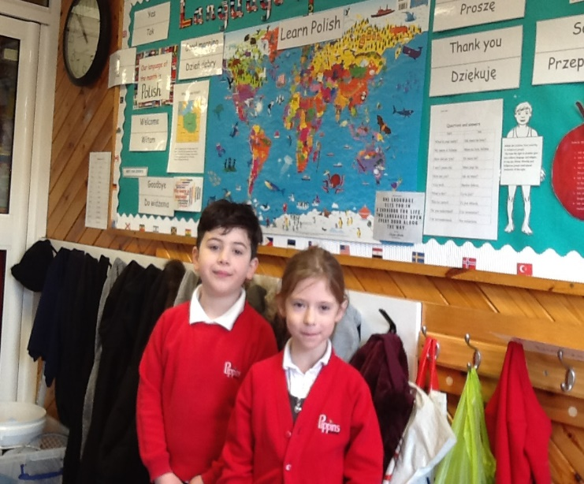

Below are some websites for you to enjoy with your child/ren.

Facts about Poland
https://kids.nationalgeographic.com/geography/countries/article/poland
Learn Polish!
https://www.digitaldialects.com/Polish.htm

Our EAL page will hopefully be available to view on the Pippins website after Easter, so you can keep up to date with the activities that have been happening in school around Language of the Month. In the meantime, please remember to post any pictures or videos of you and your child/ren enjoying learning the language, reading a story, or learning about the culture so I can add it to the Pippins website.
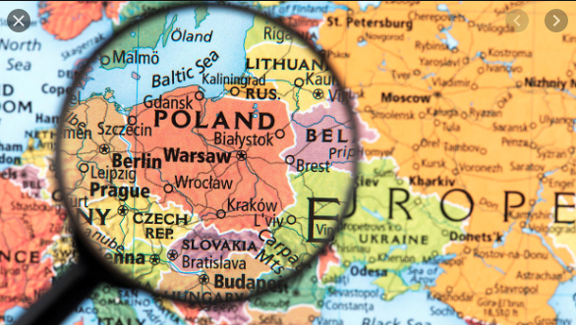
Dziękuję
Mrs Rehinsi

