Wednesday 18th March

Dear Parent/Carer,
Your child is currently studying GCSE Dance. The final GCSE practical examination is taking place on Tuesday 24th March. This will go towards 30% of your child’s grade. Your child will perform their choreography, and this will be recorded for moderation.
On Tuesday 24th March, your child must attend school at 8:40am in full school uniform and bring their full dance kit with hair suitably tied back/braided.
Thanks in advance for your ongoing support. Please do not hesitate to contact me at school on 01514778710 or admin@kirkbyhighschool.net.

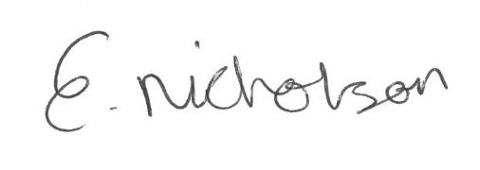
Yours faithfully,

Miss E Nicholson
Deputy Head of PE/Dance

