Bridgelea
Primary School

Child Friendly
E-Safety Policy
2021/2022

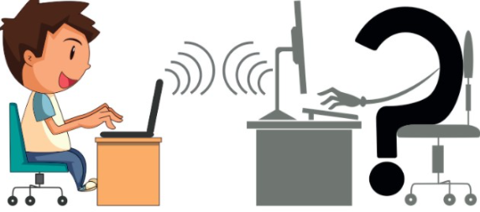

If you feel unsafe online:-

DO:-
- STOP communicating with the people online and BLOCK them.
- TELL a trusted adult straight away.
- Report anything that worries or upsets you
- Save messages to show an adult.
- Stay calm and do not panic.

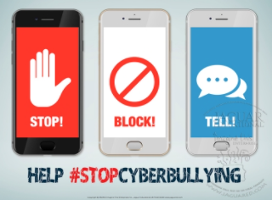

DON’T:-
- Keep worries to yourself or hide it.
- Be nasty or be unkind back to them.
- Delete the messages without showing them to an adult.
- Get angry or upset
- Hide it.
- Reply to cyber bulling.

What should I do if I know someone is being unsafe online?

- Tell an adult straight away.
- Don’t be a bystander!

The Head, the Governors and the staff will work together to:-

- Make our school a place where everyone can feel safe and happy. That means no bullying allowed in person or online and listening to your worries.
- Investigate anything that gets reported.
- Contact parents and carers
- Educate everyone about being safe online.

What will happen to people being unsafe online?

Teachers will get involved and help the bully solve problems, talking to their parents and friends. They will be helped to think about how their behaviour has an impact on others and be taught how to be safe online.


Who can I tell?

A Friend

Parents/Carers | 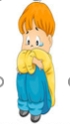
Adults within school
Escorts

Any Other Adult

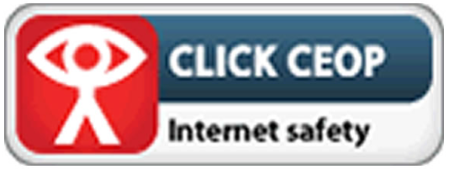

REMEMBER, when you are online:

T – Is it TRUE?

H – Is it HELPFUL?

I – Is it ILLEGAL?

N – Is it NECESSARY?

K – Is it KIND?
What is E-safety?

E-safety stands for electronic safety.

E-safety is about making sure everyone is using the internet safely and everyone feels protected when using any technology.

The internet is great for so many reasons.
- You can play games and have fun
- You can talk with friends and family
- You can use it to help you learn new things

When people do not use the internet in the right way, it can lead us to feel unsafe and it can be dangerous. This might include:

- CYBER BULLYING
When others are mean to us and they do or say unkind things to us online
- STRANGER DANGER
People are not always who they say are and they do lie to try and become our friends.
- UNSUITABLE ONLINE MATERIAL
Looking at things online that are not suitable for children my age.
- VIRUSES
Links online can contain viruses.
- IDENTITY THEFT
When people use our personal information.

How can I stay safe online?
 SAFE
Never give out personal information such as your full name, birthday or address. Be Safe, secure and sensible online.

 NEVER MEET
Don’t meet up with people you have met online. Tell someone you trust if someone is asking you to meet with them.

 DON’T ACCEPT
Don’t open emails or links from people you do not know as they could contain viruses. Be appropriate and accountable online.

 RELIABLE
Don’t believe everything you read online – check your facts! Follow the rules and be responsible online.

 TELL
Tell an adult if something worries you online.

