\

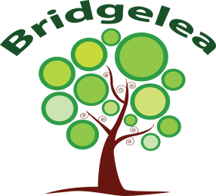
Bridgelea Primary School Curriculum Overview
PHSE
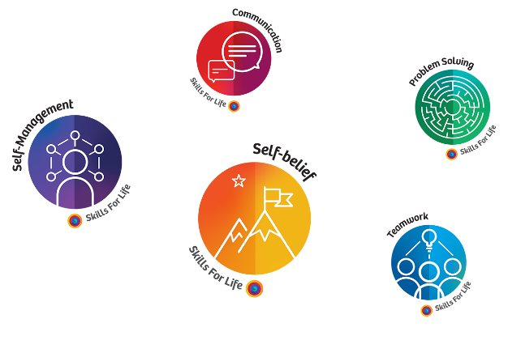
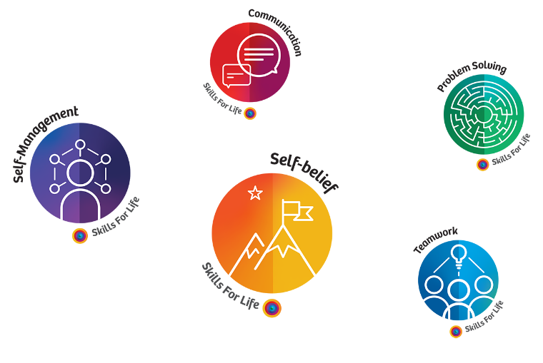
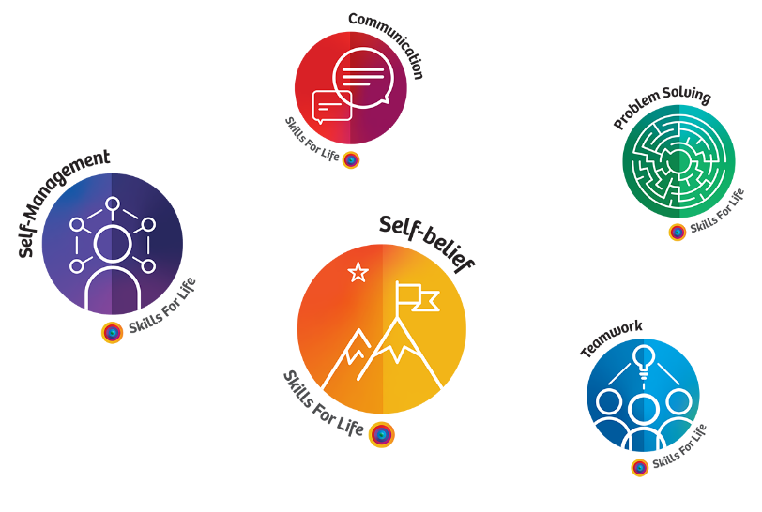
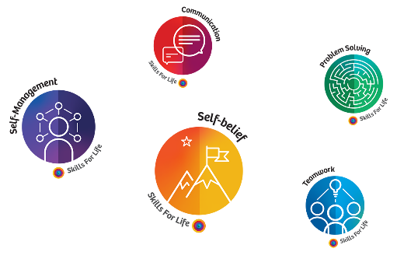
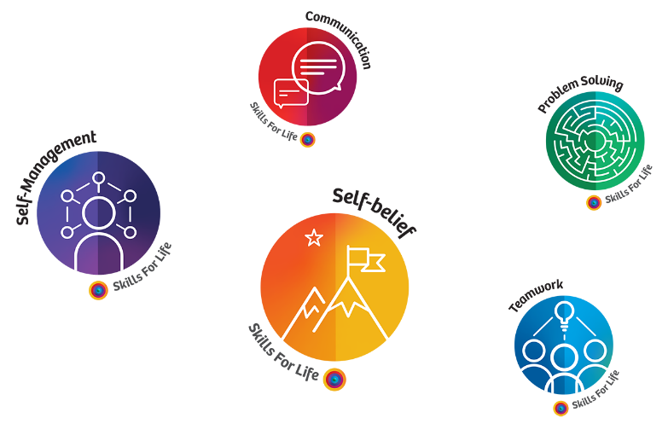

Early Years
Strand | End of Early Years
Autumn 1  Living in the wider world | - Talk about members of their immediate family and community.  - Name and describe people who are familiar to them.  - Recognise that people have different beliefs and celebrate special times in different ways.
Autumn 2  Relationships and RSE | - Continue developing positive attitudes about the differences between people.  - Know that there are different countries in the world and talk about the differences they have experienced or seen in photos.  - See themselves as a valuable individual.  - Build constructive and respectful relationships.  - Identify and moderate their own feelings socially and emotionally.  - Think about the perspectives of others.
Spring 1  Keeping Safe | - Use talk to help work out problems and organise thinking and activities, and to explain how things work and why they might happen.  - Develop social phrases.
Spring 2  Mental and Emotional Health  (Including Online safety) | - Recognise that people have different beliefs and celebrate special times in different ways.  - Understand what the internet is and what they use he internet for (E.G. watching videos, playing games, learning things.)  - Express their feelings and consider the feelings of others.  - Show resilience and perseverance in the face of challenge.
Summer 1  Healthy Lifestyles | - Use talk to help work out problems and organise thinking and activities, and to explain how things work and why they might happen.  - Develop social phrases.  - Identify and moderate their own feelings socially and emotionally.  - Think about the perspectives of others.  - Manage their own needs.
Summer 2  Transition | - Identify changes that may happen in school next year.  - Discuss having a new teacher/ new classroom.

Mile Post One
Strand | End of MP1 | Manchester Skils4Life
Autumn 1  Living in the wider world | Year 1 objectives  - Class rules. What are our class rules?  - Recognising money. Where does money come from?  - Environment. What is the environment?  Year 2 objectives  - Groups and communities. What groups and communities am I a part of?  - Spending money. How do we make choices about spending money?  - Environment. How can we look after the environment?
Autumn 2  Relationships and RSE | Year 1 objectives  - Families. Who are the people in my life that love and care for me?  - Differences. What are the differences and similarities between people?  - Body Parts. What are the similarities between girls and boys?  Year 2 objectives  - Privacy. What is private? (body parts)  - Growing up. What happens when the body grows young to old?  - Fair/Unfair. What is fair, unfair, kind and unkind?
Spring 1  Keeping Safe | Year 1 objectives  - Safety school and outside. What are the rules for keeping me safe at school and outside?  - Safety at home. What are rules about household substances?  - Emergency. What is an emergency and what do I do?  Year 2 objectives  - Feeling unwell. How do medicines help us when we are unwell?  - Safe at home. How do I keep safe at home?  - My responsibilities. What is my responsibility for keeping myself and others safe?
Spring 2  Mental and Emotional Health  (Including Online safety) | Year 1 objectives  - Feelings. What makes me happy? What are feelings?  - Secrets. What is the difference between good secrets and bad secrets?  - Behavior. How does my behavior affect others?  Year 2 objectives  - Big and small feelings. What is the difference between small feelings and big feelings?  - Online safety. How can I keep safe online?  - Bullying. What makes others happy? What is the different between joking, teasing and bullying?
Summer 1  Healthy Lifestyles | Year 1 objectives  - Healthy foods. What foods should I eat to help me stay healthy?  - Healthy teeth. How can I look after my teeth?  - Hand washing. Why is important to wash my hands?  Year 2 objectives  - Keeping healthy. How do I keep myself healthy?  - Keeping active. Why is it important to keep active?  - Infection prevention. How can I prevent diseases from spreading?
Summer 2  Transition | - Identify changes that may happen in school next year.  - Discuss having a new teacher/ new classroom.  - What has worked well this year? What have they improved on this year? What would they like to continue to work on next year?

Mile Post Two
Strand | End of MP2
Autumn 1  Living in the wider world | Year 3 objectives  - Rules and laws. How do rules and laws protect me?  - Community. What is the difference between my local British community and global communities?  - Work and money. What are the links between work and money?  Year 4 objectives  - Rights of the child. What are the rights of a child?  - Looking after money. How do we look after our money?  - Sustainability. What is sustainability?
Autumn 2  Relationships and RSE | Year 3 objectives  - Personal Space. What is personal space?  - Healthy relationships. What does a healthy relationship look like?  - Equal relationships. Why is being equal important in relationships?  Year 4 objectives  - Diversity. What is diversity?  - Gender roles. Do boys and girls have different roles?  - Changes to my body. What changes happen to my body?
Spring 1  Keeping Safe | Year 3 objectives  - Smoke. What happens when I breathe smoke in the air?  - Recognizing risk. How do I recognise risks in my life?  - Responding to an emergency. What do I do in an emergency?  Year 4 objectives  - Managing risk. How do I manage risks in my life?  - Self-control. What is self-control?  - Types of drugs. What is the difference between legal and illegal drugs? Are all drugs harmful?
Spring 2  Mental and Emotional Health  (Including Online safety) | Year 3 objectives  - Emotions. How do my feelings affect my behavior? How can I manage my feelings?  - Online Safety. What are the ways we are communicating online?  - Strengths and differences. What am I good at?  Year 4 objectives  - Resilience. What is resilience?  - Actions and responsibilities. What does it mean to have responsibility over my choices and actions?  - Discrimination. What is discrimination?
Summer 1  Healthy Lifestyles | Year 3 objectives  - Healthy diet. What is a healthy diet? What is an unhealthy diet?  - Sun safety. How do I keep safe in the sun?  Personal hygiene. Why is personal hygiene important?  Year 4 objectives  - Sleeping Well. How do I make sure I sleep well?  - Healthy diet. What is fuel for the body?  - Feeling ill. How do I know if I am ill?
Summer 2  Transition | - Identify changes that may happen in school next year.  - Discuss having a new teacher/ new classroom.  - What has worked well this year? What have they improved on this year? What would they like to continue to work on next year?

Mile Post Two
Strand | End of MP2
Autumn 1  Living in the wider world | Year 5 objectives  - Rules and laws. How are rules and law made and changed?  - Fair trade. What is Fair Trade?  - Enterprise. How can I combine sustainability with fair trade using my enterprise skills?  Year 6 objectives  - Media. Why is it important to be critical of the media online and offline?  - Managing money. How do people manage money?  - Aspirations – What do I want to be?
Autumn 2  Relationships and RSE | Year 5 objectives  - Puberty. What is puberty?  - Different relationships. What are the different relationships in my life?  - Unwanted touch. What is unwanted touch?  Year 6 objectives  - Changes in life. What changes happen in my life?  - Loving relationships. What happens in a loving relationship (incl. marriage) and what is forced marriage?  - How babies are made – How is a baby made?  Additional optional lesson – FGM
Spring 1  Keeping Safe | Year 5 objectives  - Dealing with dares. How do I respond dares?  - Habits. What are ‘Habits’?  - Influences. Who or what influences me?  Year 6 objectives  - Different drugs. How do drugs affect the mind and body?  - Peer pressure. How do I manage peer pressure?  First aid. What are basic emergency first aid skills?
Spring 2  Mental and Emotional Health  (Including Online safety) | Year 5 objectives  - Mental Health. What is mental health?  - Negotiation. How do I negotiate and compromise?  - Online Safety. How do I stay safe on a mobile or tablet?  - Personal qualities. How can I be happy being me?  Year 6 objectives  - Challenging negative feelings. How can I challenge negative thoughts and feelings?  - Challenging stereotypes. What are stereotypes?  Online safety. How can the internet positively and negatively affect our mental health?
Summer 1  Healthy Lifestyles | Year 5 objectives  - Vaccines. How can we stop the spread of infection?  - Balanced diet. Why is it important to know about nutritional content of food?  Year 6 objectives  - Mental and physical wellbeing. How is my mental and physical wellbeing connected?  - Keeping physically healthy. How do I keep physically healthy?  - Healthy meals. Can I plan and prepare a healthy meal?
Summer 2  Transition | - Identify changes that may happen in school next year.  - Discuss having a new teacher/ new classroom.  - What has worked well this year? What have they improved on this year? What would they like to continue to work on next year?

