 | Brookside Primary School  Long Term Plan  Subject: PSHE

Reception
Autumn 1 | Autumn 2 | Spring 1

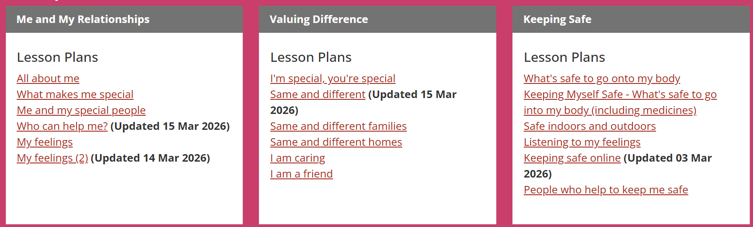

Spring 2 | Summer 1 | Summer 2

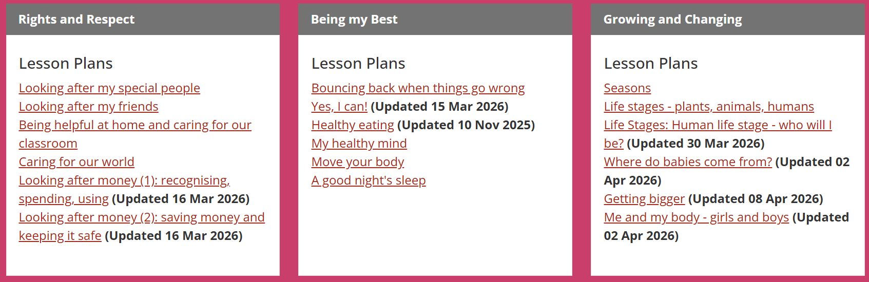

Blackbird Cycle A 2025/6
Autumn 1 | Autumn 2 | Spring 1

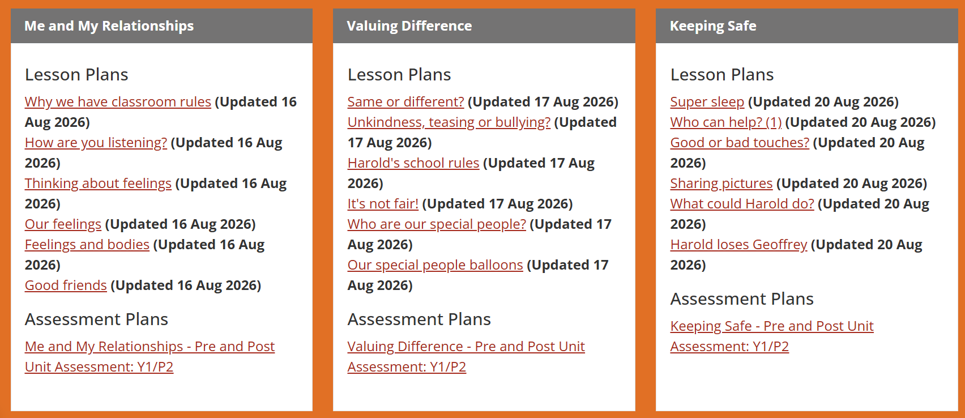

Spring 2 | Summer 1 | Summer 2

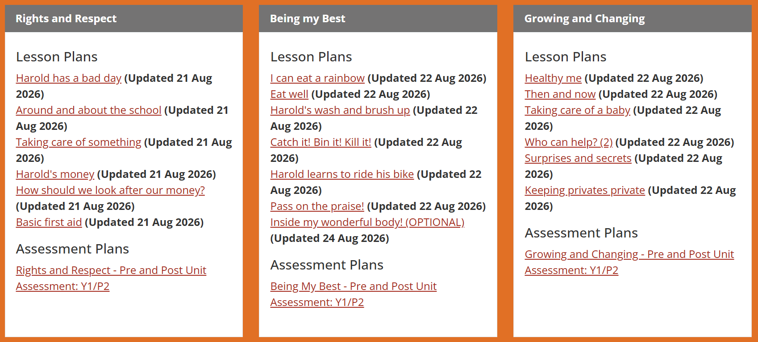

Blackbird Cycle B 2026/7
Autumn 1 | Autumn 2 | Spring 1

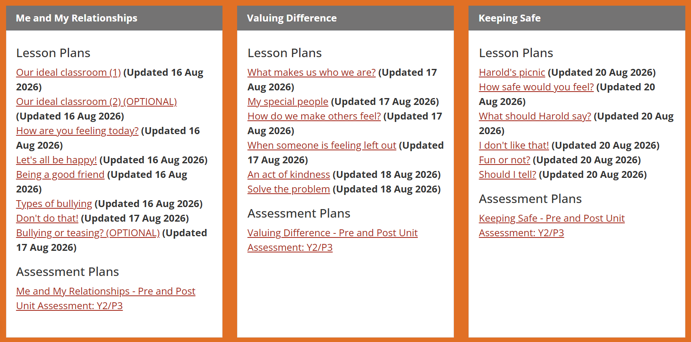

Spring 2 | Summer 1 | Summer 2

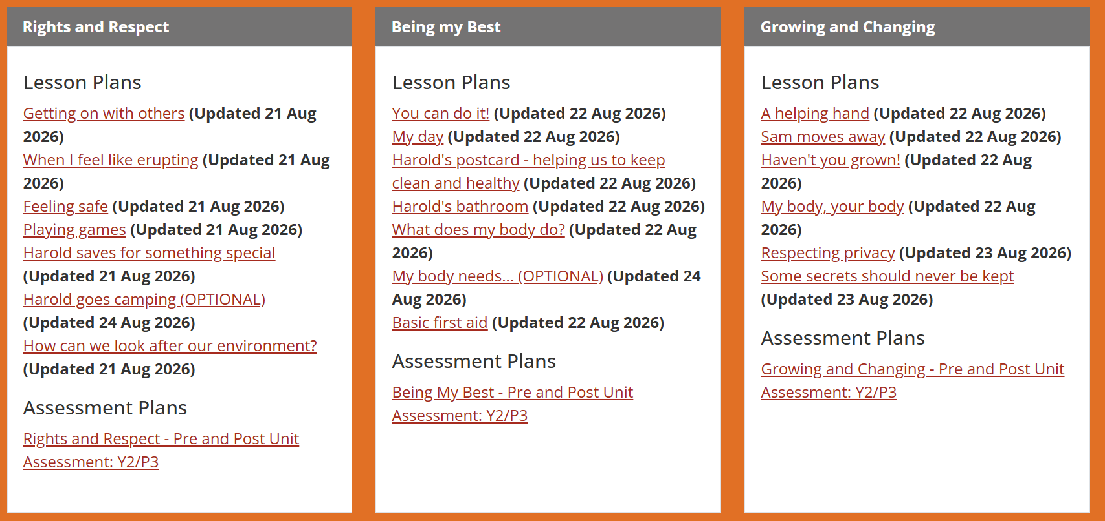

Starling Cycle A 2025/6
Autumn 1 | Autumn 2 | Spring 1

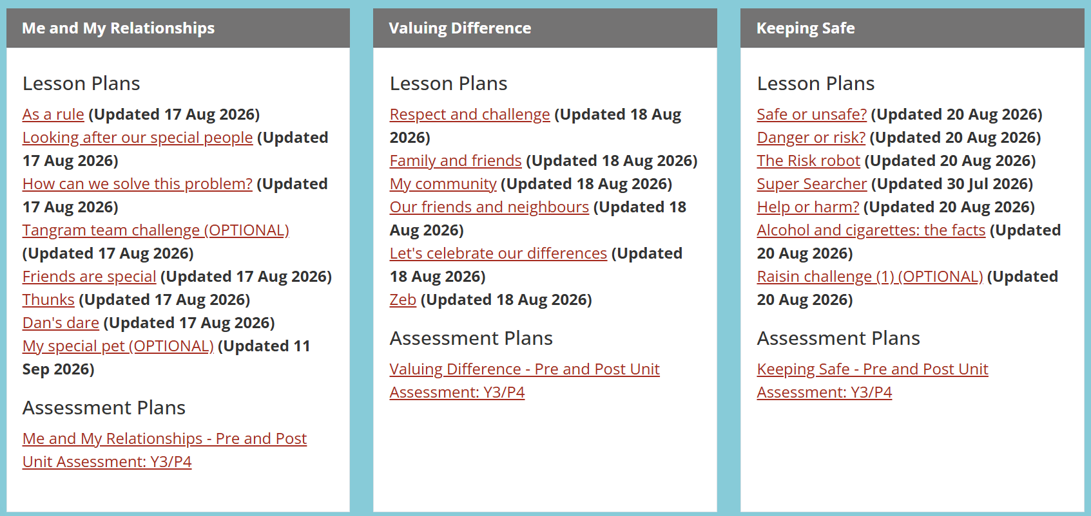

Spring 2 | Summer 1 | Summer 2

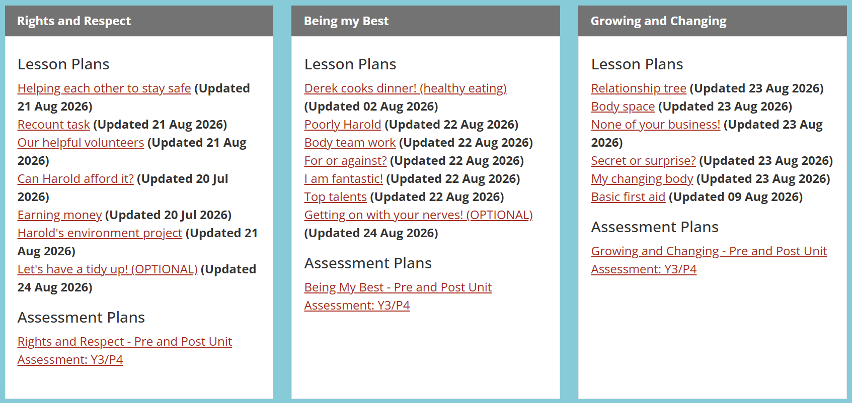

Starling Cycle B 2026/7
Autumn 1 | Autumn 2 | Spring 1

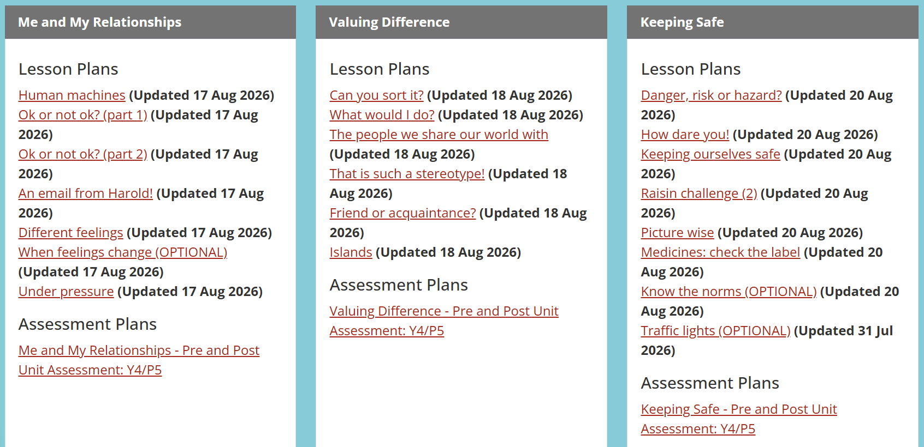

Spring 2 | Summer 1 | Summer 2

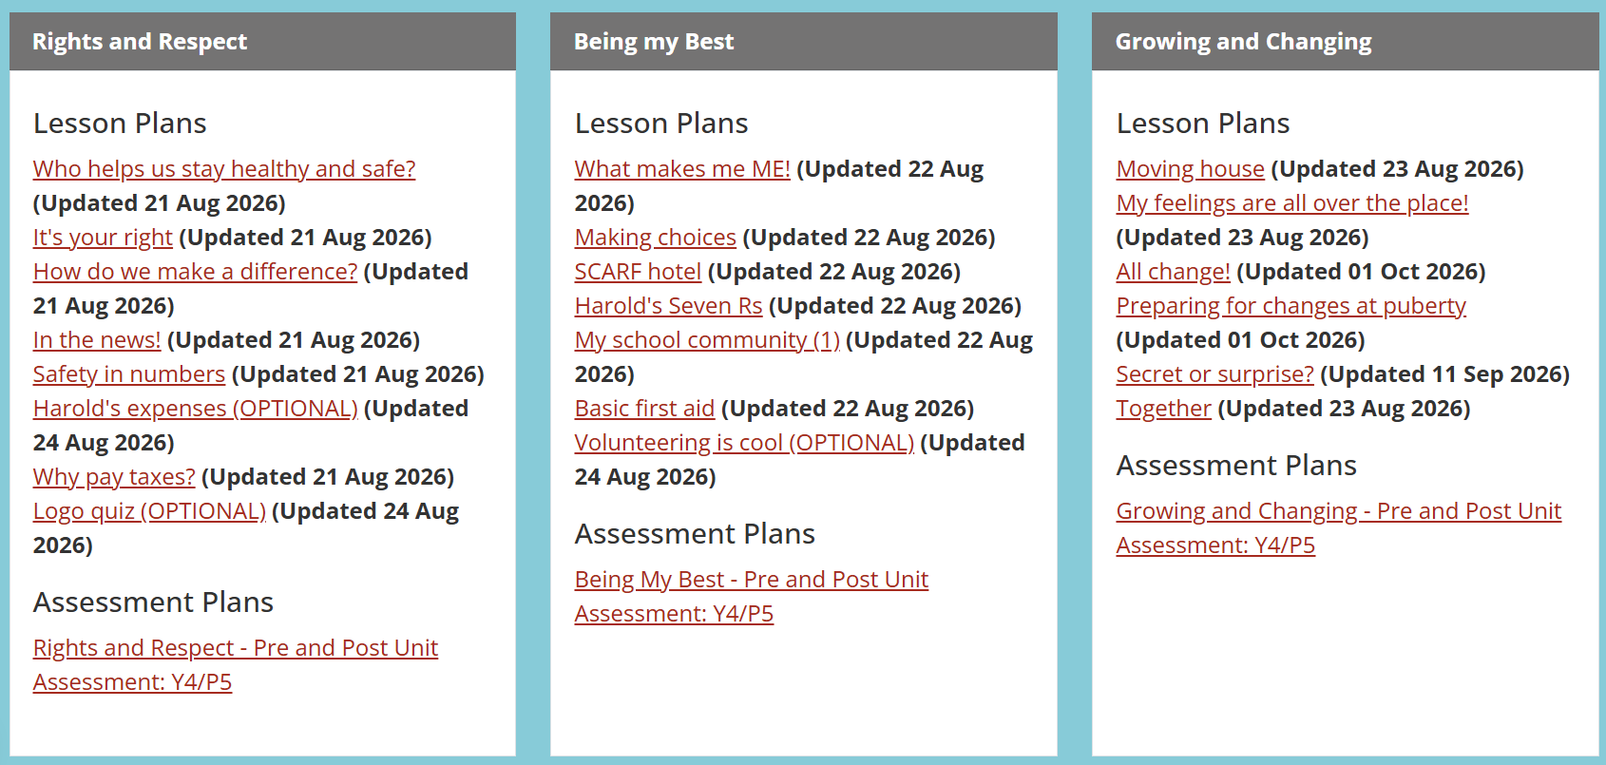

Goldfinch Cycle B 2026/7
Autumn 1 | Autumn 2 | Spring 1

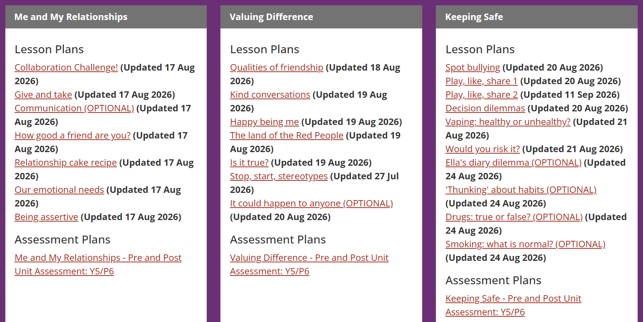

Spring 2 | Summer 1 | Summer 2

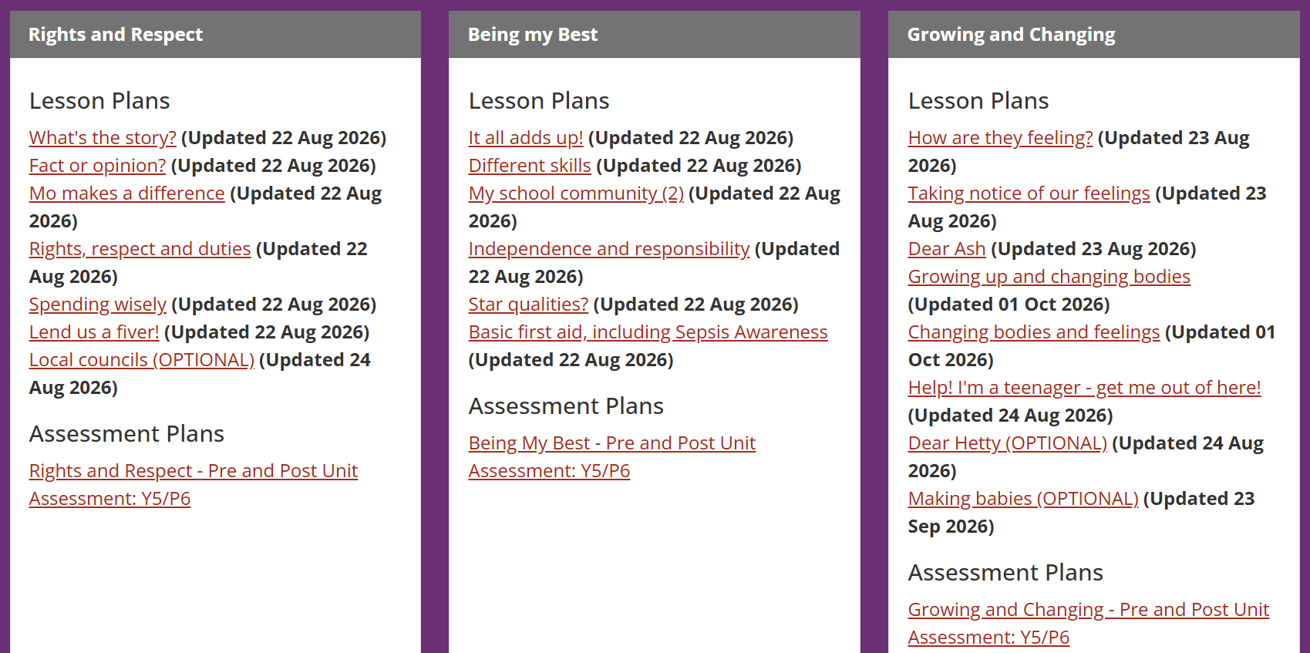

Goldfinch Cycle A 2025/6
Autumn 1 | Autumn 2 | Spring 1

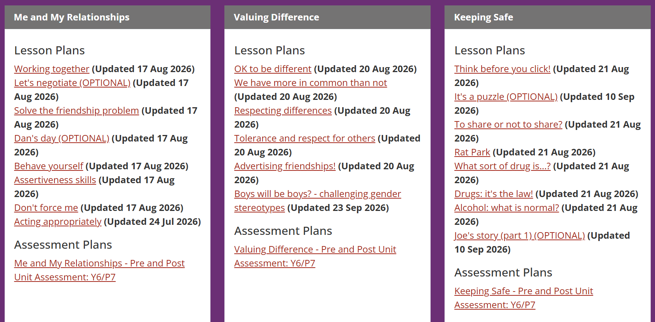

Spring 2 | Summer 1 | Summer 2

