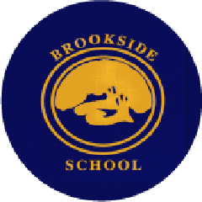

END OF KEY STAGE DATA 2026

Provisional

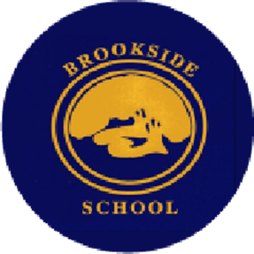

Year 6 Results 2026 – Cohort: 15 Pupils

Subject | Expected | Deeper Learning | Average scaled score*
READING | 40% | 20% | 103
SPELLING, PUNCTUATION | 33% | 13% | 100
and GRAMMAR |  |  | 100
MATHS | 47% | 7% | 100
WRITING (Teacher | 47% | 7%
Assessment)
SCIENCE | 67%
An average scaled score of 100 indicates that the expected standard has been achieved.

Year 1 Phonics Check

% Achieving the Expected Standard (pupils)

2024 | 2025 | 2026
68.2 (22) | 80 (15) | 20 (10)

Early Years Foundation Stage Profile (EYFSP) Results Percentage of children achieving

Good Level of Development (LANCS)

2024 | 2025 | 2026
86.7 (72) | 35.7 (71.3) | 72.7 (75.6)

