Robin Class Geography Knowledge Organiser
Our Local Area
Pupils should be taught to:
Locational knowledge:
Name and locate the four countries and capital cities of the United Kingdom
Place knowledge
Study the human and physical geography of Clitheroe
Human and physical geography
Use basic geographical vocabulary to refer to: key physical features, including: forest, hill, river, soil, valley, vegetation, weather; key human features, including: city, town, village, factory, farm, house, office, park and shop
Geographical skills and fieldwork
Use world maps, atlases and globes to identify the United Kingdom and its countries
Use simple compass directions (North, South, East and West) and locational and directional language.
Key Vocabulary
UK (United Kingdom) | The United Kingdom. It is made up of four countries: England, Scotland, Wales and Northern Ireland.
Country | An area of land with its own government rules and borders.
Capital City | The main city of a country. It is where the government is situated.  England – London  Scotland – Edinburgh  Wales – Cardiff  Northern Ireland - Belfast
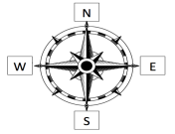  Compass | A special tool that helps you know which direction you are facing.  North, East, South, West.
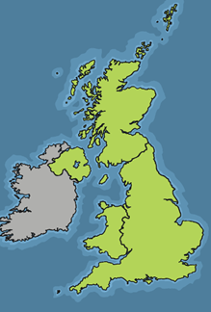  England  Scotland  Wales  Northern Ireland | 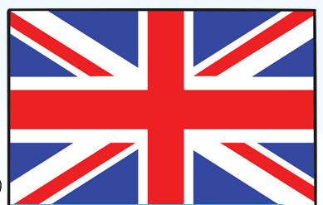  Flag for the united Kingdom

