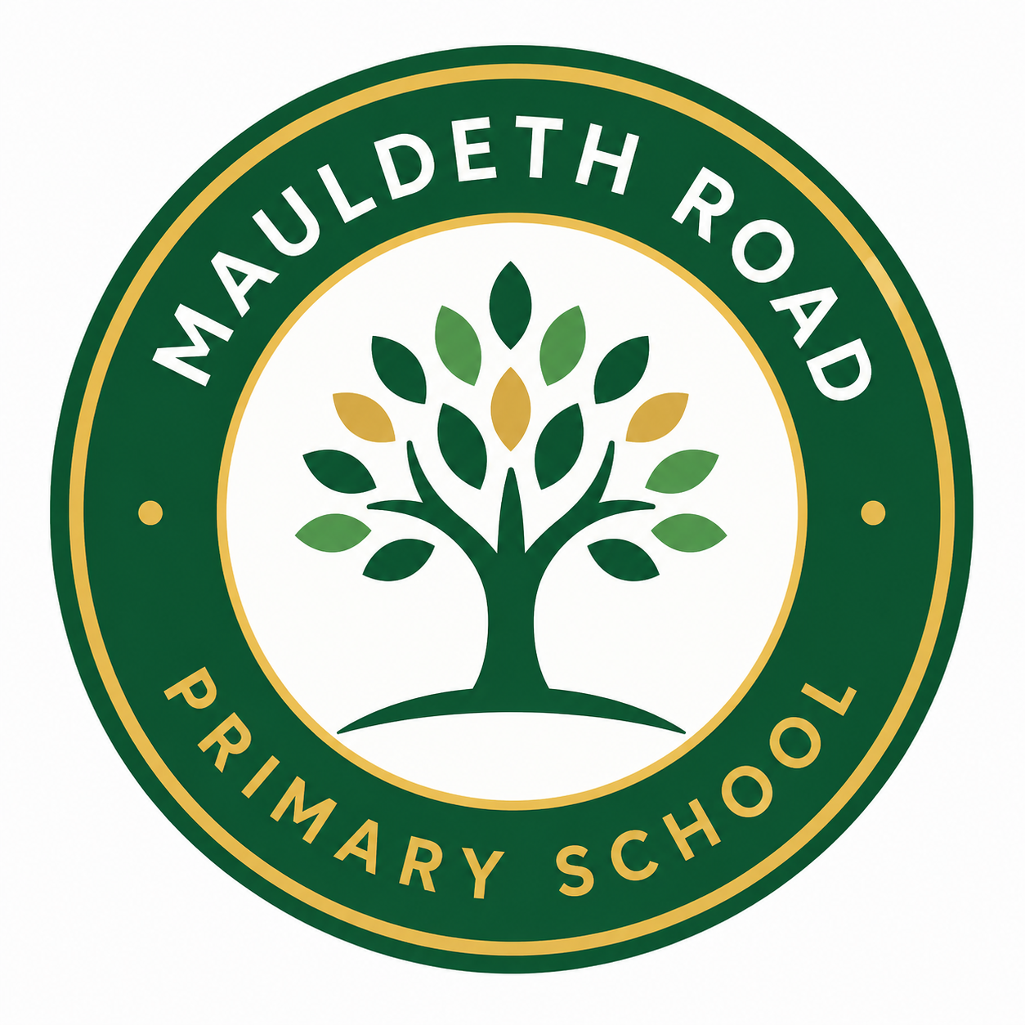

Allergy Safety Policy

September 2026

Version | Changes | Created by
1.0 | A new policy has been created to incorporate Benedict’s law and will be shared with governors and staff | P.Cope

1. Purpose and Commitment
Mauldeth Road Primary School is committed to providing a safe, inclusive and supportive environment for all pupils and staff, including those with allergies and those at risk of anaphylaxis. The school recognises that allergies can be serious, unpredictable and potentially life-threatening. This policy sets out the whole-school arrangements for identifying, reducing and managing allergy risks, responding to allergic reactions, supporting individual pupils and meeting the school’s statutory duties.

2. Legal Context: Benedict’s Law
This policy incorporates the requirements introduced through Benedict’s Law, the name commonly used for the allergy safety provisions in section 34 of the Children’s Wellbeing and Schools Act 2026, which amends section 100 of the Children and Families Act 2014. From the 2026/27 academic year, relevant schools in England are required to maintain, publish and review an allergy safety policy, have regard to statutory Department for Education guidance on allergy safety in schools, strengthen staff training, support Individual Healthcare Plans, stock spare adrenaline auto-injectors where appropriate, and record and learn from allergy-related incidents and near misses.

3. Scope
This policy applies to all pupils, staff, volunteers, visitors, governors, supply staff, contractors, catering staff, wraparound care providers and any other adults working with or supporting pupils on the school site or during school activities. It applies during the school day, breakfast and after-school provision, educational visits, residential trips, sports events, clubs, performances and other off-site or extended school activities.

4. Roles and Responsibilities
The Governing Body will ensure that this policy is in place, published, implemented, monitored and reviewed at least annually. Governors will seek assurance that staff training, emergency preparedness and incident review arrangements are effective.
The Headteacher has overall responsibility for allergy safety and will ensure that staff understand their duties, that appropriate risk controls are in place and that parents and carers are kept informed of arrangements affecting their child.
The Named Allergy Safety Lead (Rachel Winter) will coordinate the implementation of this policy, maintain allergy registers and records, support the development and review of Individual Healthcare Plans, arrange training, monitor emergency medication arrangements, liaise with catering and pastoral teams, and oversee incident and near-miss learning.
All staff must follow the school’s allergy procedures, complete required training, know how to recognise and respond to allergic reactions and anaphylaxis, understand the needs of pupils they supervise, take reasonable steps to prevent allergen exposure and report concerns, incidents or near misses immediately.
Parents and carers are responsible for informing the school promptly of any allergy diagnosis, providing up-to-date medical information, supplying prescribed medication where required, ensuring medication is in date, supporting the creation and review of Individual Healthcare Plans and reinforcing safe allergy practices with their child.
Pupils will be supported, in an age-appropriate way, to understand their allergies, avoid sharing food, recognise early symptoms, seek adult help immediately and participate fully and safely in school life.

5. Identifying Pupils with Allergies
The school will ask parents and carers to disclose allergy information on admission, update records annually and notify the school immediately of any new diagnosis, change in symptoms, medication or emergency action advice. The school will maintain a confidential allergy register accessible to staff who need the information to keep pupils safe. Allergy information will be shared sensitively and proportionately with teaching, lunchtime, catering, office, first aid, wraparound and trip staff.

6. Individual Healthcare Plans
Pupils with diagnosed allergies, particularly those at risk of anaphylaxis or requiring emergency medication, will have an Individual Healthcare Plan where this is needed to ensure safe support in school. The plan will be agreed with parents and carers, the pupil where appropriate, relevant health professionals where available, and key school staff. It will include known allergens, symptoms, medication, emergency response steps, storage arrangements, consent, risk controls, catering information and arrangements for trips, clubs and transitions.

7. Allergy Risk Reduction
The school cannot guarantee an allergen-free environment but will take reasonable and proportionate steps to reduce the risk of exposure. These may include careful management of food and ingredients, clear communication with families, cleaning routines, supervision during eating, safe classroom activities, risk assessment for events and visits, and prompt response to concerns. The school will avoid relying solely on blanket “nut-free” statements and will instead use practical, pupil-specific and whole-school risk controls.
- Food must not be shared between pupils unless specifically authorised and checked by an adult.
- Classroom rewards and celebrations should avoid unmanaged food risks and should be discussed in advance where pupils with allergies may be affected.
- Staff will consider allergy risks in science, art, cookery, sensory play, gardening, animal handling and other practical activities.
- Cleaning arrangements will reduce the risk of allergen residue on tables, utensils and shared equipment.
- Visitors and external providers will be informed of relevant allergy safety expectations.

8. Catering and Food Provision
The school will work with catering providers to ensure allergen information is accurate, accessible and used safely. Catering staff will follow procedures for ingredient checking allergen labelling, menu changes, meal identification, cross-contact prevention and communication with school staff. Where special meals are required, arrangements will be documented and reviewed. Parents and carers should not rely on verbal assurances alone and should communicate dietary needs through the school’s agreed process.

9. Medication and Spare Adrenaline Autoinjectors
Where a pupil has been prescribed allergy medication, parents and carers must provide it to school in the original packaging, clearly labelled and in date. Medication will be stored safely but accessibly in line with the pupil’s Individual Healthcare Plan. In accordance with statutory allergy safety expectations, the school will hold spare in-date adrenaline auto-injectors for emergency use where permitted and required. These will be stored in the school office and the nursery building, allowing time for staff to retrieve them in the required five minutes. The dates of these will be checked on a termly basis by the allergy lead of the school. Spare devices are not a replacement for a pupil’s own prescribed medication but may be used in an emergency in line with current law, guidance, consent and school procedures.

10. Recognising and Responding to Allergic Reactions
All staff must treat suspected anaphylaxis as a medical emergency. Symptoms may include breathing difficulty, swelling of the lips, tongue or throat, wheeze, persistent cough, dizziness, collapse, pale or floppy presentation, confusion, sudden tiredness, widespread rash, vomiting or severe abdominal pain. If anaphylaxis is suspected, staff must administer adrenaline without delay in line with training, even if this is the child’s first presentation of these symptoms, and the pupil’s emergency plan, call 999, state “anaphylaxis”, inform the school office and parents or carers, and continue to monitor the pupil until emergency services arrive.
Staff must not ask a pupil to stand or walk during a suspected severe allergic reaction. The pupil should be positioned safely according to symptoms and current training guidance. A second adrenaline auto-injector should be given if symptoms do not improve or return after the recommended interval, in line with current medical guidance and the device instructions.

11. Staff Training
All staff will receive allergy awareness and emergency response training at induction and at least annually. Training will cover common allergens, risk reduction, recognising mild and severe reactions, anaphylaxis response, use of adrenaline auto-injectors, asthma and allergy links, communication, pupil inclusion, incident reporting and the school’s procedures. Additional role-specific training will be provided for staff with responsibilities, including first aiders, catering staff, lunchtime supervisors, trip leaders, office staff and wraparound care staff.

12. Trips, Visits and Off-Site Activities
All educational visits and off-site activities will include allergy risk assessment. Trip leaders will check Individual Healthcare Plans, medication, emergency contacts, food arrangements, staff training and access to emergency services. Medication and emergency plans must travel with the pupil and remain accessible. External venues and transport providers will be informed of relevant requirements where necessary.

13. Inclusion and Participation
The school will support pupils with allergies to participate fully in lessons, lunch, playtimes, trips, clubs, performances and wider school life. Reasonable adjustments will be made where needed. Staff will promote respectful behaviour and will address teasing, bullying or exclusion linked to allergies in line with the school’s behaviour and anti-bullying policies.

14. Communication with Parents, Carers and the School Community
The school will make this policy generally known within the school community, publish it on the school website and bring it to the attention of pupils, parents, carers and all adults working in school at least annually. Parents and carers will be asked to keep allergy information current and to work in partnership with the school. Where a pupil’s allergy affects classroom activities, food events, trips or shared celebrations, staff will communicate arrangements in advance where practical.

15. Incident and Near-Miss Reporting
All allergy-related incidents and near misses must be reported to the Named Allergy Safety Lead as soon as possible and recorded using the school’s safeguarding, medical or health and safety reporting systems as appropriate. Serious incidents will be reviewed to identify what happened, whether procedures were followed, what learning is needed and whether this policy, training, risk assessments or Individual Healthcare Plans should be updated. Parents and carers will be informed in line with the seriousness of the incident and school procedures.

16. Record Keeping
The school will keep appropriate records of allergy information, Individual Healthcare Plans, parental consent, staff training, medication checks, emergency medication stock, incidents, near misses and policy reviews. Records will be managed in line with data protection requirements and shared only with those who need the information to safeguard pupils.

17. Monitoring and Review
This policy will be reviewed at least annually by the Headteacher, Named Allergy Safety Lead and Governing Body. It will also be reviewed following any serious allergic reaction, significant near miss, change in statutory guidance, change in catering arrangements, or change in the needs of pupils attending the school.

