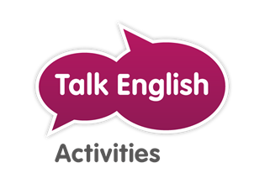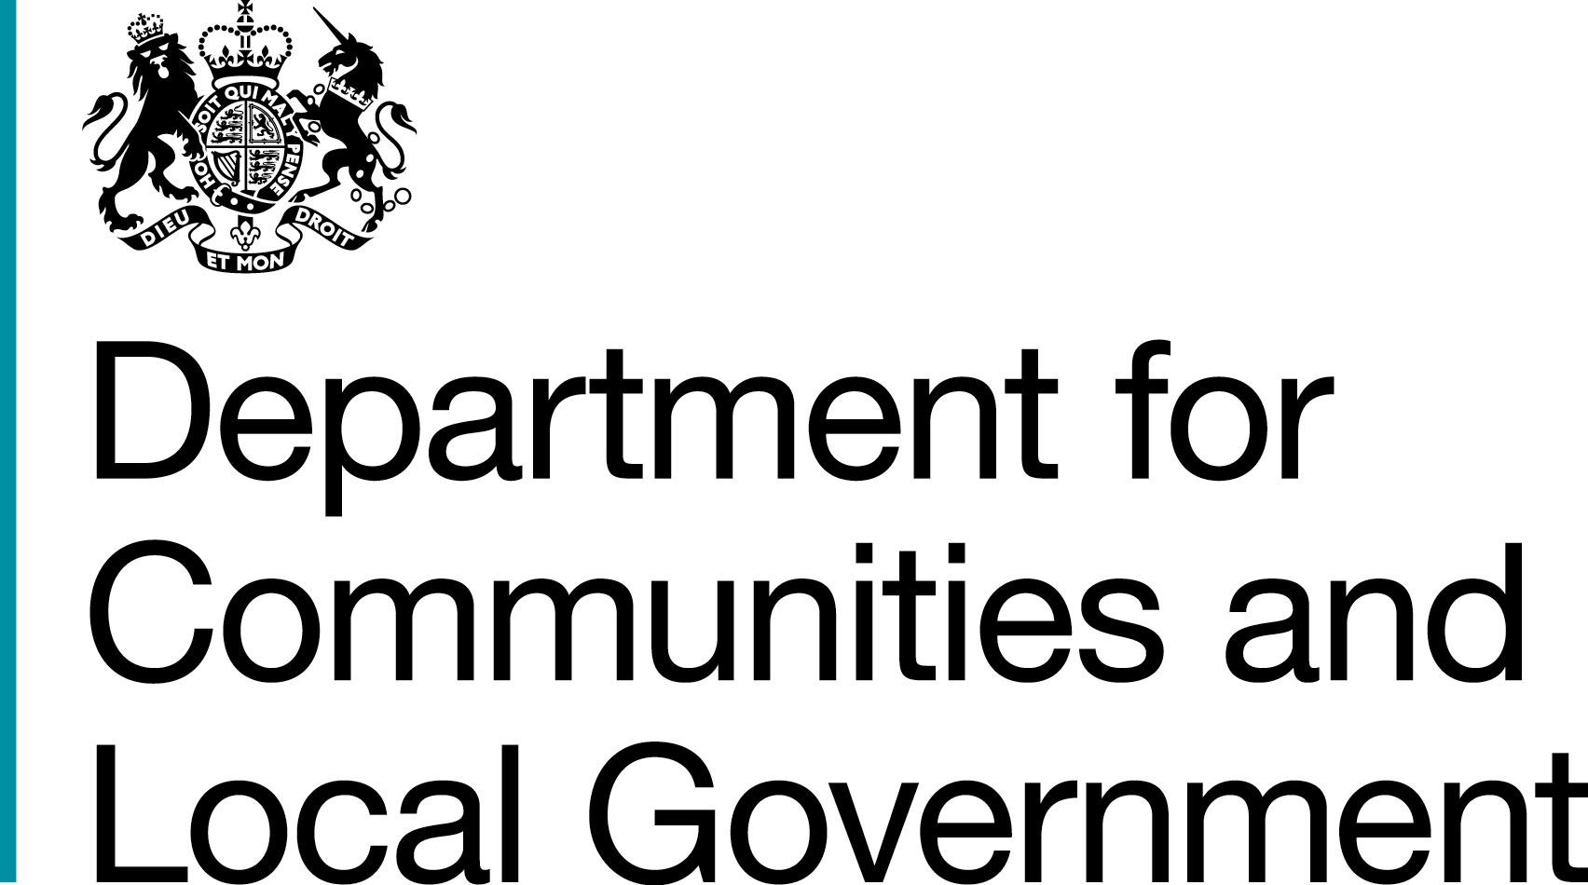

“Cafe English”
at Mauldeth Road Primary School
Learning English? Come to our “Café English” at Mauldeth Road School on Monday afternoons from 1.30-3.15 pm

Our volunteers will help you to practise speaking, reading and writing English with other people.

You can get a free cup of tea or coffee as you chat and make some new friends!

Mauldeth Road Primary School, Withington, M14 6SG
0161 224 3588 or ask
at reception for details.

