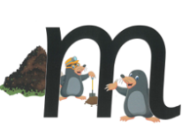 | mat | man | map | mad
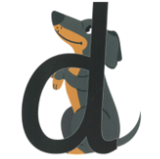 | dad | dip | dam | did
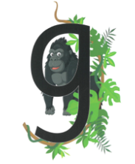 | gap | gas | gig | dig
This week, we have learnt the phonemes: m,d,g

