
Sycamore Class – Homework Grid – Summer 2
On the grid below are homework tasks for the Summer 2 Half Term. There are a range of activities that the children can complete. These tasks are optional and extra to our regular weekly homework.
English    Blue John by Bertie Doherty is a story about a boy who discovers a mysterious place called Blue John and learns important lessons about friendship, courage, and understanding feelings.  You could do some research on The Blue John Cavern in The Peak District and make a poster about what you’ve learnt.  https://www.bluejohn-cavern.co.uk/about-us/ | Maths  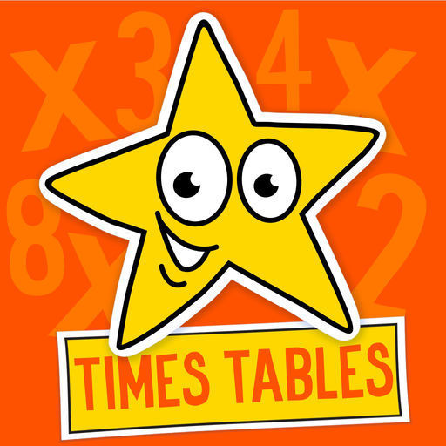  Times Tables Challenge  Spend time learning your times tables – spending just 10 minutes a day revising your tables and corresponding division facts will give you great confidence in maths.  https://www.topmarks.co.uk/maths-games/hit-the-button  https://www.timestables.co.uk/ | Geography    Think about a river you know, or make up your own!  Draw your river on a piece of paper.  Show:  - Source (where it starts)  - Tributaries (smaller streams that join it)  - Meanders (bends in the river)  - Mouth (where it ends, maybe in a lake or the sea)  Add labels and a few interesting facts about your river (like animals that live there or what people use it for). | Science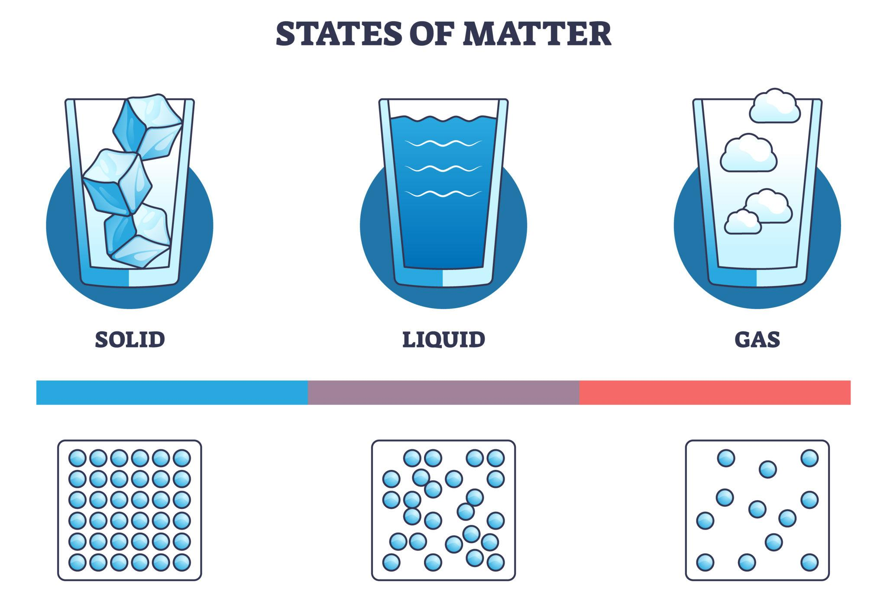  📝 Your challenge: find examples of solids, liquids, and gases at home!  1. 🏠 Find and write down: 3 solids (e.g. table, toy, book); 3 liquids (e.g. water, milk, juice); 1 gas (e.g. air, steam)  2. 🎨 Draw and label clearly: A solid, A liquid, A gas
Computing  This half-term, we are going to be using Scratch again You could have a practise yourself by Animating Your Name  Instructions:  - Go to Scratch. https://scratch.mit.edu/  - Create a new project.  - Make your name appear on the screen using the “Text” tool or a sprite.  - Add a simple animation, like: Make the letters bounce / Make the letters change colour / Make the letters spin | RE  This half-term, our RE branch is ‘Dialogue and Encounter’ where we find out about other religions. You could go to BBC Bitesize – What is Ramadan? https://www.bbc.co.uk/bitesize/  articles/zjc2bdm  Answer these questions on paper:  - When is Ramadan, and how long does it last?  - What are some of the special practices people do during Ramadan?  - Why is Ramadan important to Muslims?  - Draw a picture showing one way people celebrate Ramadan, like fasting, praying, or helping others. | Design and Technology  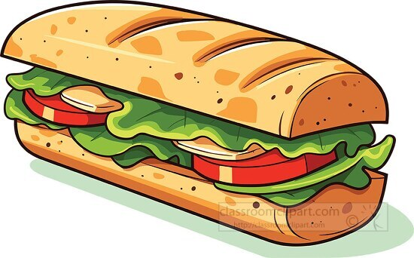  Design Your Own Sandwich  Think about your favourite ingredients for a sandwich (bread, fillings, spreads, vegetables, etc.).  Draw your sandwich on paper. Make it colourful and label all the ingredients. Write 3–4 sentences about: Why you chose these ingredients / How your sandwich is healthy or tasty.  Optional: With an adult’s help, make your sandwich at home and take a picture to show the class. | PE  This half-term, keep practising those throwing and catching skills. 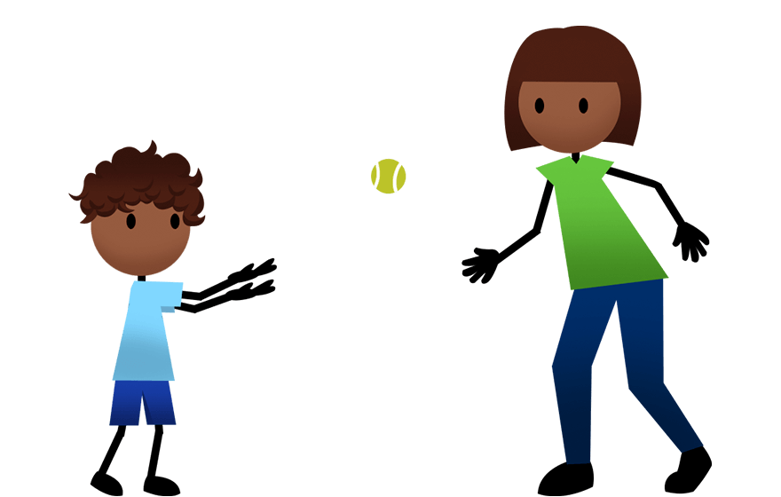

Spellings – These will be tested each Friday.
5th June | 12th June | 19th June | 26th June | 3rd July
accidentally  address  breathe  experiment  knowledge  learn  naughty  possess  promise  therefore | ascent  crescent  descend  discipline  fascinate  scene  scent  scented  science  scissors | applying / applied  bullying / bullied  dancing / danced  smiling / smiled  waving / waved  writing / wrote  performing / performed  joking / joked  happening / happened  opening / opened | babies’  boys’  children’s  class’s  classes’  fathers’  girls’  James’s  mothers’  parents’ | accept/except  affect/effect  berry/bury  medal/meddle  missed/mist  scene/seen  weather/ whether  whose/who’s


BBC Bitesize
A plethora of extra learning opportunities available for your pleasure.
www.bbc.co.uk/bitesize/primary
Hit the Button is an interactive maths game with quick fire questions on number bonds, times tables, doubling and halving, multiples, division facts and square numbers.
Times Tables
To help you with your times tables, please look at the times tables songs on our Class 3 webpage, use Hit The Button and also www.timestables.co.uk is a website I would really recommend for practising your times tables.

Reading
Make sure you read your home-reader book at least three times a week – if possible every night. Can you get to the next level on your home-reader challenge?

