
Key Instant Recall Facts
Pre-School – Summer 1 & 2

I can recite number names in order to 10.

By the end of this term, children should be able to say the number names in order from 0 to 10. The aim is for them to recall these numbers instantly.

Children should be able to start at zero and then count on:  0 1 2 3 4  5 6 7 8  9 10  Ask them to count a set of objects and touch them as they count. Check they can say one number for one object. | If confident they could try counting backwards:  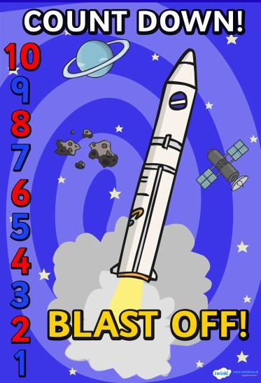

Top Tips
The secret to success is practising little and often. Use time wisely. Can you practise these KIRFs while walking to school or during a car journey?

https://www.topmarks.co.uk/maths-games/3-5-years/counting - Teddy numbers, Underwater counting, Gingerbread man game etc

https://www.bbc.co.uk/cbeebies/topics/numeracy - Lots of video clips here

