
Sycamore Class – Homework Grid – Autumn 2
On the grid below are homework tasks for the Autumn 2 Half Term. There are a range of activities that the children can complete. These tasks are optional and extra to our regular weekly homework.
English  This half term, we’ll be reading a magical story called Leon and the Place Between.To get ready, your challenge is to use your imagination!  Imagine you are at a magic show.  The magician calls you onto the stage…  You step inside a magic box — and when it opens, something amazing has happened!  Write a short story or description (about half a page) to tell us:  - What the magic show is like  - What magic happens to you  - What you see when you come out of the box  You can also draw your magic scene if you’d like!  ✅ Remember to:  - Use describing words (adjectives)  - Write in full sentences  - Use your imagination! | Maths  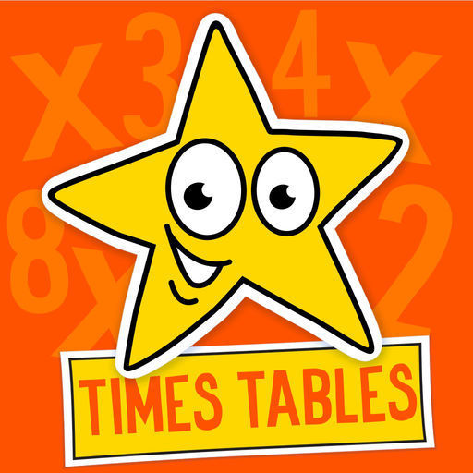  Times Tables Challenge  Spend time learning your times tables – spending just 10 minutes a day revising your tables and corresponding division facts will give you great confidence in maths. Next half term, we’ll be reading a magical story called Leon and the Place Between.  To get ready, your challenge is to use your imagination!  https://www.topmarks.co.uk/maths-games/hit-the-button | Geography  Antarctica Amazing Animals  - Choose two animals that live in Antarctica (e.g. penguin, seal, whale, krill).  - Draw them and write three facts about each on a poster  (What do they eat? How do they stay warm?)  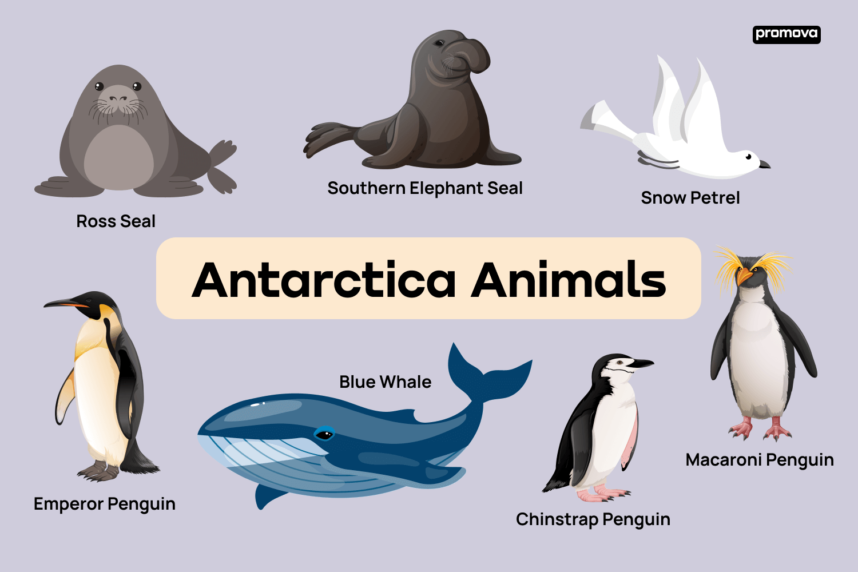 | Science  Can you design and/or make a set of noise blocking ear-muffs using recycled packaging and scraps of material (such as old clothes)?  Which materials are most useful?  Remember you need to think about comfort as well as the properties of materials!  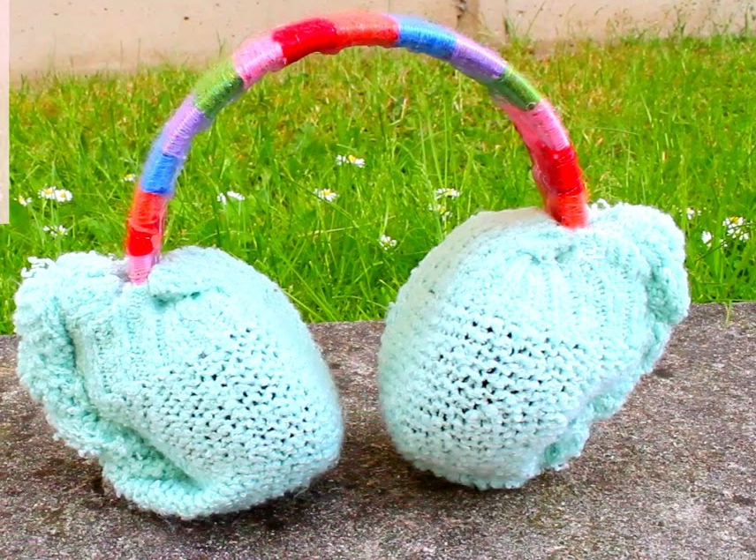
Music  This half-term, our topic will be Rock and Roll!    You could ask your parents and grandparents who their favourite Rock and Roll musicians are.  You could write a short paragraph about the artist and why you like that particular song. You may wish to explore listening to music on cassettes, CDs or record players. Let me know your favourite song, we can play it to the class and discuss why you like it. | RE  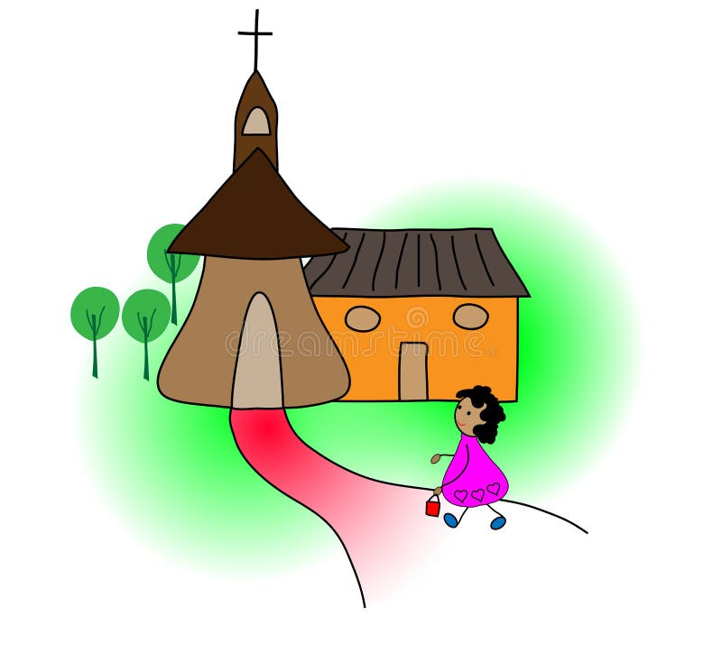  This half-term, we will be learning about the Mass. After going to Sunday Mass, you could write a short reflection on your experience. E.g. – what you noticed, what you enjoyed, what hymns were sung, what was the Gospel about, how did you feel, what did people do at Mass? | Computing  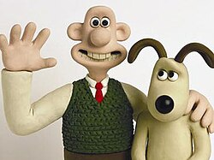  https://www.bbc.co.uk/bitesize/ articles/z7p9cmn  Explore this website about how Stop-Motion animation works. Perhaps you could create your own? There is a free app called “Stop Motion Studio” you could use. You could show your work to Sycamore Class!  You may wish to watch Wallace and Gromit and consider how it was made. | PE    In PE this half-term, we will be learning some netball-based skills. Why not see if there is a hoop down your local park and see if you practise passing and shooting?
Spellings – These will be tested each Friday.
7th November | 14th November | 21st November | 28th November | 5th December | 12th December
although  appear  describe  disappear  famous  favourite  guide  heard  heart | imagine  material  occasion  popular  regular  sentence  special  through  various | brochure  chalet  champagne  charlatan  chef  chic  chiffon  crochet  machine  parachute | babies’  boys’  children’s  class’  Cyprus’s  fathers’  girls’ | James’s  Leon’s  men’s  mothers’  parents’  people’s | accept  except  affect  effect  berry  bury  medal  meddle


BBC Bitesize
A plethora of extra learning opportunities available for your pleasure.
www.bbc.co.uk/bitesize/primary
Hit the Button is an interactive maths game with quick fire questions on number bonds, times tables, doubling and halving, multiples, division facts and square numbers.
Times Tables Olympics
To help you with your times tables, please look at the times tables songs on our Class 3 webpage, use Hit The Button and also www.timestables.co.uk is a website I would really recommend for practising your times tables.

Reading
Make sure you read your home-reader book at least three times a week – if possible every night. Can you get to the next level on your home-reader challenge?

