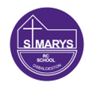
Sycamore Class – Homework Grid – Autumn 1
On the grid below are homework tasks for the Autumn 1 Half Term. There are a range of activities that the children can complete. These tasks are optional and extra to our regular weekly homework.
English  Task:  Imagine a gorilla comes to visit you – just like in Gorilla by Anthony Browne!  Write a story about the adventure you go on together.  In your story, try to include:  - Where the gorilla takes you  - What you do together  - How you feel  - How the adventure ends  You can also:  - Draw some pictures to go with your story  - Give your story a fun title  Tip:  Remember to use full sentences, capital letters and full stops. | Maths  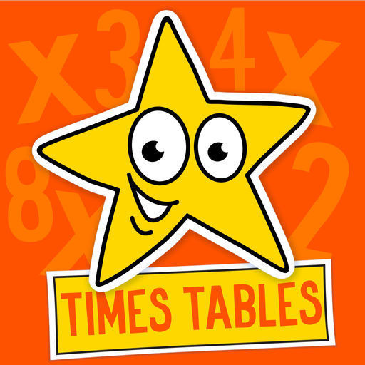  Times Tables Challenge  Spend time learning your times tables – spending just 10 minutes a day revising your tables and corresponding division facts will give you great confidence in maths. Use Hit the Button – how many can you score in a minute?  https://www.topmarks.co.uk/maths-games/hit-the-button | History  Imagine you are a time traveller who has visited the Stone Age, the Bronze Age, and the Iron Age.  Create a Survival Guide to help other children know how to live in each time period!  Your guide should include:  🪨 What to wear – What clothes did people wear?  🔥 What to eat – What kind of food would you find or cook?  🏠 Where to live – What were homes like?  🛠️ Tools and weapons – What were they made from?  You can present it as:  - A mini booklet  - A poster  - A PowerPoint (if you prefer using a computer)  - Or even as a comic strip!  Bonus Challenge:  Include pictures, drawings or diagrams to show what life was like. | Science  Task:  Look around your home and make a list or draw pictures of things that use electricity.  What to do:  - Walk around your house with an adult.  - Look for things that need electricity to work (e.g. toaster, TV, lightbulb, phone charger).  - Make a list or draw at least 6 things that use electricity.  - Write or say how each one helps us (e.g. "The kettle boils water to make tea").  Extra Challenge:  Can you find something that uses batteries instead of being plugged in?  You can present it as:  - A list with pictures  - A mini poster  - A photo collage (if your family lets you take photos)
Art: Abstract Shape Sculpture  Task: Create your own abstract sculpture using shapes! You can use things you already have at home, like: Cardboard or scrap paper, Recycled materials (e.g. boxes, tubes, foil), String, straws, sticks, or anything else you can find!  What to do:Cut or build different shapes – they don’t need to look like real objects, arrange them into a 3D sculpture – tall, wide, twisty, or wobbly!  Give your sculpture a name – something fun or mysterious! | Design Your Own Super Sandwich! 🥪  Task:  Design your dream sandwich!  Draw it and label all the ingredients.  Then write one or two sentences explaining:  - Why it’s your perfect sandwich  - What makes it special (funny names welcome!)  Example:  "This is the Mega Choco-Berry Sandwich. It has strawberries, chocolate spread and marshmallows!" | RE  God made a beautiful world for us to enjoy and take care of. Your task is to create something that shows what you love most about God’s creation.You can choose one of the following:  - A drawing or painting of a beautiful part of the world (e.g. animals, flowers, mountains, oceans)  - A short poem or prayer thanking God for creation  - A collage made from natural materials (leaves, petals, etc.)  - A mini poster showing how we can help look after the world (e.g. recycling, saving water)  - A photo diary of things in nature that you see on a walk | Computing  Find out what the internet is and how we use it in everyday life.  Then create a poster, leaflet or fact sheet to show what you’ve learned.  Your work should include:  🖥️ What the internet is (in your own words)  📱 Ways people use the internet (e.g. sending emails, watching videos, learning)  🛑 One or two rules for staying safe online  You can: Draw pictures or print images, write short sentences or facts, decorate it to make it eye-catching!
Spellings – These will be tested each Friday and will be taken from the below lists.
12th September | 19th September | 26th September | 3rd October | 10th October | 17th October
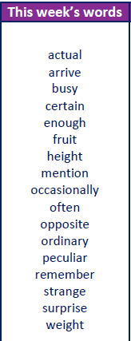 | 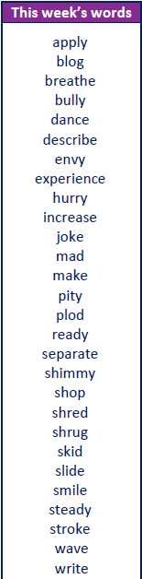 | 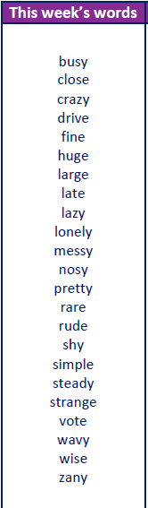 | 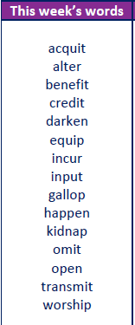 | 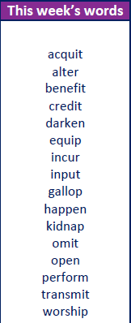 | 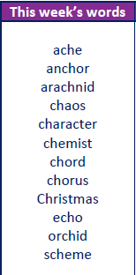
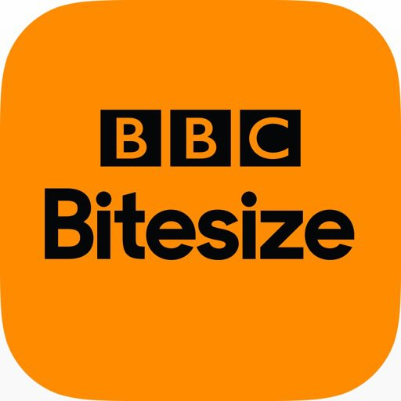

BBC Bitesize
A plethora of extra learning opportunities available for your pleasure.
www.bbc.co.uk/bitesize/primary
Hit the Button is an interactive maths game with quick fire questions on number bonds, times tables, doubling and halving, multiples, division facts and square numbers.
Times Tables Olympics
To help you with your times tables, please look at the times tables songs on our Class 3 webpage, use Hit The Button and also www.timestables.co.uk is a website I would really recommend for practising your times tables.

Reading
Make sure you read your home-reader book at least three times a week – if possible every night. Can you get to the next level on your home-reader challenge?

