
Sycamore Class – Homework Grid – Spring 1
On the grid below are homework tasks for the Spring 1 Half Term. There are a range of activities that the children can complete. These tasks are optional and extra to our regular weekly homework.
English  In Our Tower, the poet shows what it is like to live in a tall tower block and how it feels to look out at the world.  ✏️ Your Task:  Draw the Setting  - Draw a picture of the tower from the poem.  - Include things you think you would see from the windows.  Write About It  Write 5–7 sentences answering these questions:  - What is the tower like?  - How do the people in the tower feel?  - What can they see from the windows?  - How does the poem make you feel? | Maths  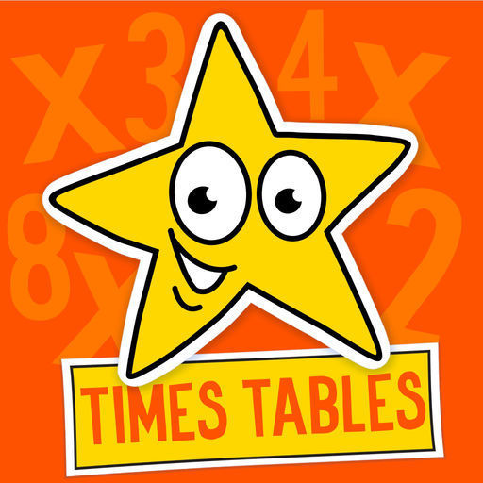  Times Tables Challenge  Spend time learning your times tables – spending just 10 minutes a day revising your tables and corresponding division facts will give you great confidence in maths. Next half term, we’ll be reading a magical story called Leon and the Place Between.  To get ready, your challenge is to use your imagination!  https://www.topmarks.co.uk/maths-games/hit-the-button | History  🏛️ Make a Roman Shield or Sword  The Romans were famous for their strong soldiers and powerful equipment.  🛡️ Option 1: Roman Shield  - Use cardboard or thick paper.  - Shape it like a rectangle or oval (Roman shields were called scutums).  Decorate it with:  - Bold patterns  - Roman colours (red, gold, black)  - Symbols (eagles, lightning, shapes)  ⚔️ Option 2: Roman Sword  - Use cardboard, paper, or foil (no sharp objects).  - Roman swords were called gladius and were short and straight.  - Add a handle and decorate the blade | Science  Research the skeletons of different animals, what do you notice about their arms and legs? Are there any similarities?  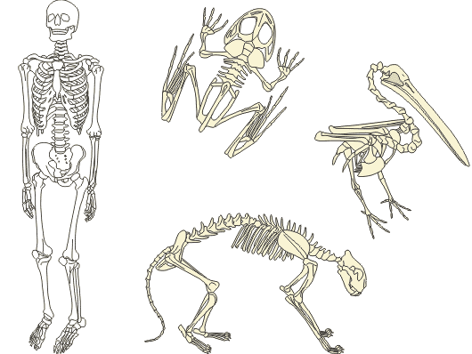
Music  A ballad is a song that tells a story. Ask your parents if they know of any famous ballads by their favourite artists e.g. Space Oddity by David Bowie', 'Unchained melody by The Righteous Brothers' , 'On my own by Samantha Barks' , 'Everything I do by Brian Adams' , 'I will always love you by Whitney Houston'  After listening, talk with an adult about:  Who is the song about?  What happens in the story?  How does the song make you feel? (happy, sad, calm, excited) | RE  This half-term, we will be looking at some of Jesus’ parables. Your task is to make a storyboard about one of Jesus’ famous parables. You could choose: The Good Samaritan  The Lost Sheep  The Prodigal Son (The Lost Son  The Sower  The Wise and Foolish Builders  Your storyboard could include ideas about what message Jesus was teaching in the parable. | Computing / Art  This half-term we will be using ICT to create pictures with repeating patterns. You could create your own artwork with a repeated pattern.  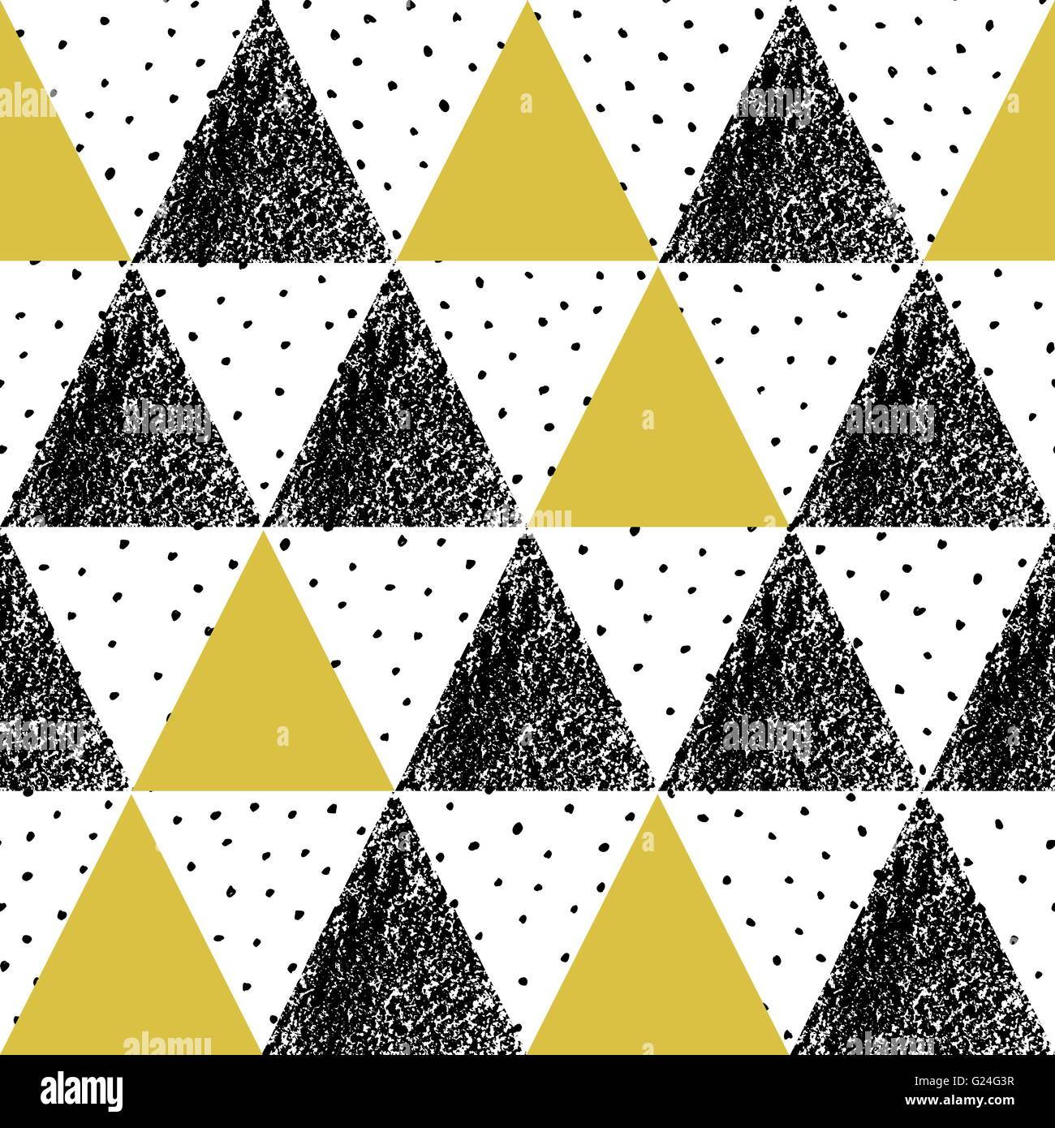 | PE  This half-term, we will be doing swimming lessons. You could politely ask your parents if they could take you to the swimming pool for extra practise. Be safe 

Spellings – These will be tested each Friday.
9th January | 16th January | 23rd January | 30th January | 6th February | 13th February
although  appear  arrive  believe  different  heard  important  notice  ordinary  remember  thought  through | action  collection  creation  devastation  direction  inclusion  infection  invasion  pollution  reflection  precision  tension | admission  aggression  confession  discussion  expression  mission  permission  possession  procession | physician  electrician  magician  mathematician  musician  optician  politician  technician | admiration  adoration  alteration  aspiration  expiration  floatation  information  inhalation  preparation  relaxation  sensation  variation | admiration  adoration  alteration  aspiration  expiration  floatation  information  inhalation  preparation  relaxation  sensation  variation


BBC Bitesize
A plethora of extra learning opportunities available for your pleasure.
www.bbc.co.uk/bitesize/primary
Hit the Button is an interactive maths game with quick fire questions on number bonds, times tables, doubling and halving, multiples, division facts and square numbers.
Times Tables Olympics
To help you with your times tables, please look at the times tables songs on our Class 3 webpage, use Hit The Button and also www.timestables.co.uk is a website I would really recommend for practising your times tables.

Reading
Make sure you read your home-reader book at least three times a week – if possible every night. Can you get to the next level on your home-reader challenge?

