
Sycamore Class – Homework Grid – Spring 2
On the grid below are homework tasks for the Spring 2 Half Term. There are a range of activities that the children can complete. These tasks are optional and extra to our regular weekly homework.
English  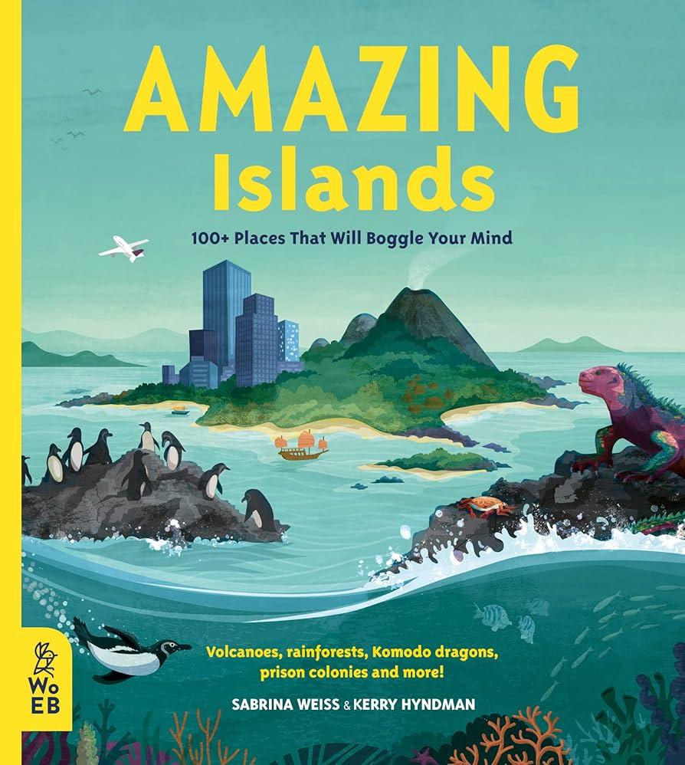  Write a postcard as if you are visiting an amazing island you learned about in class. Describe what you can see, hear, or feel.  You could design the back of the postcard to show which island you have chosen from around the world. Set out the front like below:  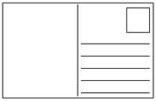 | Maths  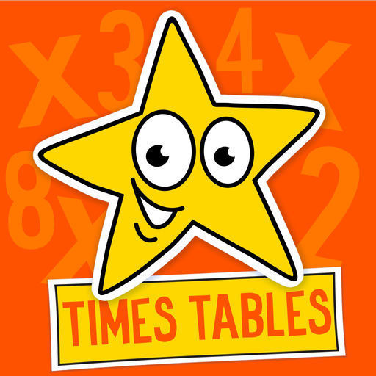  Times Tables Challenge  Spend time learning your times tables – spending just 10 minutes a day revising your tables and corresponding division facts will give you great confidence in maths. Next half term, we’ll be reading a magical story called Leon and the Place Between.  To get ready, your challenge is to use your imagination!  https://www.topmarks.co.uk/maths-games/hit-the-button | Geography – Settlements  Become a Settlement Spotter and investigate the place where you live (or a place you know well).  What kind of settlement is it?  Circle one (or choose the closest):🏠 Village, 🏘️ Town, 🏙️ City  What can you find there?  Draw or write at least 5 things, such as:, Houses or flats, Shops, School, Park or field, Roads, Church / mosque / temple, Bus stop / train station | Science  Teeth and Digestion Task  Choose two different foods (with an adult’s help), for example:  - Soft food: banana, bread, pasta  - Hard or crunchy food: apple, carrot, cracker  • Take small bites and chew carefully.  • Think about these questions (you can write or draw your answers):  - Which food was easier to chew?  - Which teeth did you use most? (front or back)  - What happened to the food as you chewed it?  • Finish this sentence:  “Teeth are important because…”
Music / Computing  As our English topic is all about Islands, you could spend some time on Isle of Tune! https://www.isleoftune.com/  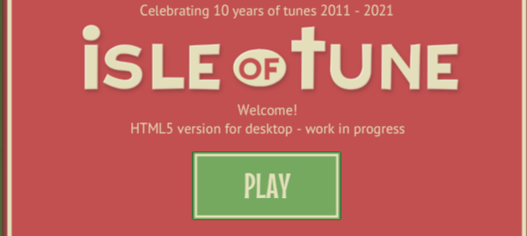 | RE Your Task: During Lent, Christians often try to do something positive or helpful. You are going to choose a Lent promise.  - Choose ONE thing you will try to do during Lent:  - Write or draw:  - What your Lent promise is, Who it might help, How it makes the world a better place  - Decorate your work with:  - A cross, A heart Leaves or flowers (to show new life) | Design and Technology  This half-term, we will be stitching using textiles. Could you ask your parents if you could do a cross-stitch pattern? Make sure you are safe and have asked permission first. You may need some help to get you started.  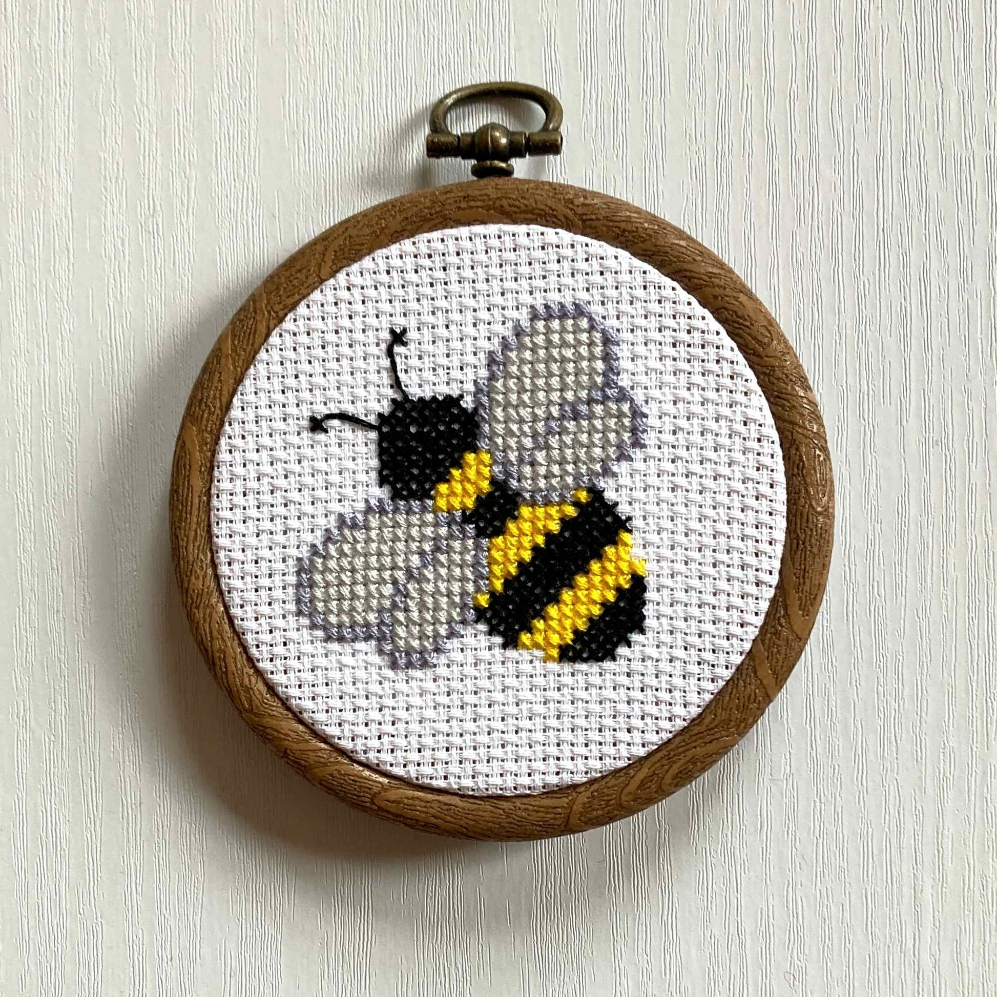 | PE  This half-term, we will be doing swimming lessons. You could politely ask your parents if they could take you to the swimming pool for extra practise. Be safe 

Spellings – These will be tested each Friday.
27th February | 6th March | 13th March | 20th March | 27th March
build  centre  circle  decide  different  difficult  early  group  island  natural  position  separate | subdued  submarine  subway  interact  international  interrelated  superhero  supermarket  superstar  antibacterial  antiseptic  antisocial | immature  immobile  immortal  impatient  imperfect  impossible  imprecise  inaccurate  inactive  incorrect  informal  inside | illegal  illegible  illiterate  illogical  irrational irresistible  irregular  irrelevant  irresponsible | missed/mist  scene/seen  weather/whether  whose/who’s


BBC Bitesize
A plethora of extra learning opportunities available for your pleasure.
www.bbc.co.uk/bitesize/primary
Hit the Button is an interactive maths game with quick fire questions on number bonds, times tables, doubling and halving, multiples, division facts and square numbers.
Times Tables Olympics
To help you with your times tables, please look at the times tables songs on our Class 3 webpage, use Hit The Button and also www.timestables.co.uk is a website I would really recommend for practising your times tables.

Reading
Make sure you read your home-reader book at least three times a week – if possible every night. Can you get to the next level on your home-reader challenge?

