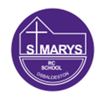
Sycamore Class – Homework Grid – Summer 1
On the grid below are homework tasks for the Summer 1 Half Term. There are a range of activities that the children can complete. These tasks are optional and extra to our regular weekly homework.
English  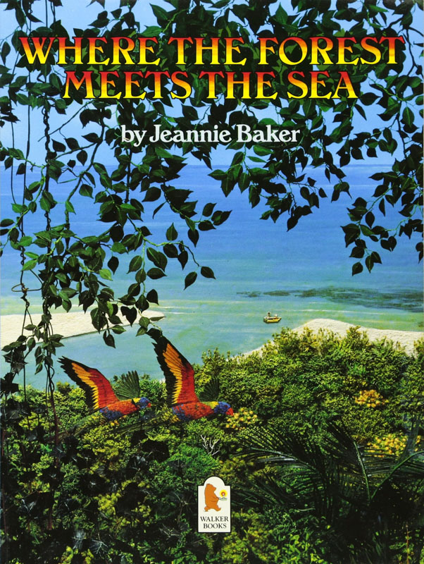  Where the Forest Meets the Sea by Jeannie Baker is a picture book that follows a young boy and his father exploring an ancient, untouched Australian rainforest on the coast.  You could challenge yourself to write a setting description of rainforest. Try and use all your senses.  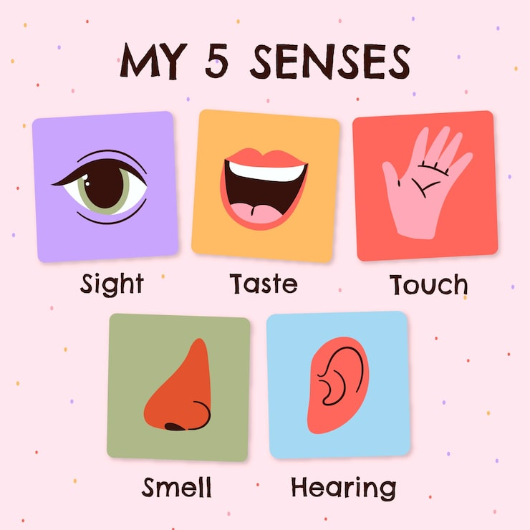 | Maths  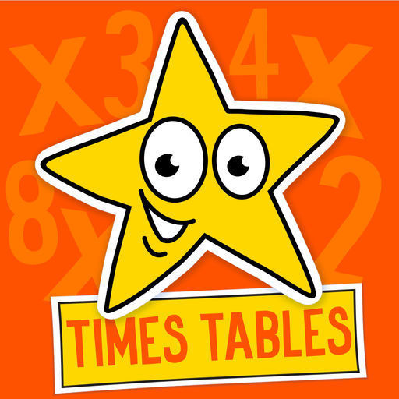  Times Tables Challenge  Spend time learning your times tables – spending just 10 minutes a day revising your tables and corresponding division facts will give you great confidence in maths.  https://www.topmarks.co.uk/maths-games/hit-the-button  https://www.timestables.co.uk/ | 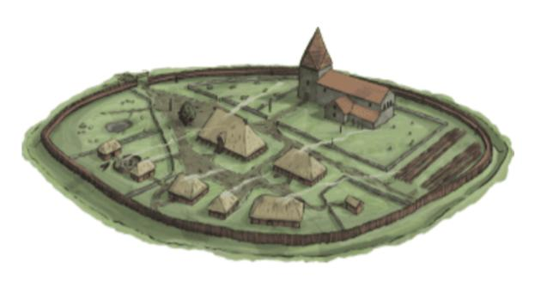  History  Design an Anglo-Saxon Village  ✏️ What to include:  🏠 Houses (wood and thatch roofs), 🌾 Farms or crops, 🐄 Animals (like cows, sheep, or chickens), 🌳 Nature (trees, rivers, or hills), 🔥 A fire or cooking area  You could write sentence about: Who lives there? What jobs do people do? What do they eat?  ⭐ Success Tips: Use labels to name different parts of your village, Add colour to make it bright and clear, Try to make it look like it might have in Anglo-Saxon times (no cars or modern buildings!) | Science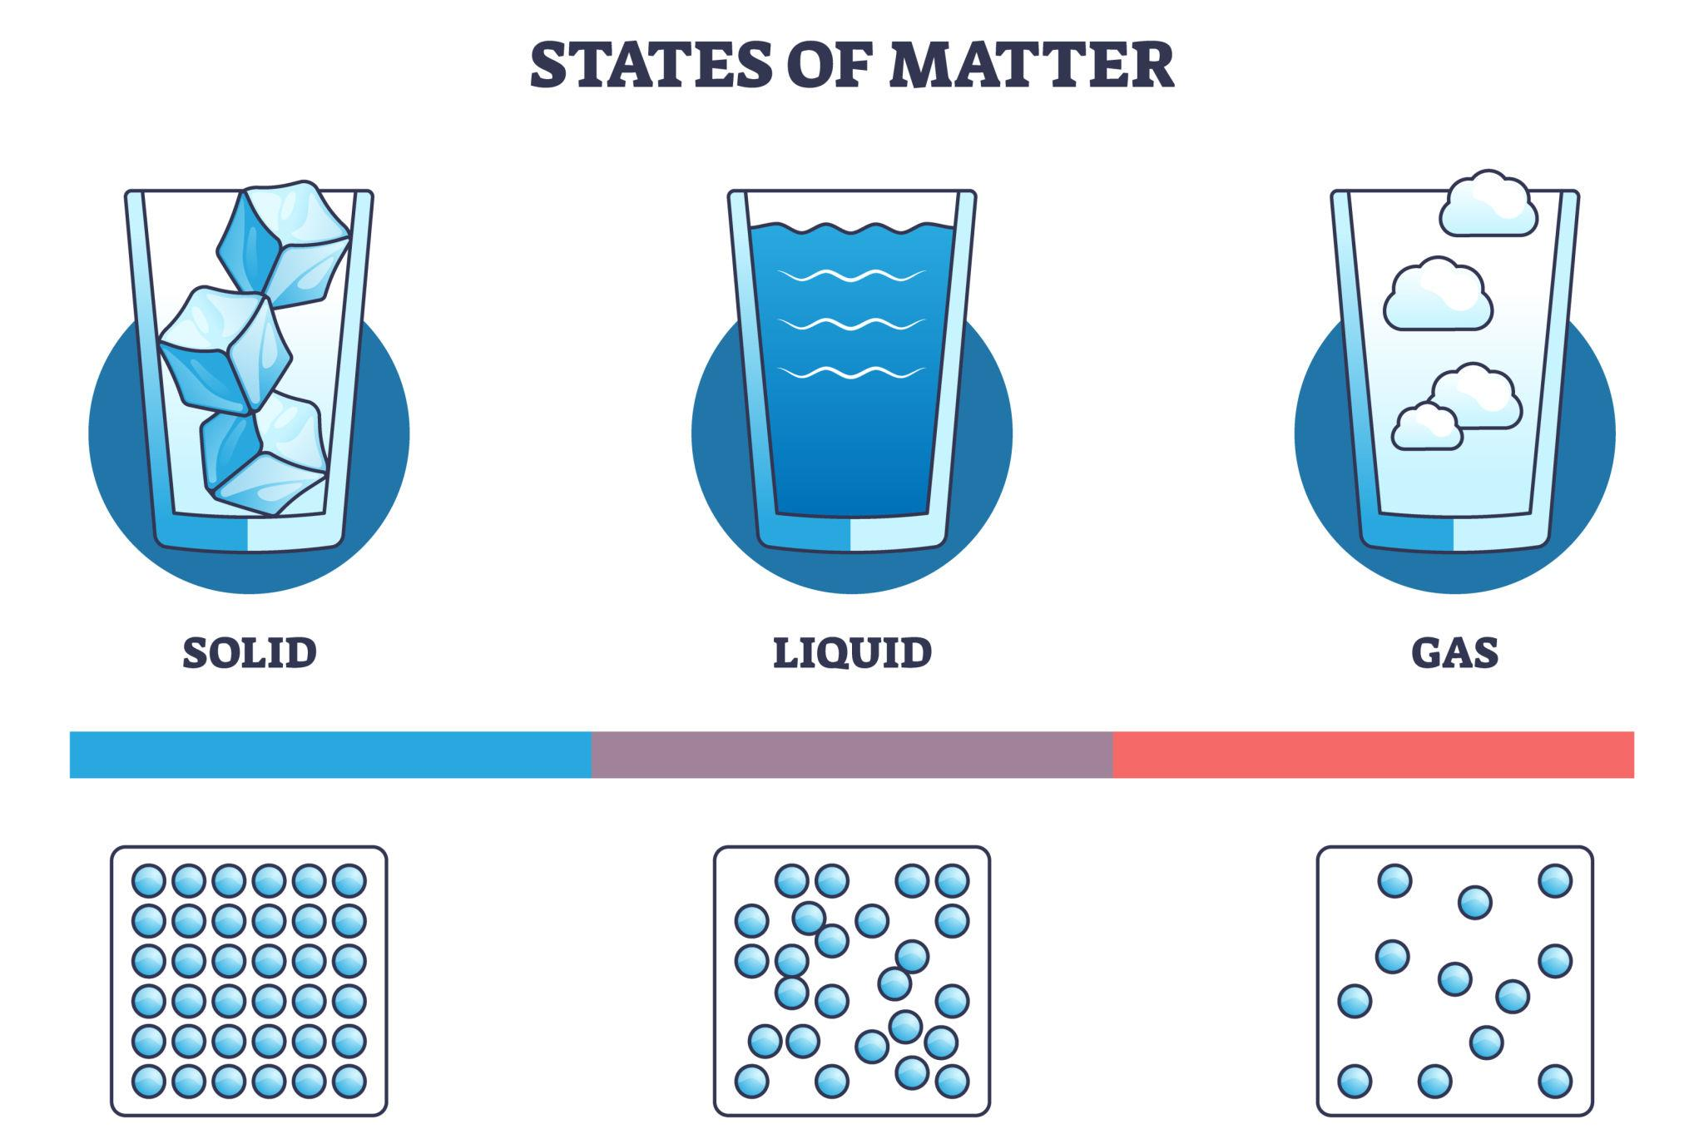  📝 Your challenge: find examples of solids, liquids, and gases at home!  1. 🏠 Find and write down: 3 solids (e.g. table, toy, book); 3 liquids (e.g. water, milk, juice); 1 gas (e.g. air, steam)  2. 🎨 Draw and label clearly: A solid, A liquid, A gas
Computing  Last half-term, we learnt all about branching databases. You could use what you have learnt to create a new one of your own. You could draw it or use https://www.j2e.com/jit5#branch  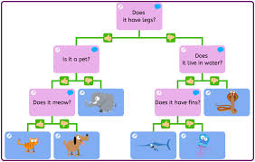 | RE  As part of our topic this half-term, we will be looking at some traditional prayers. You could research the below traditional prayers, write them out and decorate them.  Sign of the Cross; The Lord’s Prayer (Our Father); Hail Mary; Glory Be;; Apostles’ Creed; Act of Contrition | Art  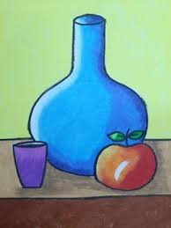  This half-term, we will be painting and colour-mixing. Could you practise your skills by painting a ‘still-life’ design. | PE  This half-term, we will be doing kwik cricket and athletics. Take some time to practise your throwing and catching skills. 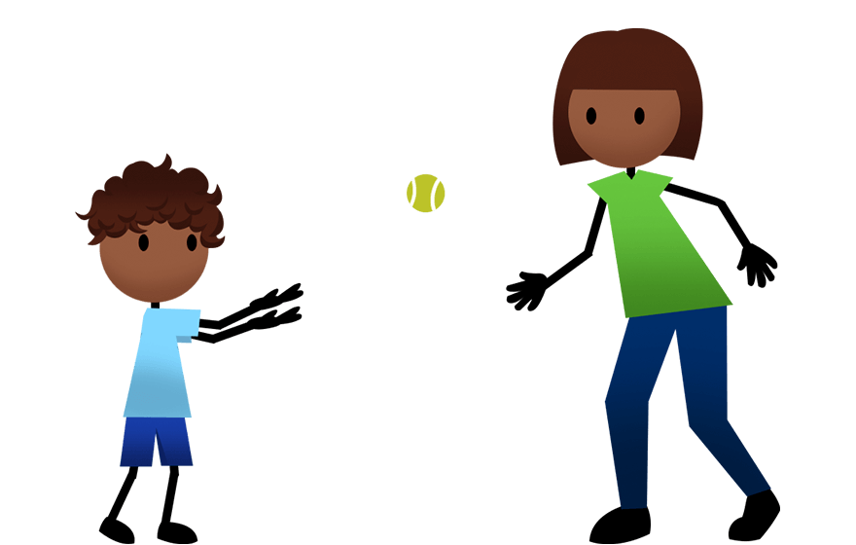

Spellings – These will be tested each Friday.
24th April | 1st May | 8th May | 15th May | 22nd May
important  complete  consider  question  possible  notice  minute  business  actually  increase | couldn’t  shouldn’t  wouldn’t  here’s  there’s  they’ll  you’ll  he’d  she’d  we’d | dangerous  enormous  famous  furious  jealous  mountainous  poisonous  tremendous  various  virtuous | courageous  courteous  curious  glamorous  hideous  humorous  obvious  outrageous  serious  spontaneous  vigorous | dialogue  league  rogue  tongue  vague  antique  boutique  mosque  technique  unique


BBC Bitesize
A plethora of extra learning opportunities available for your pleasure.
www.bbc.co.uk/bitesize/primary
Hit the Button is an interactive maths game with quick fire questions on number bonds, times tables, doubling and halving, multiples, division facts and square numbers.
Times Tables Olympics
To help you with your times tables, please look at the times tables songs on our Class 3 webpage, use Hit The Button and also www.timestables.co.uk is a website I would really recommend for practising your times tables.

Reading
Make sure you read your home-reader book at least three times a week – if possible every night. Can you get to the next level on your home-reader challenge?

