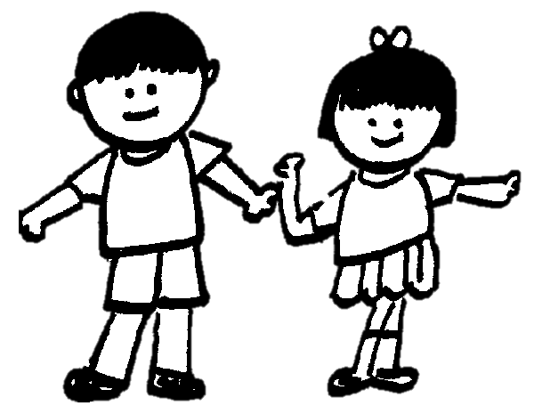



++

There is an optional homework grid on our class page if you would like to complete some or all the activities from it. Weekly spellings are on our class page, along with the KIRFS discussed at parents evening. Please practise both spellings and KIRFS weekly to support your child’s learning – thank you!

Please wherever possible share books with your children at home – snuggling up together for a bedtime story is a great way to do this! Listening to your child read their reading book at least 4 times a week is vital and will help your child to reach their full potential. Please record in their reading record every time you hear them read as this contributes to their home reading certificates. Cedar class have now had 2 children achieve the certificate for reading 100 times which is a huge achievement, well done!
Kindest Regards,
Miss Pinn

Literacy
Fiction:
Grandad’s Secret Giant
Numeracy
Money
Fractions
Length and Height
Mass, Capacity and Temperature
June 2026

Dear Parents / Carers,

I hope you all had a lovely half term holiday together. We’re very excited to welcome the children back for another half term full of new learning! We will be learning to play cricket and improve our football skills in the sunshine (hopefully), making sculptures out of clay, investigating life in Shanghai and in English, we will be writing our own stories based on our key text; Grandad’s Secret Giant.

As ever, please know that my door is always open to you and you are more than welcome to bob in and have a chat. You can either speak to me at the beginning or end of a school day, phone the office or email school any time at parents@smrc.lancs.sch.uk.

PE
PE days are Monday and Friday. Your child needs to bring their PE kit to school on these days please.

P.E.

Kwik Cricket

Football FUNS

RE
Dialogue and Encounter
Science
Animals including Humans
ICT

Making Music
Geography

What’s it like to like in Shanghai?
Art
Sculpture and 3D: Clay Houses
Music
Structure: Myths and Legends
Cedar - Miss Pinn, Mrs Halstead and Miss Thornber
Please find lots of additional information about our learning this half-term on our class webpage.

