
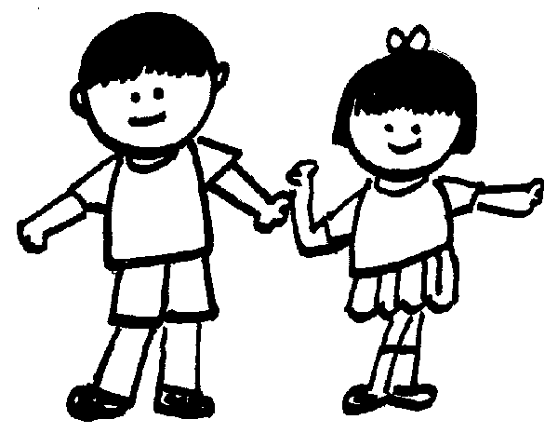


- +Step 17 Round to the nearest 10, 100 or 1,000

Geography
Are all settlements the same?

Literacy Targets:
Year 3
- Build an increasing range of sentence structures
- Use adverbs to express time, place and cause
- Choose nouns or pronouns appropriately for clarity and cohesion and to avoid repetition
- Use inverted commas to punctuate direct speech
Year 4
- Expand noun phrases by the addition of modifying adjectives, nouns and prepositional phrases
- Choose nouns or pronouns appropriately for clarity and cohesion and to avoid repetition
- Use and punctuate direct speech
- Use commas after fronted adverbials

History

Literacy
Amazing Islands

Adventure
P.E.
Swimming

Boccia
ICT

Branching Databases
February 2026
Dear Parents/ Carers,
Welcome back to St Mary’s for the Spring 2 Half-Term. I hope that you all had a nice half-term break.

Our English topic for this half-term is based on Amazing Islands by Sabrina Weiss & Kerry Hyndman and also a story called Koji’s Island. The children will learn how to write fictional adventure stories. In maths we will be focusing on fractions, mass & capacity.

There is an optional Home Learning Grid on our class page if you would like to complete some of the challenges. Also I would also like to remind you of the importance of reading regularly at home. Reading not only develops a love of reading but also develops imagination which is essential for story writing. Please wherever possible encourage your child to read at home and bring their reading and library books back into school when they are ready to change them. We want to inspire a love of reading.

Spellings will be given out on Friday and will be tested on the following Friday. P.E is on Mondays and swimming is on Tuesdays.

Best wishes,
Mr J Wormleighton

Spanish
My Home

Spring 2: Sycamore Class - Mr Wormleighton
Numeracy
Fractions A
Mass & Capacity
Fractions B
RE
Desert to Garden
Science
Teeth & Digestion

- Step 18 Roman numerals
Fractions B
Step 1 Add fractions
Step 2 Add fractions and mixed numbers
Step 3 Subtract fractions
Step 4 Subtract from whole amounts
Step 5 Subtract from mixed numbers
Step 6 Unit fractions of an amount
Step 7 Non-unit fractions of an amount
Step 8 Reasoning with fractions of an amount
Mass & Capacity
Step 1 Measure mass in grams
Step 2 Measure mass in kilograms and grams
Step 3 Equivalent masses
Step 4 Compare mass
Step 5 Add and subtract mass
Step 6 Measure capacity and volume in millilitres
Step 7 Measure capacity and volume in millilitres and litres
Step 8 Equivalent capacities and volumes
Step 9 Compare capacity and volume
Step 10 Add and subtract capacity and volume
Fractions A
Step 1 Understand denominators
Step 2 Compare & order unit fractions
Step 3 Understand numerators
Step 4 Understand the whole
Step 5 Fractions on a number line
Step 6 Compare & order non-unit fractions
Step 7 Equivalent fractions
Step 8 Count beyond 1
Step 9 Partition a mixed number
Step 10 Compare & order mixed numbers
Step 11 Understand improper fractions
Step 12 Convert mixed numbers to improper fractions
Step 13 Convert improper fractions to mixed numbers
Step 14 Equivalent fraction families

