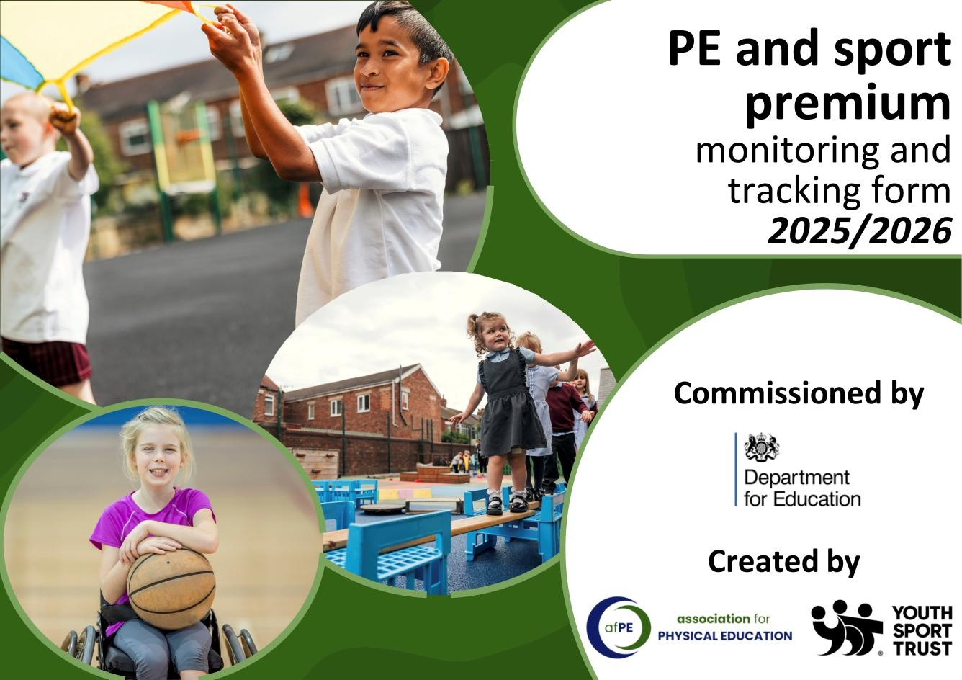


PE and sport premium monitoring and tracking form

- It is intended that this template should be used as preparation for the completion of the statutory DfE PE and sport premium digital expenditure reporting return. You can upload data (including swimming) from this template onto this platform once it becomes accessible.
- The template is a working document that you can amend and update during the year.
- Before you decide how you are going to use the funding for this academic year you should reflect and evaluate
the impact of your use of you PE and sport premium funding in 2024/25.
- You should use your evaluation of last year’s funding to help you decide what to do this academic year, how you will do it, and what impact you expect it to have.
- All spending of the funding must conform with the terms outlined in the conditions of grant
- The summative digital expenditure reporting from June 2026 will continue to include swimming and water safety information. PE and sport premium funding can be used to provide top-up lessons, where necessary, to ensure pupils meet national curriculum swimming requirements
- To ensure funding is used effectively and based on your school’s needs; guidance and examples of best practice across schools can be found here.
- You must use the funding to make additional and sustainable improvements to the PE and sport in your school.
- You must develop and add to the PESSPA activities that your school already offers.

Useful Links:
  - PE and sport premium for primary schools - GOV.UK
  - PE and sport premium: conditions of grant 2025 to 2026 - GOV.UK


Review of the last academic year (2025/2026)

- Take some time to reflect on your intent, implementation and impact from last academic year to celebrate your wins but to also think about improvements for the year ahead.
- You do not need to complete every box. Just record the information that is key to your school's priorities and areas of focus.
Remember - Be clear about how you focused spending on key groups such as SEND, girls and disadvantaged pupils.

Swimming and Water Safety | What went well? Supporting evidence? | What didn't go well? Supporting evidence?
1. Swim competently, confidently and proficiently over a distance of at least 25 meters. | 75% of the year 6 cohort could confidently swim 25 meters and use a range of strokes. | Some children who were expected to pass did not pass. This was due to absences throughout the two-week top up swimming sessions.
2. Use a range of strokes effectively (for example, front crawl, backstroke and breaststroke) | Again, 75% of children managed to carry out the following stokes. | Some children who were expected to pass did not pass. This was due to absences throughout the two-week top up swimming sessions.
3. Perform safe self-rescue in different water-based situations | Only a small number of children were capable of completing the self-rescue. | Pupil absences slowed down momentum. Not as many children were able to complete the self-rescue.


Review of the last academic year (2025/2026)

Key areas as outlined in PE and sport premium guidance | What went well? Supporting evidence? | What didn't go well? Supporting evidence?
1. Increasing confidence, knowledge and skills of all staff in teaching PE and sporting activities prioritizing CPD and training where needed | The PE coaches employed by the school continue to develop teaching staff in helping deliver high quality PE lessons.  The school has again, provided a variety of sporting activities and experiences to help children become more confident athletes.  The school again continue to regularly carry out gymnastics and dance sessions deployed by a qualified instructor. | Due to staff calendars, CPD evenings were rearranged or cancelled.
2. Increasing engagement of all pupils in regular physical activity and sporting activities | The school continues to provide extra-curricular activities for children interested in sport. This includes: Cricket, netball, football and gymnastics.  Furthermore, Outside agencies such as ASM provided enrichment days for pupils.  As well as this, lunchtime clubs proved very popular and the inclusion of sports ambassadors was a huge a huge success. | Not all students took part in extra- curricular clubs.

Review of the last academic year (2025/2026)

Key areas as outlined in PE and sport premium guidance | What went well? Supporting evidence? | What didn't go well? Supporting evidence?
3. Raising the profile of PE and sport across the school, to support whole school improvement | The school frequently took part in a variety of events including boys, girls and mixed inter house competitions.  The school also took part in county sports hall athletics events as well as town sports.  Games for all incorporated opportunities less active children opportunities to represent the school in a sporting capacity.  Children taking part in events were celebrated during assembly and obtained a certificate. | Due to staff calendars, the school were unable to facilitate staffing, therefore the school was unable to take part in some sporting competitions.
4. Offer a broader and more equal experience of a range of sports and physical activities to all pupils and ensure equal access to sport for boys and girls | Introduction of sports ambassadors offered opportunities for lunch time clubs carried out by members of Crewe Alex coaching staff.  ASM enrichment days provided a variety of different games and activities for lesser known sports.  Bikability days for year 5 and 6 children proved a great success.  Girls football clubs throughout KS2 throughout the summer term. | The school will specifically target early on in the next academic year opportunities to take part in more girls sporting events such as football. Staff to accommodate this by running girls football club afterschool throughout the year alongside boys football.
5. Increasing participation in competitive sport | Continued membership with our local School Sports Network to allow us to enter a wide variety or organised competitions against other local schools.  Frequent interaction with organisers about further opportunities for ways to promote sport throughout the school. | The school will look to seek opportunities to practice events such as high jump and long jump at local secondary school in the build up to town sports.


Aims for the next academic year (2026/2027)

- Using your whole school priorities, school development plan and previous PE, school sport and physical activity data, set out your aims for the year ahead.
- Think about specific areas of need such as inactive girls, SEND and disadvantaged pupils
- Remember to also input your swimming data and reflections in the table located at the bottom of this page.
- Consider which of the 5 key areas improvements will be focusing on:
- Increasing confidence, knowledge and skills of all staff in teaching PE and sporting activities prioritising CPD and training where needed.
- Increasing engagement of all pupils in regular physical activity and sporting activities
- Raising the profile of PE and sport across the school, to support whole school improvement
- Offer a broader and more equal experience of a range of sports and physical activities to all pupils and ensure equal access to sport for boys and girls
- Increasing participation in competitive sport

Swimming and Water Safety | What went well? Supporting evidence? | What didn't go well? Supporting evidence?
1. Swim competently, confidently and proficiently over a distance of at least 25 metres
2. Use a range of strokes effectively (for example, front crawl, backstroke and breaststroke)
3. Perform safe self-rescue in different water-based situations


Review of the last academic year (2025/2026)

Aim | Why? | Key Area | Supporting evidence
Continue with year 6 PE ambassadors throughout the year having two children each lunch time break assist the Crewe Alex coaching staff with set up of activities. | This will give the children involved ownership and responsibility. This will also help develop their teamwork skills as well as sporting understanding. | Increased engagement of pupils taking part in physical activity.  Promote pupil voice finding out from pupils which sports would the children like to do. | Success in running the sports ambassador’s role for the previous 2 years. This has had a great impact on playground behavior and has given opportunities for less academic children to shine.
Continued membership with CNSSP. | Promote enjoyment in sport as well a competitive attitude when representing the school. | Take part in more sporting competitions and provide opportunities for boys and girls events as well as less active children. | Continued participation with the local community by taking part in sporting events throughout the year.
Offer more extra-curricular sporting clubs for both boys and girls. | Promote enjoyment of sport in the form of both boys and girls sporting clubs. With the objective to enter in competitions. | Promote inclusion of girl’s football competitions as well as tag rugby. | Higher number intake for girls’ football in the summer term.
Continued opportunities for outside agencies to carry out after school clubs such as cricket. | Opportunities to develop enjoyment of different sports. | Offer of Sandbach cricket coaches in the summer to carry out cricket clubs will build confidence. This helped train children for upcoming participation in competitions later in the year. | Continued partnership with Sandbach cricket. Previously entered a cricket competition at the end of the academic year.
Further enrichment days in the form of ASM and Bikeability. | Enrichment day will help encourage less active children to take part in a variety of sports.  Bikeability will promote an active lifestyle encouraging children to cycle to school. | Promotion of enjoyment for less active children through enrichment days will help for participation for games for all competitions. | Great enjoyment from children and we will continue the partnership moving forward.


Plan, monitor and evaluate (2026/2027)

  - Please aim to use this as a live working document through the year.
  - Keep returning to this to evidence adaptations and progress made through the PESSPA opportunities you provide.
  - There is no set number of objectives you must have.
  - Make as many or as few as you see fit that will support your aims for the year ahead.
  - Consider which of the 5 key areas improvements will be focusing on:
- Increasing confidence, knowledge and skills of all staff in teaching PE and sporting activities prioritising CPD and training where needed.
- Increasing engagement of all pupils in regular physical activity and sporting activities
- Raising the profile of PE and sport across the school, to support whole school improvement
- Offer a broader and more equal experience of a range of sports and physical activities to all pupils and ensure equal acce ss to sport for boys and girls
- Increasing participation in competitive sport

Plan, monitor and evaluate (2025/2026)

Example objective shown below is for reference purposes only:

 | Intent - what is your objective? | Implementation - How will you achieve this? | Impact - What do you hope to see? | Supporting evidence
Plan and monitor | Develop lunchtime play provision to increase activity for least active groups. | Develop pupil leadership (training programme), Midday supervisor training, Staff CDP to develop their understanding of games and play, Range of equipment, Youth voice activities to understand pupils wants and needs Outdoor play provision such as OPAL | A confident and competent group of activity leaders that take initiative and create a more active and inclusive playground for all pupils. Midday supervisors and all staff leading a range of physical activities and joining in with movement daily to role model. A happier, more active playground that meets the needs of all pupils especially SEND and girls. | Youth voice data through half-termly surveys and interviews/group discussions with a variety of pupils (leaders, children participating and those that are less active at break times). Conduct regular observations of the playground to gauge activity levels of the least active children. Staff voice and feedback.
 | What impact have you seen? | Are the improvements sustainable? How? | Supporting evidence | Approx. cost
Evaluate | Activity leaders are leading a broad range of activities and actively seeking children that are not engaged in physical activity during lunch times. Midday supervisors have grown in confidence and far more active and engaged in games with the children. Lunch times are more active with children having fun. Activity options have been tailored to suit the needs of SEND pupils through considerate choices of equipment and the types of games played. Girls are proving to be the hardest group to engage as some are still choosing not to be active. | Continued training for activity leaders and bringing new leaders into the group to bring new ideas and expertise. More leaders will also mean more activities are able to be delivered. Continued training with midday supervisors.  Establish lead midday supervisors to empower them and give them ownership. Continue to listen to SEND pupils and tailor activities to their needs and wants. Focus priorities on engaging girls. Work with least active girls to create activities that are meaningful and enjoyable for them. Do they want to be activity leaders for younger children to give them purpose and confidence? | 100 out of 100 activity leaders want to carry on with this role next year. 30 more children have enquired to joining the team. Meetings and the end of year survey have shown all leaders feel positive and enjoy making a difference for others. Interviews by random selection were conducted and 92% of pupils were either 'happy' or 'very happy' with the activities on offer at lunch time. End of year physical activity survey findings such as:  - Am I involved with games at lunch time - 89% Yes  - Do I enjoy lunch time? 97% Yes  - Have I joined in with a game with the activity  leaders? 100% Yes | Physical Resources - £1000 CPD for staff - £500  OPAL - £8000

Your objective:

 | Intent - what is your objective? | Implementation - How will you achieve this? | Impact - What do you hope to see? | Supporting evidence
Plan and monitor  (Complete now and monitor) | Choose ten sports ambassadors to assist with lunch time sports club throughout the year assisting coaching staff. | 2 children each day will assist staff in setting up activities for lunchtime club. | Giving children a sense of ownership and responsibility. This will also help develop their teamwork skills as well as sporting understanding | Promotion of PE display to showcase PE monitors throughout the year. Discussion with coaching staff about impact of PE ambassadors.  Pupils voice discussing which sports children would like to do.
 | What impact have you seen? | Are the improvements sustainable?  How? | Supporting evidence | Approx. cost
Evaluate  (Complete in July) | Add text here | Add text here | Add text here | Add text here

Your objective:

 | Intent - what is your objective? | Implementation - How will you achieve this? | Impact - What do you hope to see? | Supporting evidence
Plan and monitor  (Complete now and monitor) | Continued partnership with CNSSP. | Promote enjoyment in sport as well a competitive attitude when representing the school.  Take part in smaller events as well as larger county events such as Sports hall athletics as well as Town sports. | Participation and Success in sporting events which will be celebrated in assemblies. | PE lead to discuss with staff and headteacher upcoming events to ensure school has enough staff to take part in events.
 | What impact have you seen? | Are the improvements sustainable?  How? | Supporting evidence | Approx. cost
Evaluate  (Complete in July) | Add text here | Add text here | Add text here | Add text here

Your objective:

 | Intent - what is your objective? | Implementation - How will you achieve this? | Impact - What do you hope to see? | Supporting evidence
Plan and monitor  (Complete now and monitor) | Audit resources and renew newer equipment required for PE teaching and extra-curricular clubs. | Full audit on PE equipment  Sports ambassadors to monitor equipment and to report back to PE lead if damaged or require more resources.  Pe lead regular communication with PE coaching staff. | Increased staff awareness of PE cupboard and where equipment is kept and stored.  Neat, tidy and accessible PE cupboard.  Greater confidence in PE staff delivering lessons. | Staff audits and pupil voice questionnaires.
 | What impact have you seen? | Are the improvements sustainable?  How? | Supporting evidence | Approx. cost
Evaluate  (Complete in July) | Add text here | Add text here | Add text here | Add text here

Your objective:

 | Intent - what is your objective? | Implementation - How will you achieve this? | Impact - What do you hope to see? | Supporting evidence
Plan and monitor  (Complete now and monitor) | Further promotion of extra-curricular sports clubs carried out throughout the year for both boys and girls. | Timetable with staff which days would be best suitable for clubs. | A variety of afterschool clubs including mixed and both girls and boys football clubs.  Participation in future sporting events including girls football teams as well as regular mixed events such as tag rugby, dodgeball and cricket. | Further entries into CNSSP competitions across the year.
 | What impact have you seen? | Are the improvements sustainable?  How? | Supporting evidence | Approx. cost
Evaluate  (Complete in July) | Add text here | Add text here | Add text here | Add text here

Your objective:

 | Intent - what is your objective? | Implementation - How will you achieve this? | Impact - What do you hope to see? | Supporting evidence
Plan and monitor  (Complete now and monitor) | Promotion of a healthy and active lifestyle. | Enrichment days for PE with different year groups completing a variety of different sporting activities.  Continued relationship with the Bikeability course offering children opportunities to complete different levels of road safety. | More children signing up for sporting extra-curricular clubs.  More children cycling to school. | Continued partnership with different outside agencies.
 | What impact have you seen? | Are the improvements sustainable?  How? | Supporting evidence | Approx. cost
Evaluate  (Complete in July) | Add text here | Add text here | Add text here | Add text here


This page has been left blank for any notes or supporting information.
Review of the last academic year (2024/2025)

