Year 2 Comparing: UK Homework Grid Autumn Term 1 2022
Each week we would like you to choose your homework to complete from the grid below. When you have completed your homework please date the box. Please hand your homework book in on a Wednesday.
1. Story Time!  Write an exciting story about a UK animal. You could base your story on a well known one e.g. The hungry caterpillar, Owl babies… | Date | 2. Fact finders!  Find five facts about a nocturnal animal e.g. a fox, a badger, an owl… | Date | 3. The Great Outdoors  Go for a walk and collect some natural materials that you might find on your walk. Use these to make a collage when you get home! | Date | 4. Maths  How many different ways can you make 35 using only addition?  Find 10 different ways! | Date
5. Geography  Draw a map of your route to school. Label all the things that you see on your map. | Date | 6. Information sheet/leaflet.  Write an information sheet for an animal, telling the reader how to look after that animal if they had it for a pet. | Date | 7. Sorting and Classifying.  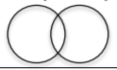  Draw a venn diagram in your book and sort animals according to your own choices. You could sort according to how many legs, where they live or if they fly. | Date | 8. Art  Create a piece of artwork to show a nocturnal animal. It can be paint, pencil sketch, collage… | Date
9. Tally Charts.  Create a tally chart to show your family and friend’s favourite creature. You can then put this information into a block graph or a pictogram. Which is the most popular? Which is the least popular? Can you write your own questions? | Date | 10. Healthy Eating  Can you keep a food diary of everything you eat for a week?  Are you a healthy eater?  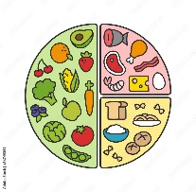 | Date | 11. Times Tables  Practise your 2 times tables.  Log on to TT Rockstars for some games.  Can you say them in order?  Can you get them right out of order?  Can you work out the division facts (e.g. 2 x 4 = 8 so 8 ÷ 2 = 4) | Date | 12. Life Cycles  Can you find out about and draw a life cycle for an animal?  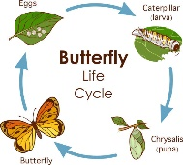 | Date

