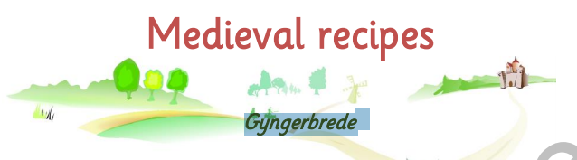
You will need:
450ml honey
Half teaspoon of white pepper
1 teaspoon of cinnamon
1 teaspoon of ginger
Pinch of saffron
2 loaves of bread crumbs

Heat honey to a slow boil and simmer for 10 minutes
Add saffron, cinnamon and breadcrumbs mix well
Spoon out into small balls abd leave to cool
Enjoy!

