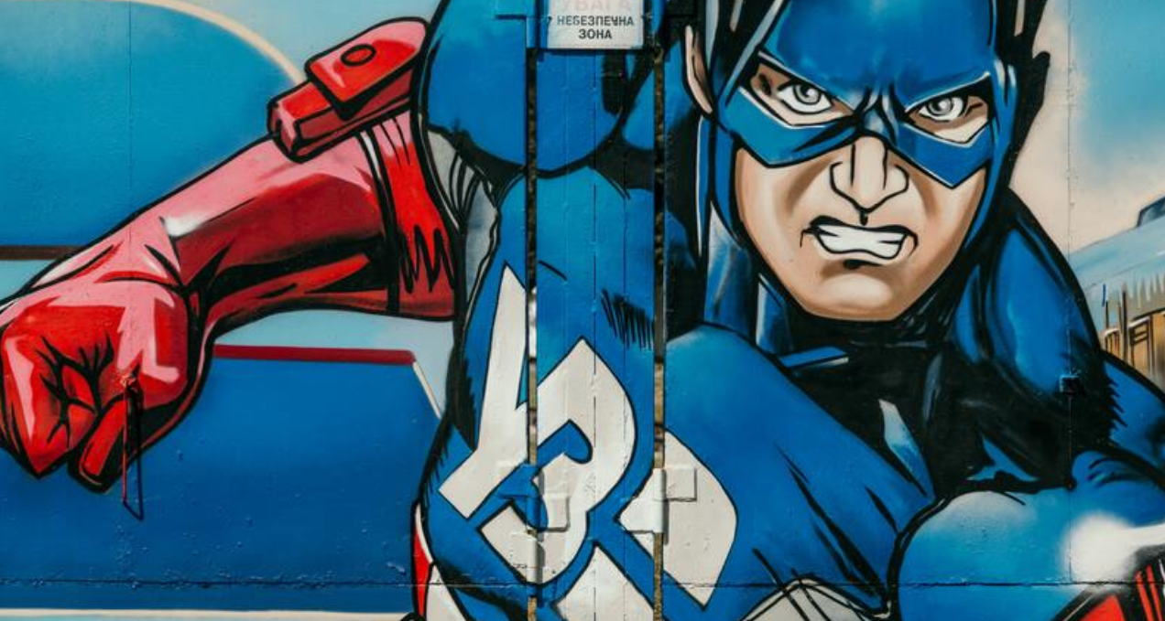

Vocabulary challenge
Select some of the words from the vocabulary list and write a paragraph about the back story of this superhero and how you think he became a superhero.
For example:
In New York, Steve Rodgers, an ordinary, second-rate citizen was rejected from the U.S military for the gazillionth time.
Dr. Sheldron Weinsten, leader of a top secret military programme, saw the agonising pain Steve had written all over his face and offered to release him from his weak and frail body.
You could either continue from this beginning or start from the beginning yourself.

