Passive Voice – Various Tenses
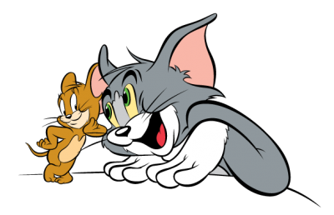


Cartoon Descriptions
Instructions:
- Find the video:
On YouTube, by searching for “English Through Videos: Cartoon Descriptions Activity – Passive Voice”.
- Watch the video clips.
- Read the description of each clip.
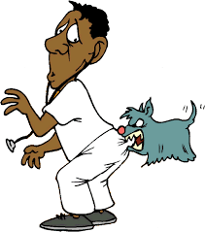
- Change the description from the active voice into the passive voice. For example:
  - Active: The dog bit the man. (Past Simple)
  - Passive: The man was bitten by the dog. (Past Simple Passive)

The cat was chasing the mouse.
- The mouse _______________________________________________________________
The goose fed the panda.
- The panda _______________________________________________________________
The man has given the panther a pair of smelly shoes.
- The panther ______________________________________________________________
The cat wakes the woman up every morning.
- The woman ______________________________________________________________
The police caught the escaped prisoners.
- The escaped prisoners _____________________________________________________
Barbie is destroying Ken’s clothes.
- Ken’s clothes _____________________________________________________________
The fishermen caught Dory in their net.
- Dory ____________________________________________________________________
The T Rex was carrying the minions on its back.
- The minions ______________________________________________________________
The crabs injured the bird.
- The bird _________________________________________________________________
The green chick has eaten the worm.
- The worm _______________________________________________________________
ANSWER SHEET
Passive Voice – Various Tenses
Cartoon Descriptions

The cat was chasing the mouse.
- The mouse was being chased by the cat.
The goose fed the panda.
- The panda was fed by the goose.
The man has given the panther a pair of smelly shoes.
- The panther has been given a pair of smelly shoes (by the man).
The cat wakes the woman up every morning.
- The woman is woken up by the cat every morning.
The police caught the escaped prisoners.
- The escaped prisoners were caught by the police.
Barbie is destroying Ken’s clothes.
- Ken’s clothes are being destroyed by Barbie.
The fishermen caught Dory in their net.
- Dory was caught in the net by the fishermen.
The T Rex was carrying the minions on its back.
- The minions were being carried by the T Rex.
The crabs injured the bird.
- The bird was injured by the crabs.
The green chick has eaten the worm.
- The worm has been eaten by the green chick.

