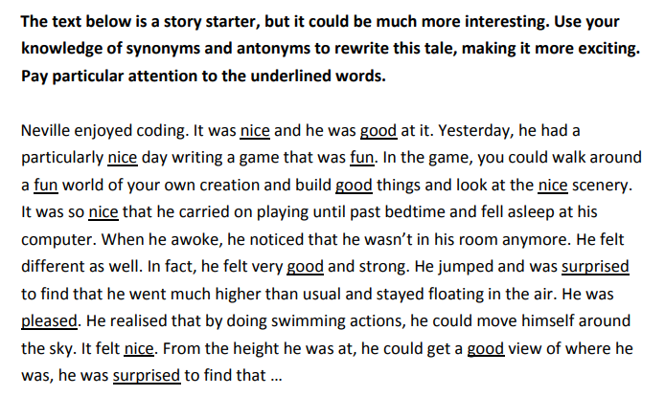
These are some of the words you may want to use:
friendly
good
repulsive
kindly
aloof
fun
pleasant
admirable
nasty
delightful
unlikeable
becoming
pretty

Challenge… can you continue the story?

