Cave  A big hole or space inside a hill, mountain, or rock.  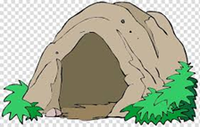 | Narrow  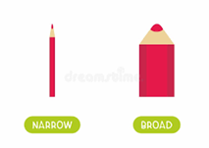  Not very wide; there is only a little space across. | Gloomy  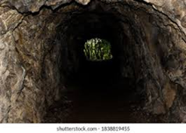  Dark and a little sad, miserable.
Thick  It is heavy and sticky and does not flow easily.  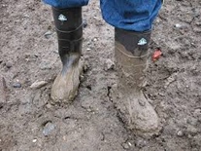 | Wavy  Having lots of curves that go up and down.  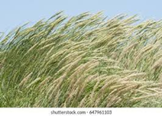 | Furry  Covered with soft hair or fur.  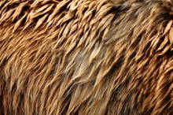
Grizzly  Scary or unpleasant.  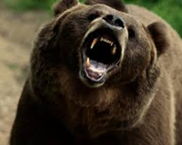 | Pour  To make a liquid flow from one container into another.  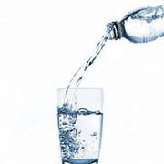 | Spread  To move something over a surface so it covers it, like spreading butter on toast.  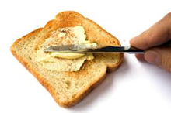
Stir

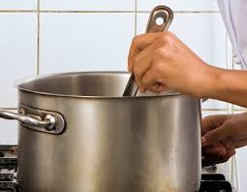
To move food or a drink around with a spoon.

