Surprise  Something that happens that you were not expecting.   | Village  A small place where people live. Smaller than a town.  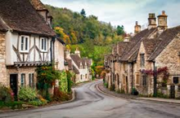 | Tasty  Something that tastes yummy.  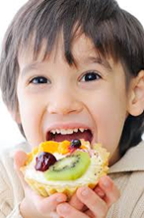
Spiky  Something that has sharp bits.  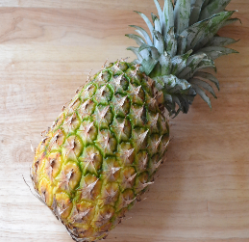 | Delicious  Something that tastes very nice.  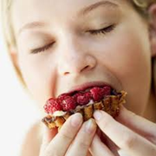 | Peel  To take the skin off something like a fruit.  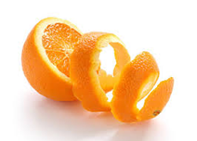
Plaque  A sticky layer of germs that build up on teeth.  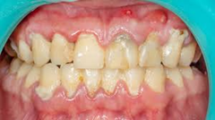 | Dentist  A person who helps and checks your teeth.  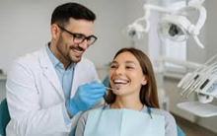 | Diet  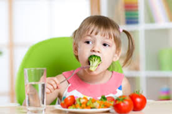  The food and drinks that you have everyday.
Balanced  Having the right amount of different things.  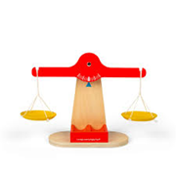 | Seed  Something tiny that grows into a plant.  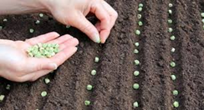 | Grow  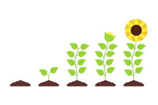  To get bigger or taller.

