Heather Garth

Langar.

menu
To update images, single click with the left mouse until they are selected. Do a right mouse click and choose Change Picture from the shortcut menu.
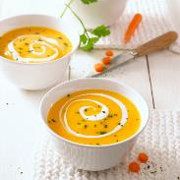

Describe your Appetizer.

Starter

Potato salad.
It is served with peppers, potato’s, lettuce and tomato’s in a creamy sauce.

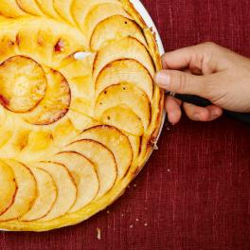

Vegetable curry
Creamy curry sauce with peas, chickpeas and peppers.
Thai sweet chili
A sweat chili with black beans, mushrooms, tomato’s and rice.

Main Course


Banana bread
A sweat banana flavour with melted sugar on top.
Kheer
A rice pudding like dessert with a powerful flavour.

Luke and Louie

Dessert

