Heather Garth Langar Menu
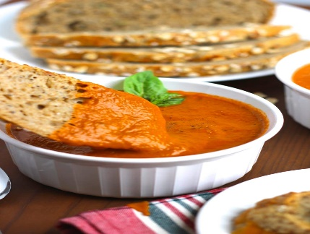
Starter:
“Gracious Gift.” {tomato and basil soup with seasoned bread.}
“Special salad.” {sliced lettuce,
cabbage, tomatoes and varied sauces.}

Main:
“Veggie surprise curry.” {tasty, curry that will blow your taste buds away.}

“veggie pillow “{blown up chapati with vegetables inside.}

“Fruity tooty blast”(amazing fruity yoghurt). Ben and Harvey

Fruity- tooty blast: (Amazing fruit yoghurt)

