Alex and Daniel | Langar
MENU
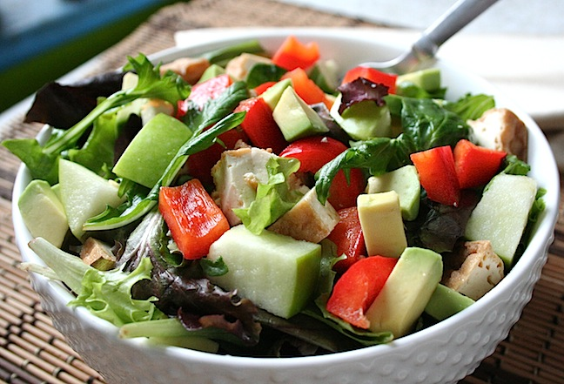

Salad Supreme- A variety of scrumptious & nutrient vegetables

Appetizer
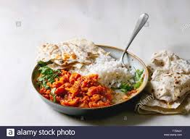


Sweet, sweet sauce - A Vegetable based curry with Rotis (bread)

Main Course


Marvelous Mango – A Mango flavored ice cream and Vanilla for an alternative

Dessert

