Autumn Two

Heather Garth
FS1 Songs and Rhymes Book

Five Little Rockets
(Sung to the tune of ‘Ten Green Bottles’)

Five little rockets standing in a row,
Five little rockets standing in a row,
When one little rocket decides it’s time to go,
Five, four, three, two, one, blast off!
There’ll be four little rockets standing in a row.

Four little rockets…
Three little rockets…
Two little rockets…

One little rocket…

Diwali Twinkle, Twinkle
(Sing to the tune of ‘Twinkle,
Twinkle, Little Star’)

Twinkle, twinkle, Diwali light,
How you sparkle in the night.
Let’s celebrate Di-wa-li,
Everyone, you and me.
Twinkle, twinkle, Diwali light,
Keep on shining oh so bright.
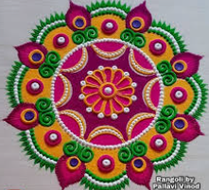


Three Baby Owls
(Sing to the tune of ‘Five Little Ducks’.)

One baby owl was in the tree,
Next to his mum, so cuddly.
Mummy owl said, ‘twit, twit, t-woo’,
And baby owl hooted, ‘I love you’.

Two baby owls were in the tree,
Next to their mum, so cuddly.
Mummy owl said, ‘twit, twit, t-woo’,
And baby owls hooted, ‘we love you’.

Three baby owls were in the tree,
Next to their mum, so cuddly.
Mummy owl said, ‘twit, twit, t-woo’,
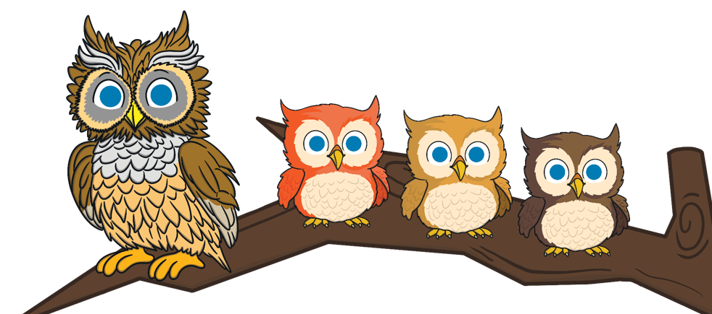
And baby owls hooted, ‘we love you’.

I’m a Little Snowman

I’m a little snowman, look at me.
These are my buttons, 1 2 3.
These are my eyes and this is my nose.
I wear a hat and scarf. Brrr…it’s cold!

I’m a little snowman, look at me.
These are my buttons, 1 2 3.
These are my eyes and this is my nose.
I wear a hat and scarf. Brrr…it’s cold!

I’m a little snowman, look at me.
These are my buttons, 1 2 3.
These are my eyes and this is my nose.
I wear a hat and scarf. Brrr…it’s cold!


In a little stable
In a little stable
Far across the sea
Was a little baby
Just like you and me.
A bed or cradle,
Not a pillow deep,
But a lowly manger
Was His place to sleep.
Shepherds stood around Him,
Angels watched with care,
For this babe was Jesus,
Lying, smiling there.
Oh, I love this Jesus,
Who was little then.
For he surely loves me,
Little though I am.
