Autumn Two
Heather Garth FS2 Songs and Rhymes Book


Fireworks
(To the tune of Wheels on the Bus)

The rockets in the sky go swish swish bang, swish swish bang, swish swish bang,
The rockets in the sky go swish swish bang, swish swish bang, swish swish bang,
On bonfire night

The Catherine wheels spin round and round, round and round, round and round,
The Catherine wheels spin round and round, round and round, round and round,
On bonfire night

The jumping jacks go jump bang jump, jump bang
jump, jump bang jump,
The jumping jacks go jump bang jump, jump bang
jump, jump bang jump,
On bonfire night

A Song for Diwali
(To the tune of Twinkle, Twinkle)

It’s Diwali, festival of light,
All the divas twinkle in the night!

Salmubarak – Happy New Year!
We’re so happy Diwali is here!

It’s Diwali, festival of light,
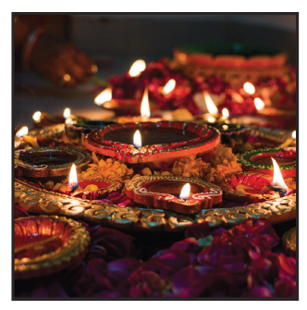
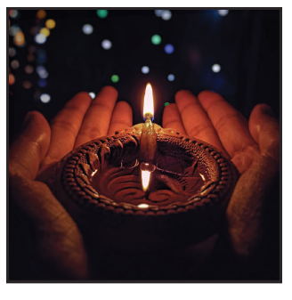
All the divas twinkle in the night!

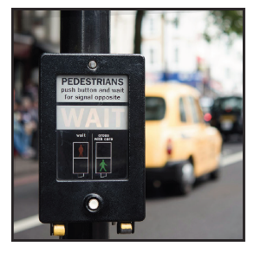

Stop, Look, Wait

Stop, look, wait.
Stop, look wait.
Before you cross the road,
before you cross the road.
We use our eyes and we use our ears and if no car or bus appears,
Well then, we cross the road, well then, we cross the road.
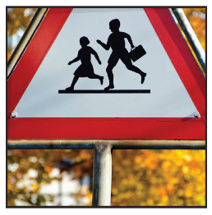
Ten green bottles hanging on the wall

TEN green bottles hanging on the wall,
TEN green bottles hanging on the wall,
And if one green bottle should accidentally fall,
There’ll be…
NINE green bottles hanging on the wall…

EIGHT green bottles hanging on the wall…

SEVEN green bottles hanging on the wall…

SIX green bottles hanging on the wall…

FIVE green bottles hanging on the wall…

FOUR green bottles hanging on the wall…

THREE green bottles hanging on the wall…

TWO green bottles hanging on the wall…

ONE green bottle hanging on the wall…

NO green bottles hanging on the wall!
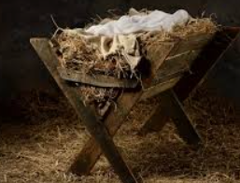
In a little stable

In a little stable
Far across the sea
Was a little baby
Just like you and me.
A bed or cradle,
Not a pillow deep,
But a lowly manger
Was His place to sleep.
Shepherds stood around Him,
Angels watched with care,
For this babe was Jesus,
Lying, smiling there.
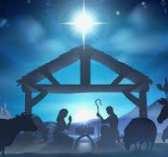
Oh, I love this Jesus,
Who was little then.
For he surely loves me,
Little though I am.

