Heather Garth Autumn FS1 Songs and Rhymes Book

**Dear Parents/Carers,**

**Please find a selection of songs we will be learning in FS1 to support our learning this half term.**

**The selection includes some songs to teach key concepts such as:**

**-Looking after our classroom environment**

**- Using and asking for the toilet**

**-Importance of hand washing**

**-Songs linked to Autumn and Harvest Time**

**Please sing these with your children at home to support their communication, vocabulary and knowledge of the key concepts taught during Autumn term 1 of FS1**

**We thank you for your continued support,**

**Mr Fisher, Miss B and Miss Bull**

**Choose it, Use it, Put it Away**

(Sing to the tune of Twinkle Twinkle Little Star)

Choose it, use it, put it away,

Keep things tidy every day.

Take one toy and when you’re through,

Put it back — that’s what we do!

Choose it, use it, put it away,

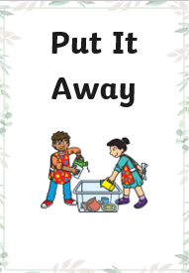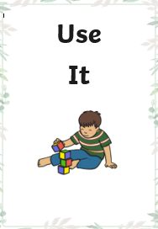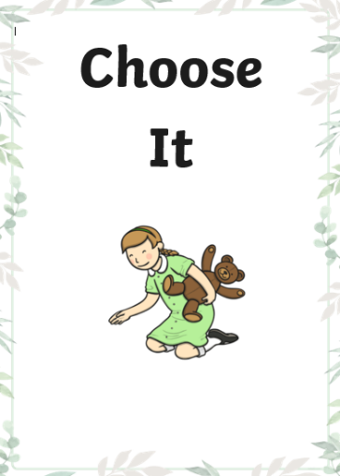Ready for more fu n and play!

**Toileting song**

(Sing to the tun of ‘Happy and you know it’)

When you need to use the toilet, ask to go! (clap, clap)

When you need to use the toilet, ask to go!

Sit down on the seat,

Wipe and flush so neat,

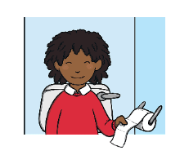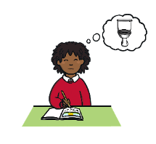Wash your hands and now you're good to go! (clap, clap)

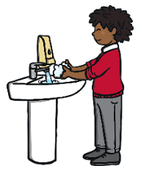



**Handwashing song**

(Sing to ‘Row, row, row your boat’)

Wash, wash, wash your hands,

Make them nice and clean,

Rub the bottoms and the tops,

And fingers in between!

**I'm a Little Hedgehog**

(Sing to the tune of 'I'm a Little Teapot'.)

I'm a little hedgehog,

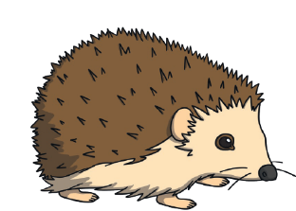Brown and small.

Very prickly,

Not that tall.

When I'm feeling frightened,

Away I crawl,

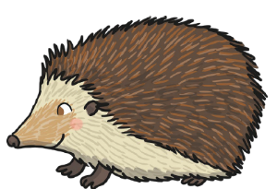And curl up into a ball!

I'm a little hedgehog,

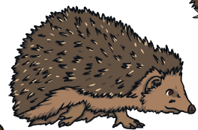Build my nest,

When it's autumn,

Leaves are best.

If you build a bonfire,

Have you guessed?

Check inside, I'm having a rest!

**Autumn Leaves**

(Sing to the tune of ‘London Bridge’)

Autumn leaves are falling down,

Falling down, falling down.

Autumn leaves are falling down,

Watch them falling.

Red and yellow and orange and brown,

Orange and brown, orange and brown.

Red and yellow and orange and brown,

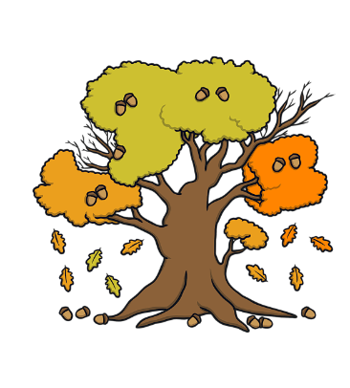Watch them falling.

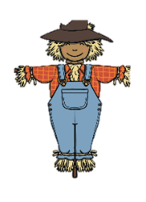

**Dingle Dangle Scarecrow**

When all the cows were sleeping

And the sun had gone to bed

Up jumped the scarecrow

And this is what he said

I'm a dingle, dangle scarecrow

With a flippy, floppy hat

I can shake my hands like this

I can shake my feet like that

When all the hens were roosting

And the moon behind a cloud

Up jumped the scarecrow

And shouted very loud

I'm a dingle, dangle scarecrow

With a flippy, floppy hat

I can shake my hands like this

I can shake my feet like that



I'm a dingle, dangle scarecrow

With a flippy, floppy hat

I can shake my hands like this

I can shake my feet like that