Heather Garth FS2 Autumn 1

Songs and Rhymes Book

**Dear Parents/Carers,**

**Please find a selection of songs we will be learning in FS2 to support our learning this half term.**

**The selection includes some songs to teach key concepts such as:**

**-Looking after our classroom environment**

**- Using a knife and fork to cut our food independently**

**-Importance of hand washing**

**-Songs linked to Autumn and Harvest Time**

**-A song to support our Mathematical development**

**Please sing these with your children at home to support their communication, vocabulary and knowledge of the key concepts taught during Autumn term 1 of FS2.**

**We thank you for your continued support,**

**Mr Fisher, Miss Bull and Miss Ball**

**Our Welcome Songs**

Hello everyone, hello everyone, glad that you are here,

Hello everyone, hello everyone, glad that you are here,

I, I, I, I, I’m, glad that you are here,

I, I, I, I, I’m, glad that you are here!

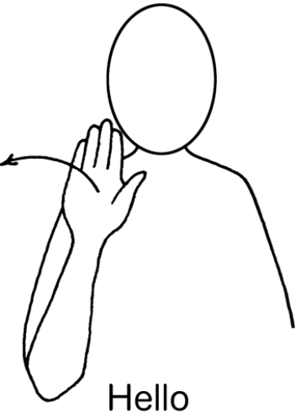

**Choose it, Use it, Put it Away (To tune of Twinkle Twinkle Little Star)**

Choose it, use it, put it away,

Keep things tidy every day.

Take one toy and when you’re through,

Put it back — that’s what we do!

Choose it, use it, put it away,

Ready for more fun and play!

**Knife and fork (To tune of row, row, row your boat)**

Knife and fork, knife and fork,

Cut your food in two,

Hold them gently in your hands,

That's the thing to do!

Cut, cut, cut your food

Cut your food in two,

Hold them gently in your hands,

That's the thing to do!

**Handwashing song (To tune of Here we go round the mulberry bush)**

This is the way we wash our hands,

Wash our hands, wash our hands,

This is the way we wash our hands,

To keep them clean and healthy!

First, we get our hands all wet

Hands all wet, hands all wet

First, we get our hands all wet

To keep them clean and healthy!

Then we add a squirt of soap

Squirt of soap, squirt of soap

Then we add a squirt of soap

To keep them clean and healthy!

Rub-a-dub-dub between our fingers

Between our fingers, between our fingers

Rub-a-dub-dub between our fingers

To keep them clean and healthy!

Now we rinse and dry them well…

Dry them well, dry them well

Now we rinse and dry them well

To keep them clean and healthy!

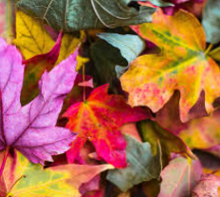 **Autumn Leaves**

*To the tune of London Bridge*

Autumn leaves are changing colours, changing colours, changing colours.  Autumn leaves are changing colours all over town.

*(Hold up both hands and turn them back and forth)*

Autumn leaves are falling down, falling down, falling down. Autumn leaves are falling down, down to the ground.

*(Like falling leaves)*

Take a rake and rake them up, rake them up, rake them up.  Take a rake and rake them up, on the ground.

*(Pretend to rake leaves)*

Make a pile and jump right in, and jump right in, and jump right in.  Make a pile and jump right in, on the ground.

**Harvest Song**

(To the tune of ‘Here we go round the mulberry bush’)

Here’s what we do at harvest time,

at harvest time, at harvest time,

Here’s what we do at harvest time,

At harvest time in the autumn.

Pull up the carrots at harvest time

Dig up potatoes ......

Share out the fruit ......

Pick up the apples ......

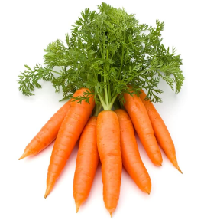Gather the blackberries ....

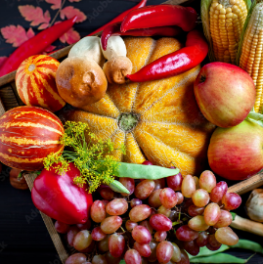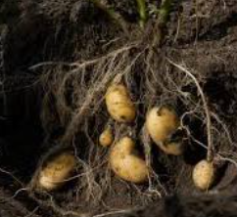

**Dingle Dangle Scarecrow**

When all the cows were sleeping, and the sun had gone to bed.

Up jumped the scarecrow, and this is what he said…

I'm a dingle, dangle scarecrow, with a flippy floppy hat.

I can shake my hands like this, and shake my feet like that.

When all the hens were roosting, and the moon behind the cloud

Up jumped the scarecrow, and shouted very loud…

I'm a dingle, dangle scarecrow. With a flippy floppy hat

I can shake my hands like this, and shake my feet like that

When the dogs were in the kennels, and the doves were in the loft

Up jumped the scarecrow, and whispered very soft…

I'm a dingle, dangle scarecrow, with a flippy floppy hat.

I can shake my hands like this, and shake my feet like that.

**Ten fat sausages**

Ten fat sausages sizzling in the pan.

One went pop, and the other went bang!

Eight fat sausages sizzling in the pan.

One went pop, and the other went bang!

Six fat sausages sizzling in the pan.

One went pop, and the other went bang!

Four fat sausages sizzling in the pan.

One went pop, and the other went bang!

Two fat sausages sizzling in the pan.

One went pop, and the other went bang!

